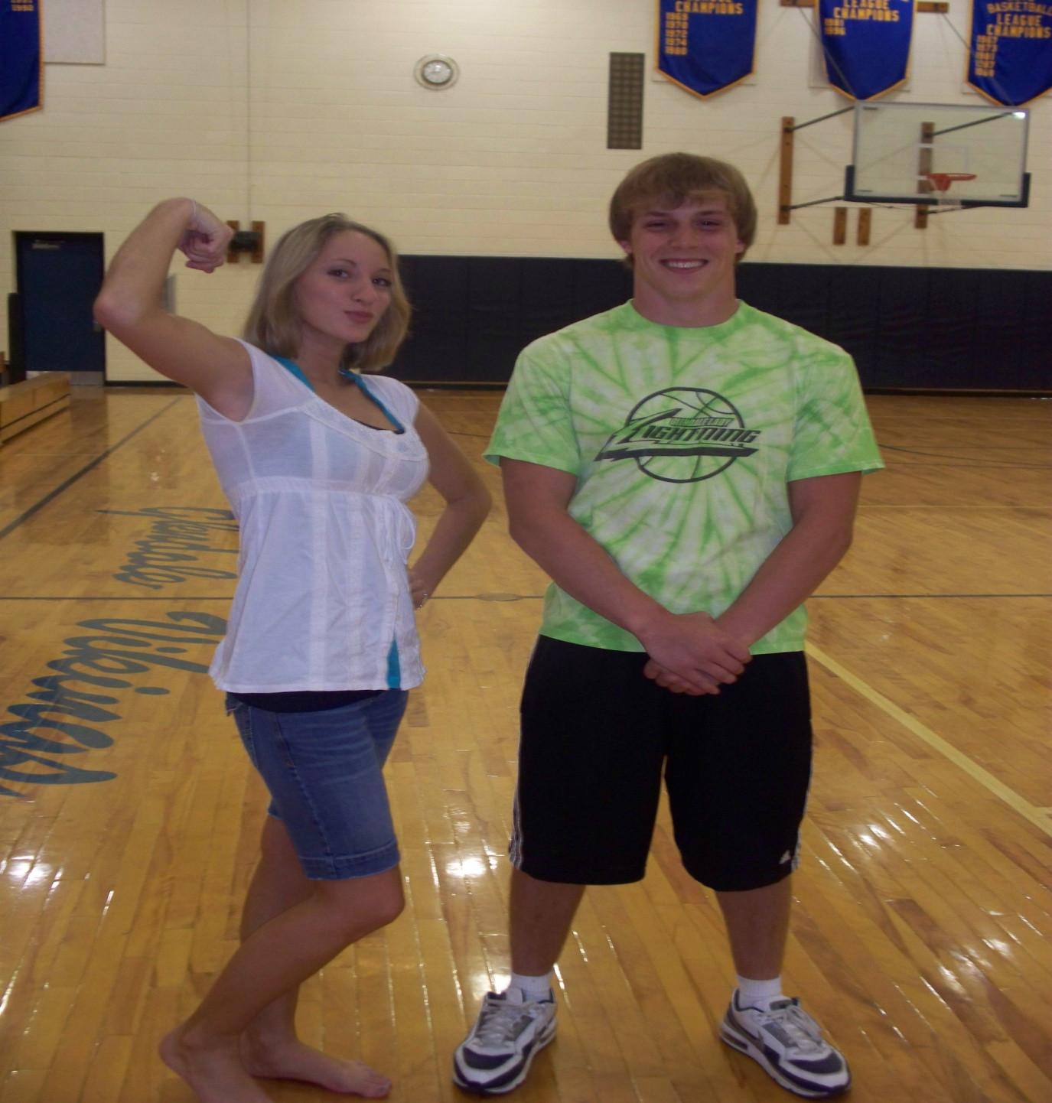
PE Students of the Year
2010
Kassandra Lee and Codi McClellan

