Name: ________________________

APPLICATION OF LINEAR EXPRESSIONS

- The expression $17n+11$ represents the entire perimeter (in feet) of the triangle. Write an expression that represents the measure of the third side of the triangle.
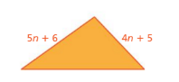

- Taxi Express charges a flat rate of $2.60 plus an additional $3.65 per mile. Cab Cruiser charges a flat rate of $2.75 plus an additional $3.90 per mile. Write an expression that represents how much more Cab Cruiser charges than Taxi Express.

- A rectangular room is 10 feet longer than it is wide. One-foot-by-one-foot tiles cover the entire floor. Write an expression that represents the number of tiles along the outside of the room.

