Name: ___________________________

CRITICAL THINKING
THE FLAG PROBLEM
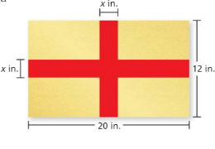
For Mr. Stevko’s class, you are asked to create a new country with your own government. To design the flag, you apply gray foil to a piece of black poster board to make the design shown.

- Write an expression in simplest form that represents the area of the gray foil.

- Find the area of the gray foil when x = 3.

