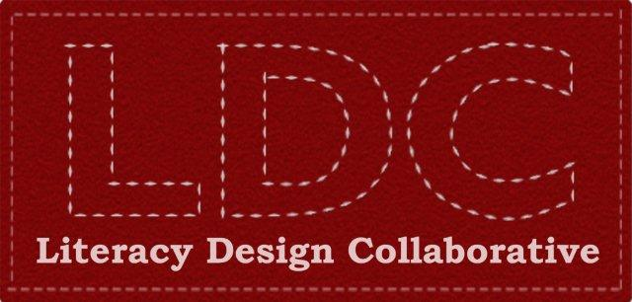

Overview
Literacy Design Collaborative is a Gates Foundation funded initiative to focus on three key goals:
- Implementation of Common Core State Standards
- Developing College Readiness for High School Students
- Promoting Effective Teaching

Literacy Design Collaborative (LDC) developed teaching tasks that provide a blueprint for seamlessly integrating literacy and content standards in a rigorous, authentic classroom experience at the secondary level. After determining the discipline, course, and grade level, educators use teaching tasks built around predefined template prompts. The teaching task requires students to read, analyze, and comprehend written materials and then write cogent arguments, explanations, or narratives in the subjects they are studying.

Task Development
PA educators across the state have been developing rigorous and relevant writing tasks designed to engage students in reading and writing at a level commensurate with Common Core expectations. Writing tasks are fully developed and defined by content area, Common Core and PA Academic Standards, as well as a set of learning objectives – and have students read, analyze, and gather relevant information from text(s) and write arguments, explanations, or narratives.

Accessing LDC Tasks
All published PA teacher designed LDC tasks are posted on the Standards Aligned System (SAS) portal. After logging on to SAS at http://www.pdesas.org, users can access the tasks in the Materials and Resources tab. Searching by keyword LDC will produce a list of all available reading and writing tasks – tasks that are designed to engage students in science and social studies topics ranging from organ transplantation to the Great Depression. All tasks include necessary resources, instructional strategies, and rubrics to evaluate student writing. Many of the posted reading and writing tasks are also supported by writing exemplars – actual student writings annotated to provide models from which classroom teachers can benchmark the quality of their own students’ writings.

LDC: A Value Added Resource
Using LDC tasks in classrooms offers multiple benefits: reading and writing tasks are well researched and developed as teacher ready lessons aligned to Common Core. Additionally, as PA schools seek to prepare students to meet proficiency standards on the Keystone Composition Exam, LDC tasks meet or exceed those expectations.

