AP Stats
Chap 12 – Experiments and Observational Studies

- observational study –

- retrospective study –

- prospective study –

Is it ever possible to prove a cause-and-effect relationship?

- experiment –

1.

2.

3.

- factor –

- response variable –

- subjects –
- participants –
- experimental units –

- levels –

- treatment –

The Four Principles of Experimental Design
- control –

- randomize –

- replicate –

- block –

A diagram of the procedure can help in thinking about experiments:

A good way to start comparing results for the treatment groups is with ________________.

A completely randomized experiment is the IDEAL simple design, just like ______
is the IDEAL simple sample!

An ad for OptiGro plant fertilizer claims that with this product, you will grow “juicier, tastier” tomatoes. You’d like to test this claim, and wonder whether you might be able to get by with half the specified dose of fertilizer. How can you set up an experiment to check this claim?

Doing an Experiment Step-by-Step
1. Plan – state what you want to know

2. Response – specify the response variable

3. Treatments – specify the factor levels and the treatments

4. Experimental Units – specify the experimental units

5. Experimental Design – the first three principles of designs…
- Control – state any sources of variability you know of and can control

- Randomly Assign – state how you will randomly assign subjects to treatments

- Replicate – state how (how often) you will replicate the experiment

6. Make a diagram – helps you think about the experiment clearly

7. State how to measure the response

8. Show – once you’ve collected the data, display them and compare the results

9. Tell – be sure to answer the initial question!

- statistically significant –

Experiments are rarely performed on random samples from a population. Since they try to assess the effects of treatments on a specific group of people, the subjects are specifically chosen. Once in the sample, THEN randomization occurs as to who gets which treatment.

Experiments can draw stronger conclusions than surveys.

- control treatments –

- control group –

- blinding –

- single-blind –

- double-blind –

- placebo –

The BEST experiments are _________________, ___________________, _______________

and _________________________.

- blocks – groups of experimental units that are similar.
  - by blocking, we isolate the variability attributable to the differences between the blocks, so that we can see the differences caused by the treatments more clearly.
  - in English…we block the subjects so that whatever difference(s) they have, when they are randomly selected for the groups, those differences will be “accounted for” as best they can be. That way, the factors that we’re actually looking for will be what we hopefully will see.
  - blocking is the same idea for experiments as stratifying is for sampling. Both group together subjects that are similar, and then randomize within those groups.

    - random block design – the method of randomizing only within the blocks.
  - remember the picture from the tomato example:
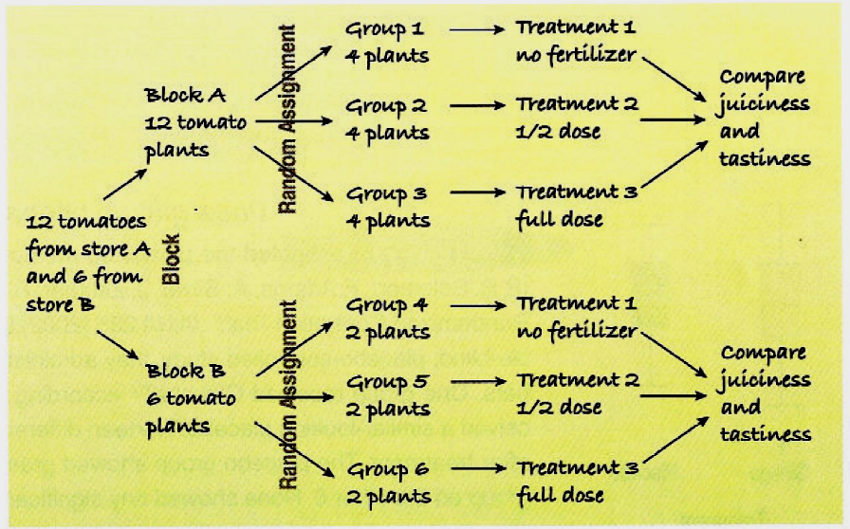

- matching – paring subjects (in retrospective or prospective studies) because they are similar in ways not under study.
  - this can reduce variation in much the same way as blocking

    - completely randomized two-factor experiment – studying two factors in the same experiment
  - it’s a misconception to think that applying several factors at once makes it difficult to separate the effects of the factors.
  - experiments with more than one factor are more efficient and provide more information than one-at-a-time experiments
  - all subjects have an equal chance of receiving any of the treatments
  - again, think of the tomatoes:

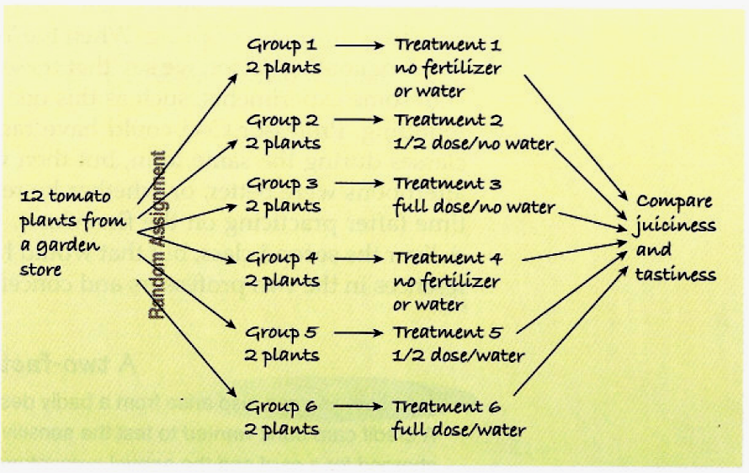

- confounding – when the levels of one factor are associated with the levels of another factors, and there is no way to tear apart the two in the results
  - in some experiments, it’s just not possible to avoid confounding
  - confounding can most often be corrected by adjusting the number of combinations of groups / treatments

    - lurking variables v. confounding –
  - lurking variables are prior causes of both x and y that makes it appear that x may be causing y
  - confounding variables are associated in a “non-causal” way with a factor, and affects the response. Because of the confounding, we can’t tell whether the effect we see was “caused” by the factor we’re studying, or the confounding variable, or both of them working together.

What Can Go Wrong?
- Don’t give up just because you can’t do an experiment. Often an observational study is a good choice.

- Beware of confounding. Use randomization whenever possible to ensure that the factors in your experiment are not confounded with your treatment levels.

- Bad things happen even to good experiments. Record ALL data from your subjects as the experiment progresses.

