Use this link (http://www.chemguide.co.uk/physical/acidbaseeqia/theories.html ) to complete these sentences.
According to the Arrhenius theory acids are defined as

and bases are defined as
Use these definitions to identify the following as acid (A), basic (B), or neither (N).
HBr KOH NH₃ H₂O

A second acid-base theory was formulated by Lowry and Bronsted. The Lowry-Bronsted theory
states that acids are

and bases are

How can this be?
Use this link (http://www.elmhurst.edu/~chm/vchembook/184ph.html ) to find out about the pH scale.
Generally the pH scale is represented by numbers between and .
Acids have pH values below while bases are above . A pH of is
considered neutral, neither acidic or basic.
On this pH scale, write each substance at the pH value it would have.
0 1 2 3 4 5 6 7 8 9 10 11 12 13 14

- Lye, B) vinegar, C) water, D) lemon juice, E) ammonia, F) battery acid, G) bleach, H) bananas

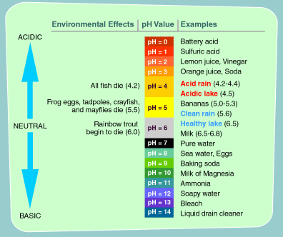
Use the chart above and the following scenario:
- Copperas Rocks is named for the coppery-yellow stain on the cliff surface. The crystalline, yellow precipitate is ferrous sulfate that leaches from a small pocket of coal. Although this substance is one of the main pollutants in acid mine drainage, the small quantity here is not harmful to the stream. The small cave at the bottom of the cliff was probably made by early settlers who used ferrous sulfate as a mordant for setting the dye color in cloth. While the settlers may have found the ferrous sulfate useful for dying purposes the presence of the Fe⁺² ion in the water causes a great problem. When the ferrous ion is dissolved in the creek water the following reaction takes place: Fe⁺² + 2 HOH Fe(OH)₂ + 2 H⁺¹ This iron (II) ion reacts with the water to produce a surplus of H⁺¹ ions making the creek acidic (according to Arrhenius). This action is similar to a pollution commonly known as “acid mine drainage.” Iron ions leech from the abandoned mine (often left over from coal samples) into streams and creeks.
Why might “mine drainage” be a serious problem for wildlife that live in a stream?

