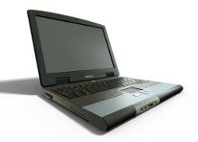
Making learning and expression accessible
Free text to speech software
- http://www.naturalreaders.com/index.htm
- http://www.readthewords.com/
CoolSpeech is a text-to-speech player for Windows for minimal cost. Free demo download for 14 days.
- http://www.nch.com.au/verbose/index.html
Other TTS (text to speech) software available with avatar voices and foreign accents for computers enabled with CoolSpeech 5.0.
Verbose TTS also available through Dragon Naturally Speaking. Converts text to voice or saves as mp3.
- http://www.nch.com.au/verbose/index.html

Dragon Naturally Speaking -Speech recognition software (99% accuracy, you talk, it types)
- http://www.squidoo.com/dragon-naturally-speaking-software
National Center on Accessible Instructional Materials
Graphic organizers to depict the relationships between facts, terms or ideas within a learning task.
- http://aim.cast.org/learn/historyarchive/backgroundpapers/graphic_organizers

