My New Dog!!!!!
Collars:
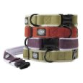
Planet Dog Cozy Hemp Adjustable Collar, Apple Green, Medium by Planet Dog (Mar 12, 2007)
$18.95
In stock but may require an extra 1-2 days to process.
More Buying Choices
$13.89 new (8 offers)
$16.29 used (1 offer)
(57)
Eligible for FREE Super Saver Shipping.
Pet Supplies: See all 55,661 items

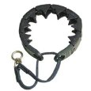
StarMark Training Collar, Large, Blue by StarMark
$9.99
Order in the next 43 hours and get it by Monday, Oct 22.
More Buying Choices
$9.99 new (11 offers)
$9.49 used (3 offers)
(147)
Eligible for FREE Super Saver Shipping.
Pet Supplies: See all 55,661 items

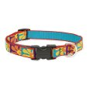
Lupine® 3/4" Crazy Daisy 13-22 Adjustable Dog Collar by Lupine
$11.00
Order in the next 38 hours and get it by Monday, Oct 22.
Only 18 left in stock - order soon.
More Buying Choices
$8.00 new (8 offers)
(78)
Eligible for FREE Super Saver Shipping.
Pet Supplies: See all 55,661 items

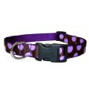
Large Orchid/Chocolate Dot Dog Collar: 1" wide, Adjusts 18-28" - Made in USA. by Sassy Dog Wear
$12.99
Order in the next 20 hours and get it by Monday, Oct 22.
Only 10 left in stock - order soon.
More Buying Choices
$12.99 new (2 offers)
(9)
Eligible for FREE Super Saver Shipping.
Pet Supplies: See all 55,661 items

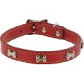
Kakadu Pet Give a Dog a Bone Leather Dog Collar, 1/2" x 12", Red by Kakadu Pet
$6.48
Order in the next 43 hours and get it by Monday, Oct 22.
More Buying Choices
$6.37 new (2 offers)
(8)
Eligible for FREE Super Saver Shipping.
Pet Supplies: See all 55,661 items

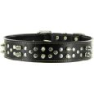
Kakadu Pet Punk Pooch Leather Studded Dog Collar, 1 1/2" x 27 1/2", Black by Kakadu Pet
$13.90
Order in the next 38 hours and get it by Monday, Oct 22.
(8)
Eligible for FREE Super Saver Shipping.
Pet Supplies: See all 55,661 items

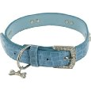
Kakadu Pet Park Avenue Leather Rhinestone Dog Collar, 1/2" x 13 1/2", Blue by Kakadu Pet
$8.08
Order in the next 43 hours and get it by Monday, Oct 22.
(7)
Eligible for FREE Super Saver Shipping.
Pet Supplies: See all 55,661 items

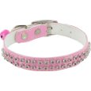
Kakadu Pet Rodeo Drive Rhinestone Dog or Cat Collar with Bell, 1/2" x 14", Pink by Kakadu Pet
$5.50
Order in the next 43 hours and get it by Monday, Oct 22.
(16)
Eligible for FREE Super Saver Shipping.
Pet Supplies: See all 55,661 items

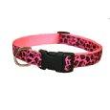
Medium Pink Leopard Dog Collar: 3/4" wide, Adjusts 13-20" - Made in USA. by Sassy Dog Wear
$11.99
Order in the next 38 hours and get it by Monday, Oct 22.
Only 7 left in stock - order soon.
More Buying Choices
$11.99 new (2 offers)
(16)
Eligible for FREE Super Saver Shipping.
Pet Supplies: See all 55,661 items

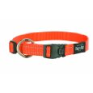
Rogz Reflective 3/4-Inch Fanbelt Dog Collar, Medium to Large, Orange by Rogz
$6.82
Order in the next 43 hours and get it by Monday, Oct 22.
(95)
Eligible for FREE Super Saver Shipping.
Pet Supplies: See all 55,661 items

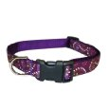
Large Pretty Paisley Dog Collar: 1" wide, Adjusts 18-28". by Sassy Dog Wear
$12.99
Order in the next 20 hours and get it by Monday, Oct 22.
Only 12 left in stock - order soon.
(6)
Eligible for FREE Super Saver Shipping.
Pet Supplies: See all 55,661 items

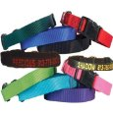
Custom Personalized Embroidered Dog Collars (FREE SHIPPING IN THE USA) by Angela Proctor's Embroidery
$14.99
Usually ships in 6 to 10 days
More Buying Choices
$9.00 new (2 offers)
(2)
Pet Supplies: See all 55,661 items


Dog Collar with Blue LED Lights, Multi-Function, Large
$15.99
Order in the next 41 hours and get it by Monday, Oct 22.
(9)
Eligible for FREE Super Saver Shipping.
Pet Supplies: See all 55,661 items

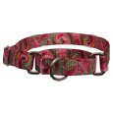
Large Martingale Pink Paisley Patterened Dog Collar by Country Brook Design, Inc.
$9.95
Order in the next 39 hours and get it by Monday, Oct 22.
(7)
Eligible for FREE Super Saver Shipping.
Pet Supplies: See all 55,661 items

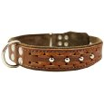
High Quality Genuine Leather Braided Studded Dog Collar, Brown 1.5" Wide. Fits 17"-22" Neck. by DML
$25.90
Order in the next 38 hours and get it by Monday, Oct 22.
More Buying Choices
$21.90 new (2 offers)
(4)
Eligible for FREE Super Saver Shipping.
Pet Supplies: See all 55,661 items

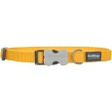
Red Dingo Dog Collar, Medium, Yellow by Red Dingo
$6.52
Order in the next 42 hours and get it by Monday, Oct 22.
(5)
Eligible for FREE Super Saver Shipping.
Pet Supplies: See all 55,661 items
Worm Medicine:
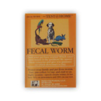
QuickView
Perfect Pet Products Fecal Worm Test at Home
$23.47
Up to 22% Off
Click & Compare
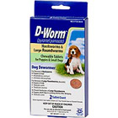
QuickView
D-Worm Dog Wormer Chewable Tablets for Puppies & Dogs
$9.59 to $19.99
Up to 20% Off
Click & Compare
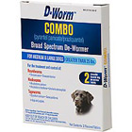
QuickView
D-Worm Combo Broad Spectrum Puppy & Dog De-Wormer
$11.99 to $35.99
Up to 20% Off
Click & Compare
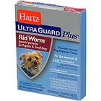
QuickView
Hartz Ultra Guard Plus Rid Worm Dog Dewormer
$9.59
Up to 20% Off
Click & Compare

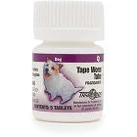
QuickView
TradeWinds Tape Worm Tabs For Dogs & Puppies
$27.99
Up to 20% Off
Click & Compare

Bed:
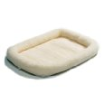
Midwest 40236 36-By-23-Inch Quiet Time Bolster Pet Bed, Fleece by Midwest Homes for Pets (Nov 30, 2006)
$19.05
Order in the next 18 hours and get it by Monday, Oct 22.
More Buying Choices
$17.07 new (25 offers)
$15.37 used (3 offers)
(672)
Eligible for FREE Super Saver Shipping.
Pet Supplies: See all 16,640 items

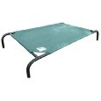
Coolaroo Large Steel-Framed Pet Bed, Brunswick Green by Gale Pacific (Apr 2, 2007)
$33.99
Order in the next 18 hours and get it by Monday, Oct 22.
More Buying Choices
$33.99 new (7 offers)
$30.89 used (1 offer)
(976)
Eligible for FREE Super Saver Shipping.
Pet Supplies: See all 16,640 items

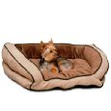
K&H Bolster Couch Pet Bed, Large 28-Inch by 40-Inch, Mocha/Tan by K&H Manufacturing
$53.76
Order in the next 18 hours and get it by Monday, Oct 22.
More Buying Choices
$49.00 new (35 offers)
$48.38 used (3 offers)
(165)
Eligible for FREE Super Saver Shipping.
Pet Supplies: See all 16,640 items

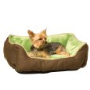
K&H Lounge Sleeper Self-warming Pet Bed, 16-Inch by 20-Inch, Mocha/Green by K&H Manufacturing
$24.00
Order in the next 17 hours and get it by Monday, Oct 22.
More Buying Choices
$24.00 new (29 offers)
(78)
Eligible for FREE Super Saver Shipping.
Pet Supplies: See all 16,640 items

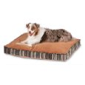
Petmate Microban Pet Bed Petmate Deluxe Pillow Bed with Microban, Gusseted Red/Gold Striped Chenille, 27-inch X 36-inch by Petmate (Sep 16, 2007)
$40.76
Order in the next 18 hours and get it by Monday, Oct 22.
More Buying Choices
$34.42 new (15 offers)
$33.34 used (2 offers)
(17)
Eligible for FREE Super Saver Shipping.
Pet Supplies: See all 16,640 items

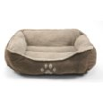
Brinkmann Pet Paw Print Pet Bed, 25-Inch, Brown by Brinkmann Pet
$29.50
Order in the next 18 hours and get it by Monday, Oct 22.
Only 20 left in stock - order soon.
(12)
Eligible for FREE Super Saver Shipping.
Pet Supplies: See all 16,640 items

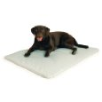
K&H Cool Bed III Cooling Dog Bed, Large, 32-Inches by 44-Inches, Gray by K&H Manufacturing (Jun 21, 2007)
$50.93
Order in the next 18 hours and get it by Monday, Oct 22.
More Buying Choices
$49.95 new (23 offers)
$29.07 used (3 offers)
(221)
Eligible for FREE Super Saver Shipping.
Pet Supplies: See all 16,640 items

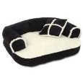
Petmate 28377 20-Inch Sofa Pet Bed with Pillow - Random Color - Beige, Black, Brown or Burgundy by Petmate
$14.35
In stock. Processing takes an additional 3 to 4 days.
More Buying Choices
$14.35 new (9 offers)
(23)
Pet Supplies: See all 16,640 items

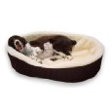
XL- Extra Large Brown Exterior with Imitation Lambswool Interior. Dog Bed King Pet Bed Cuddler. Outside Dim. 42x32x7". Inside Dim. 38x28x7". Washable Cover. We make them in America. Arrives in 2-9 Business days. by Dog Bed King
$47.99
In Stock
(20)
Pet Supplies: See all 16,640 items

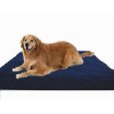
Extra Large 40"X35"X4" Orthopedic 100% Memory Foam Pad Pet Bed for Large Dog with long lasting denim cover + Waterproof case + Free Bonus Cover by dogbed4less
$82.95
In Stock
(150)
Pet Supplies: See all 16,640 items

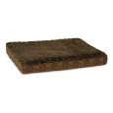
Petmate Orthopaedic Pet Bed, 27 inch by 36 inch, Colors may vary by Petmate
$46.99
Order in the next 18 hours and get it by Monday, Oct 22.
More Buying Choices
$39.53 new (8 offers)
(21)
Eligible for FREE Super Saver Shipping.
Pet Supplies: See all 16,640 items

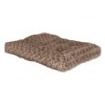
Midwest Quiet Time 35-By-23-Inch Ombre? Swirl Deluxe Pet Bed by Midwest Homes for Pets
$30.00
Order in the next 18 hours and get it by Monday, Oct 22.
More Buying Choices
$21.76 new (15 offers)
(49)
Eligible for FREE Super Saver Shipping.
Pet Supplies: See all 16,640 items

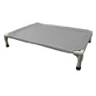
Coolaroo Aluminum Pet Bed, Extra Large, Gray by Coolaroo
$89.99
Order in the next 18 hours and get it by Monday, Oct 22.
More Buying Choices
$89.99 new (2 offers)
(23)
Eligible for FREE Super Saver Shipping.
Pet Supplies: See all 16,640 items

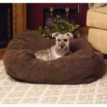
K&H Cuddle Cube Pet Bed, Small 24-Inch by 24-Inch, Mocha by K&H Manufacturing
$41.78
Order in the next 18 hours and get it by Monday, Oct 22.
More Buying Choices
$34.99 new (28 offers)
(197)
Eligible for FREE Super Saver Shipping.
Pet Supplies: See all 16,640 items

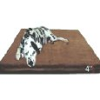
Orthopedic Rate Extra Large Brown Microsuede Waterproof Full Memory Foam Pad Dog Pet Bed 40 inches X 35 inches with 4 inches thick + Free Bonus Cover by dogbed4less
$82.85
In Stock
(46)
Pet Supplies: See all 16,640 items

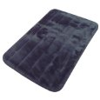
Precision Pet SnooZZy Sleeper Mat, Medium/Large, 4000 35x23", Black by Precision Pet
$18.42
Order in the next 18 hours and get it by Monday, Oct 22.
More Buying Choices
$13.49 new (7 offers)
(96)
Eligible for FREE Super Saver Shipping.
Pet Supplies: See all 16,640 items

Food:
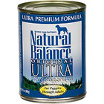
Natural Balance Ultra Premium Original Formula Canned Dog Food
$18.88 to $24.28
Up to 10% off
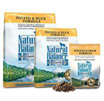
Natural Balance L.I.D. Potato & Duck Dry Dog Food
$15.28 to $50.13
Up to 15% off
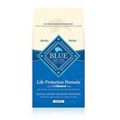
Blue Buffalo Chicken & Brown Rice Adult Dog Food
$18.99 to $48.99
Up to 17% off
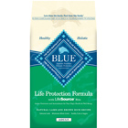
Blue Buffalo Lamb & Brown Rice Adult Dog Food
$20.68 to $52.18
Up to 10% off
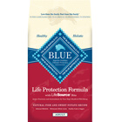
Blue Buffalo Fish & Sweet Potato Adult Dog Food
$20.68 to $52.18
Up to 10% off
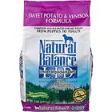
Natural Balance L.I.D. Limited Ingredients Diets Sweet Potato & Venison Dry
$16.82 to $58.39
Up to 11% off
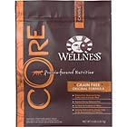
Wellness CORE Original Adult Dog Food
$15.99 to $55.99
Up to 12% off
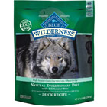
Blue Buffalo Wilderness Duck with Sweet Potatoes Adult Dry Dog Food
$19.42 to $50.13
Up to 15% off
Top of Form

View By: Show:
Page: 1 2 3 4 5 .. 13
Select up to 5 products to compare.
COMPARE
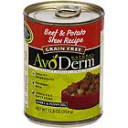
QuickView
AvoDerm Grain Free Canned Dog Food
$26.98
Up to 10% Off
Click & Compare
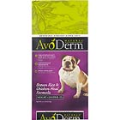
QuickView
AvoDerm Natural Brown Rice & Chicken Meal Formula Weight Control Adult Dog...
$11.05 to $44.98
Up to 10% Off
Click & Compare
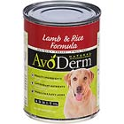
QuickView
AvoDerm Natural Canned Adult Dog Food
$25.18
Up to 10% Off
Click & Compare
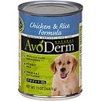
QuickView
AvoDerm Natural Canned Puppy Food
$24.83
Up to 10% Off
Click & Compare

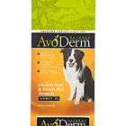
QuickView
AvoDerm Natural Chicken Meal & Brown Rice Formula Adult Dog Food
$11.05 to $44.08
Up to 10% Off
Click & Compare
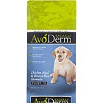
QuickView
AvoDerm Natural Chicken Meal & Brown Rice Formula Puppy Food
$11.68
Up to 10% Off
Click & Compare
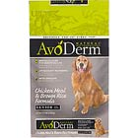
QuickView
AvoDerm Natural Chicken Meal & Brown Rice Formula Senior Dog Food
$29.68
Up to 10% Off
Click & Compare
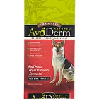
QuickView
AvoDerm Natural Grain Free Red Meat Meal & Potato Dry Dog Food
$11.05 to $50.39
Up to 10% Off
Click & Compare

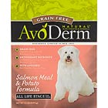
QuickView
AvoDerm Natural Grain Free Salmon Meal & Potato Dry Dog Food
$11.05 to $50.39
Up to 10% Off
Click & Compare
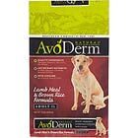
QuickView
AvoDerm Natural Lamb Meal & Brown Rice Adult Dog Food
$11.05 to $50.39
Up to 10% Off
Click & Compare
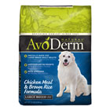
QuickView
AvoDerm Natural Large Breed Adult Chicken Meal & Brown Rice Formula Dry Dog
$28.70 to $50.39
Up to 10% Off
Click & Compare
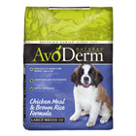
QuickView
AvoDerm Natural Large Breed Puppy Chicken Meal & Brown Rice Formula Dry...
$29.68
Up to 10% Off
Click & Compare

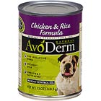
QuickView
AvoDerm Natural Lite Canned Dog Food
$25.18
Up to 10% Off
Click & Compare
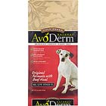
QuickView
AvoDerm Natural Original with Beef Meal Oven-Baked Adult Dog Food
$29.68 to $50.39
Up to 10% Off
Click & Compare
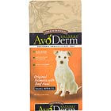
QuickView
AvoDerm Natural Original with Beef Meal Oven-Baked Small Bites Adult Dog...
$11.05
Up to 10% Off
Click & Compare
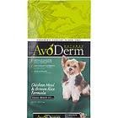
QuickView
AvoDerm Natural Small Breed Adult Chicken Meal & Brown Rice Formula Dry Dog
$10.88 to $16.72
Up to 10% Off
Click & Compare

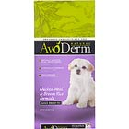
QuickView
AvoDerm Natural Small Breed Puppy Chicken Meal & Brown Rice Formula Dry...
$10.88
Up to 10% Off
Click & Compare
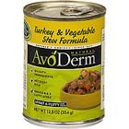
QuickView
AvoDerm Natural Stews Adult Canned Dog Food
$24.28
Up to 10% Off
Click & Compare
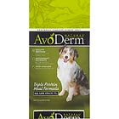
QuickView
AvoDerm Natural Triple Protein Meal Dry Dog Food
$11.05 to $52.18
Up to 10% Off
Click & Compare
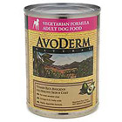
QuickView
AvoDerm Natural Vegetarian Adult Canned Dog Food
$25.18
Up to 10% Off
Click & Compare

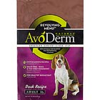
QuickView
AvoDerm Revolving Menu Natural Duck Recipe Adult Dog Food
$14.39 to $44.99
Up to 10% Off
Click & Compare
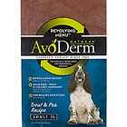
QuickView
AvoDerm Revolving Menu Natural Trout & Pea Recipe Adult Dog Food
$14.39 to $44.99
Up to 10% Off
Click & Compare
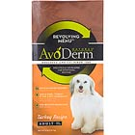
QuickView
AvoDerm Revolving Menu Natural Turkey Recipe Adult Dog Food
$14.39 to $44.99
Up to 10% Off
Click & Compare
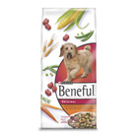
QuickView
Beneful Adult Dog Food
$4.79 to $28.79
Up to 20% Off
Click & Compare

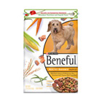
QuickView
Beneful Adult Dog Food Healthy Radiance Formula
$11.43 to $28.79
Up to 20% Off
Click & Compare
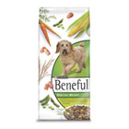
QuickView
Beneful Adult Dog Food Healthy Weight Formula
$4.79 to $28.79
Up to 20% Off
Click & Compare
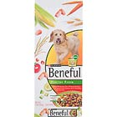
QuickView
Beneful Healthy Fiesta
$10.39 to $28.79
Up to 20% Off
Click & Compare
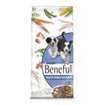
QuickView
Beneful Healthy Growth for Puppies
$11.43 to $28.79
Up to 20% Off
Click & Compare

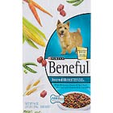
QuickView
Beneful IncrediBites Adult Dog Food
$5.27 to $19.19
Up to 20% Off
Click & Compare
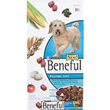
QuickView
Beneful Playful Life Dog Food
$11.43 to $28.79
Up to 20% Off
Click & Compare
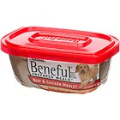
QuickView
Beneful Prepared Meals Dog & Puppy Food
$14.79
Up to 20% Off
Click & Compare
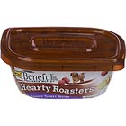
QuickView
Beneful Prepared Meals Hearty Roasters Dog & Puppy Food
$14.79
Up to 20% Off
Click & Compare

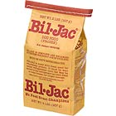
QuickView
Bil-Jac Frozen Dog Food
$19.30 to $26.96
Up to 12% Off
Click & Compare
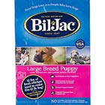
QuickView
Bil-Jac Large Breed Puppy Food
$27.89 to $47.69
Up to 10% Off
Click & Compare
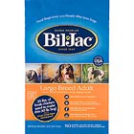
QuickView
Bil-Jac Large Breed Select Dog Food
$26.09 to $44.99
Up to 10% Off
Click & Compare
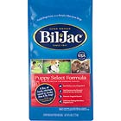
QuickView
Bil-Jac Puppy Food
$16.19 to $62.09
Up to 10% Off
Click & Compare

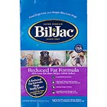
QuickView
Bil-Jac Reduced Fat Dog Food
$16.19 to $43.19
Up to 14% Off
Click & Compare
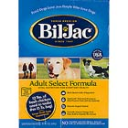
QuickView
Bil-Jac Select Dog Food
$16.19 to $44.99
Up to 10% Off
Click & Compare
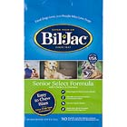
QuickView
Bil-Jac Senior Dog Food with Chicken & Oatmeal
$16.19 to $44.99
Up to 10% Off
Click & Compare
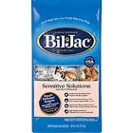
QuickView
Bil-Jac Sensitive Solutions Dog Food
$16.19
Up to 10% Off
Click & Compare

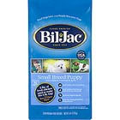
QuickView
Bil-Jac Small Breed Puppy Food
$16.19
Up to 10% Off
Click & Compare
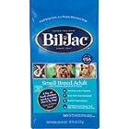
QuickView
Bil-Jac Small Breed Select Adult Dog Food
$16.19
Up to 10% Off
Click & Compare
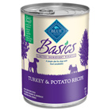
QuickView
Blue Buffalo Basics Canned Adult Dog Food
$30.58
Up to 10% Off
Click & Compare
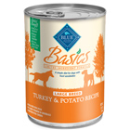
QuickView
Blue Buffalo Basics Large Breed Canned Adult Dog Food
$30.58
Up to 10% Off
Click & Compare

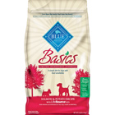
QuickView
Blue Buffalo Basics Limited Ingredient Formula Salmon & Potato Adult Dry...
$18.52 to $53.08
Up to 10% Off
Click & Compare
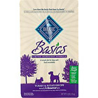
QuickView
Blue Buffalo Basics Limited Ingredient Formula Turkey & Potato Adult Dry...
$18.52 to $54.88
Up to 13% Off
Click & Compare
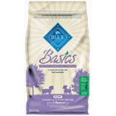
QuickView
Blue Buffalo Basics Limited Ingredient Formula Turkey & Potato Dry Puppy...
$18.52
Up to 10% Off
Click & Compare
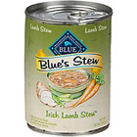
QuickView
Blue Buffalo Blue's Stew Adult Canned Dog Food
$32.38
Up to 10% Off
Click & Compare
Bottom of Form
Dog Toy:
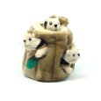
Kyjen PP01056 Hide-A-Squirrel Pet Toy, Large by Kyjen
$9.24
Order in the next 41 hours and get it by Monday, Oct 22.
More Buying Choices
$7.71 new (51 offers)
$8.78 used (1 offer)
(860)
Eligible for FREE Super Saver Shipping.
Pet Supplies: See all 22,925 items

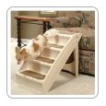
Dog Supplies
Beds & Furniture
Apparel & Accessories
Food
Toys
Collars, Harnesses & Leashes
Grooming

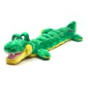
Kyjen Plush Puppies Squeaker Mat Long Body Gator Dog Toy with 16 Squeakers by Kyjen
$8.39
Order in the next 41 hours and get it by Monday, Oct 22.
More Buying Choices
$6.84 new (26 offers)
$7.97 used (1 offer)
(197)
Eligible for FREE Super Saver Shipping.
Pet Supplies: See all 22,925 items

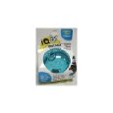
Ourpets DT-10504 Smarter Toys IQ Treat Ball , 5 Inches , Colors may vary by Smarter Toys
$7.60
Order in the next 41 hours and get it by Monday, Oct 22.
More Buying Choices
$7.29 new (19 offers)
$7.07 used (2 offers)
(547)
Eligible for FREE Super Saver Shipping.
Pet Supplies: See all 22,925 items

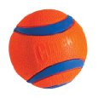
ChuckIt! Ultra Balls Classic 2-Pack by Canine Hardware (Jan 18, 2007)
$7.53
Order in the next 41 hours and get it by Monday, Oct 22.
More Buying Choices
$5.89 new (48 offers)
(216)
Eligible for FREE Super Saver Shipping.
Pet Supplies: See all 22,925 items

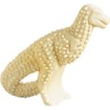
Nylabone Durable Dental Dinosaur Chew Toy (Dinosaur Varies) by Nylabone
$6.27
Order in the next 42 hours and get it by Monday, Oct 22.
More Buying Choices
$3.71 new (41 offers)
(172)
Eligible for FREE Super Saver Shipping.
Pet Supplies: See all 22,925 items

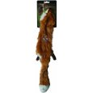
Ethical Plush Skinneeez Fox 24-Inch Stuffingless Dog Toy by Ethical
$6.63
Order in the next 41 hours and get it by Monday, Oct 22.
More Buying Choices
$4.20 new (35 offers)
(51)
Eligible for FREE Super Saver Shipping.
Pet Supplies: See all 22,925 items

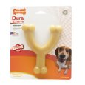
Nylabone Dura Chew Wishbone Chew Toy, Original Flavor, Wolf by Nylabone
$7.78
Order in the next 42 hours and get it by Monday, Oct 22.
More Buying Choices
$2.71 new (32 offers)
$3.20 used (1 offer)
(201)
Eligible for FREE Super Saver Shipping.
Pet Supplies: See all 22,925 items

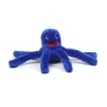
Kyjen Oakley the Octopus Junior Plush Pet Toy by Kyjen
$3.41
Add it to a qualifying order within 42 hours to get it by Monday, Oct 22
More Buying Choices
$2.42 new (15 offers)
(36)
Eligible for FREE Super Saver Shipping.
Pet Supplies: See all 22,925 items

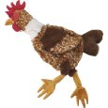
Ethical Pet Skinneeez Exotic Series 18-Inch Dog Toy, Chicken by Ethical Pet
$6.63
Order in the next 41 hours and get it by Monday, Oct 22.
More Buying Choices
$5.57 new (23 offers)
(69)
Eligible for FREE Super Saver Shipping.
Pet Supplies: See all 22,925 items

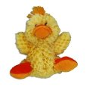
Kong Duck Dog Toy, Small, Yellow by Kong (Sep 6, 2006)
$4.65
Only 5 left in stock - order soon.
More Buying Choices
$1.94 new (30 offers)
(58)
Pet Supplies: See all 22,925 items

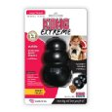
KONG Extreme Dog Toy, Large, Black by Kong (May 3, 2008)
$9.65
Order in the next 42 hours and get it by Monday, Oct 22.
More Buying Choices
$5.50 new (73 offers)
(365)
Eligible for FREE Super Saver Shipping.
Pet Supplies: See all 22,925 items

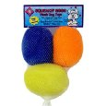
Kyjen Squeakin' Eggs Plush Dog Toys, 3-Pack by Kyjen
$3.37
Add it to a qualifying order within 41 hours to get it by Monday, Oct 22
More Buying Choices
$2.89 new (19 offers)
(47)
Eligible for FREE Super Saver Shipping.
Pet Supplies: See all 22,925 items

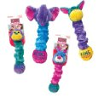
KONG Squiggles Small Dog Toy (Colors vary) by Kong
$4.56
Add it to a qualifying order within 41 hours to get it by Monday, Oct 22
More Buying Choices
$0.01 new (23 offers)
(84)
Eligible for FREE Super Saver Shipping.
Pet Supplies: See all 22,925 items


Kong Flyer Dog Toy, Large, Red by Kong (Sep 6, 2006)
$9.26
Order in the next 42 hours and get it by Monday, Oct 22.
More Buying Choices
$4.10 new (63 offers)
(299)
Eligible for FREE Super Saver Shipping.
Pet Supplies: See all 22,925 items

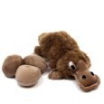
Kyjen Egg Babies Dog Toy, Original Series, Platypus by Kyjen
$9.03
Order in the next 42 hours and get it by Monday, Oct 22.
More Buying Choices
$5.64 new (29 offers)

