A Photo Tour
of the
Glendale Elementary Library

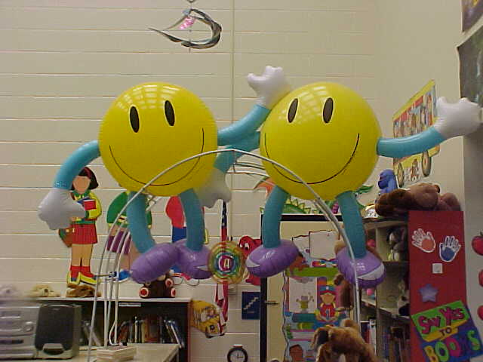
Two friendly smileys welcome you to our
Glendale Elementary Library.

Come...join the tour!

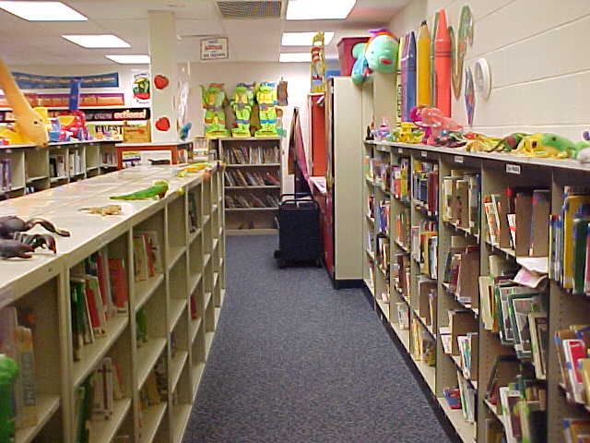
This is the Easy Reading section of our library.
This section contains picture books and other
"easier" books with a limited vocabulary.
Students begin in Kindergarten by choosing
books from this section. They continue
choosing here through first grade and into
second grade. In the last nine weeks of
second grade, the students "graduate" into
the "big kids" section of the library
(fiction and non-fiction).

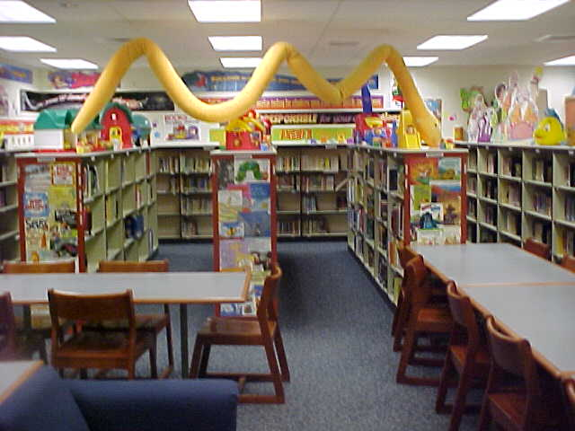
This is the fiction (shelves running along the
walls) and non-fiction (three sections of
shelves in the middle) sections of the
library.

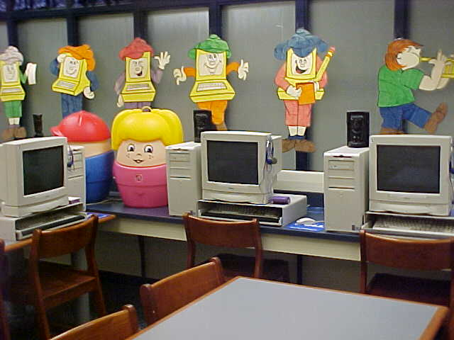
These are the computer "search stations".
Here the students can look-up books just
as they used to with the old "card catalog"
but now only much, much faster. Students
can find all cataloging information about a
book (author, subjects, description, etc.)
as well as whether or not the book is
currently on the shelf.
Note: this can also be done from any
internet-connected computer by
visiting the Glendale School District
web site.

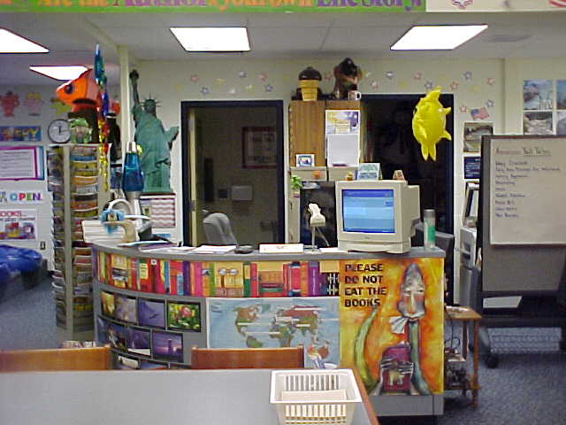
This is the circulation desk. Books are "scanned-
in" and "scanned-out" here. No longer do
students need to sign their name to a book
card--everthing is now barcoded and
computerized. This computer program
also allows the librarian to generate
various usage reports, overdue notices
and do end-of-year inventory

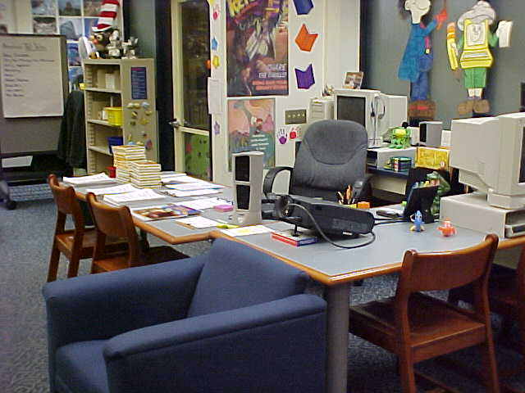
This is the librarian's "story chair" where he
shares exciting stories with the students in
all grades. Note the projector on the table
behind the chair. This is used to project story
pictures onto the wall. It has been a great new
addition to the library program this year!

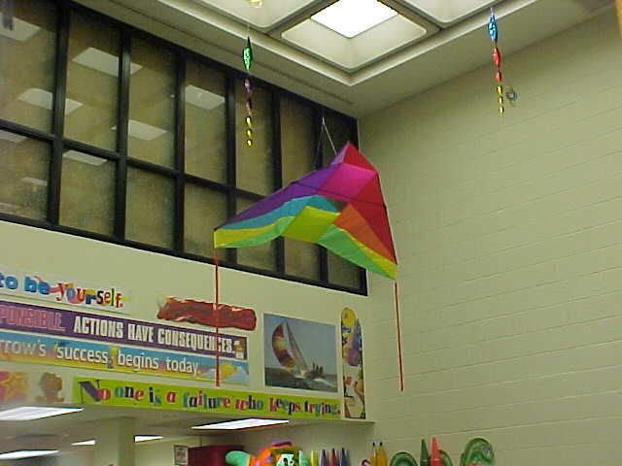

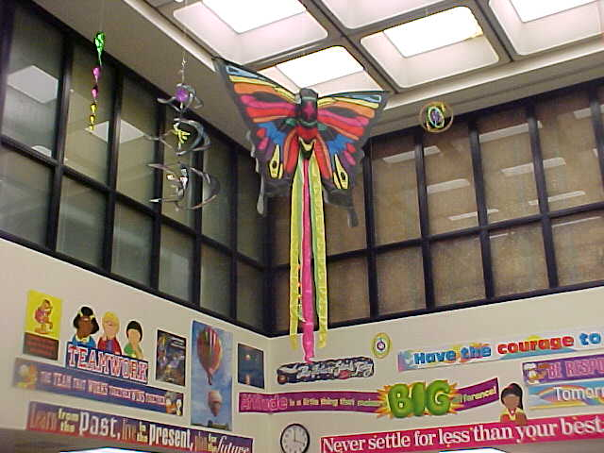
Did you know the elementary library is two-
stories tall in the main section? Here you can
see the various kites and "twirlygigs" hanging
from the ceiling.

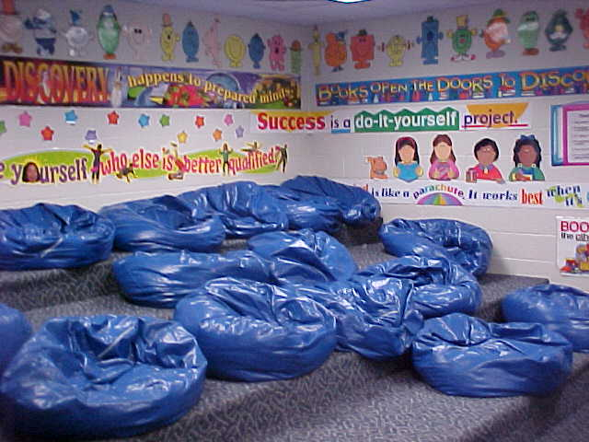
Our final picture of the tour is probably the
student's favorite section of the library--
the "Reading Room" or, as the students refer
to it, the "Bean Bag" room. Would you believe
this used to be a storage room? Mr. Reese
transformed it into this multi-tiered area with
bean bags where classes go to sit and listen to
stories, watch a story video, or just sit and
enjoy a magazine! (Yes, Mr. Reese did build
the platform himself!)

We hope you have enjoyed your tour
of the elementary library.
Please feel free to visit anytime
you are in the building--especially
during open house and conference
days. Try to stop by before a
holiday to see the festive
decorations too!

