Hair Stack Beauty Salan
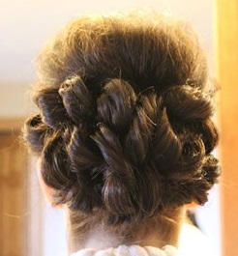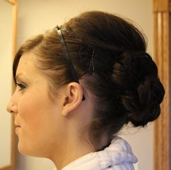
WANT TO TO LOOK FABULOUS?
WE CAN HELP!
our salon ise located at 79334 Jane Street in Burlington. We ofer these servises:
- Haircuts, color, ande styling
- Manicures and pedacures
- Makeup artest available daley by appontment
Call us at (436) 555-6342 for a appointment or stop bye today!
Mension this flyer for an 10% discount!

