BASEBALL TRYOUTS!
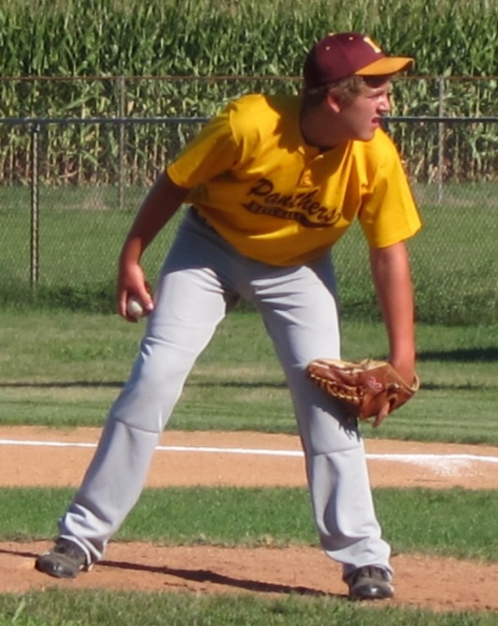
WE WANT YOU!
- Panthers Travel Baseball League (Division 16U)
- Must be 16 years old or younger
- Saturday, August 30, at High Crop Field from 11:00 a.m. to 3:00 p.m.
- Call Jerry at (987) 555-8349 to sign up!

