Physical Science
Chapter 4 - Atomic Structure
Section 4.1 Studying Atoms
Studying the structure of atoms is a little like studying wind. Because you cannot see air, you must use indirect evidence to tell the direction of the wind. Atoms pose a similar problem because ______________ ____________________________________________________________________________________.
Ancient Greek Models of Atoms
If you cut a piece of aluminum foil in half, you have two smaller pieces of the same shiny, flexible substance. You could cut the pieces again and again. Can you keep dividing the aluminum into smaller pieces? Greek philosophers debated a similar question about 2500 years ago.
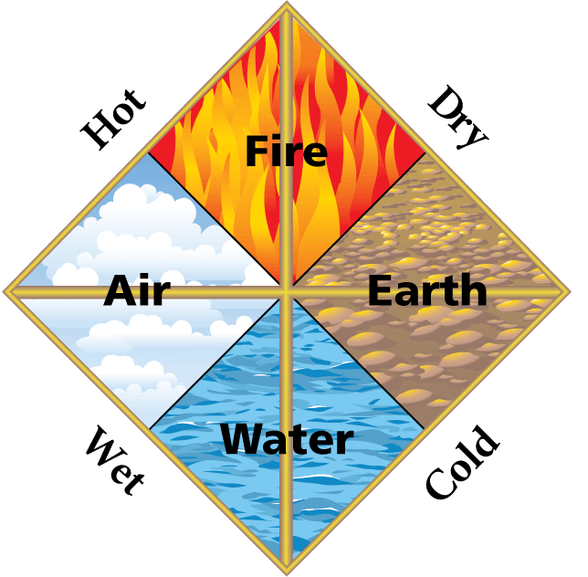
The philosopher Democritus believed that ____________________________________________________ ____________________________. He called these particles ______________________ ________________________________________________________
_______________________________________________________________ ________________________________________________________—earth, air, fire, and water. He did not think there was a limit to the division of matter.
For many centuries, most people accepted Aristotle’s views on the structure of matter______________, scientists had ____________________________ ______________________________________________________________________.
Dalton's Atomic Theory
What was Dalton’s theory of the structure of matter?
Answer: ____________________________________________________________________________ ____________________________________________________________________________________
Evidence for Atoms
John Dalton __________________________________________. Based on the way gases exert pressure, Dalton correctly concluded that a ________________________________________________________.
Dalton measured masses of elements that combine when compounds form. _________________________ ________________________________________________________. In other words, ______________ ____________________________________________________________________________________
When magnesium burns, it combines with oxygen. In magnesium oxide, the ratio of the mass of magnesium to the mass of oxygen is always about 3 : 2. Magnesium dioxide has a fixed composition.
Dalton’s Theory
- ________________________________________________________________________________.
- ______________________________________________________________________, and atoms of different elements have different masses.
- ________________________________________________________________________________.
- In a particular compound, ________________________________________________________ ______________________________________________________________________.
Dalton made these wooden spheres as a model to represent the atoms of different elements. A tiny, solid sphere with a different mass represents each type of atom.
A theory ______________________________________________________________________. Because Dalton’s atomic theory met that goal, ________________________________________________________.
Over time, scientists found that not all of Dalton’s ideas about atoms were completely correct. _________ ____________________________________________________________________________________.
Thomson's Model of the Atom
What contributions did Thomson make to the development of atomic theory?
Answer: ___________________________________________________________________________ ____________________________________________________________________________________.
____________________________________________________________________________________. Such materials are said to _________________________________________________________________.
  - Objects with ____________________________, or push apart.
  - Objects with ____________________________, or pull together.
Amber is the hardened form of a sticky, viscous liquid that protects trees from insects and disease. If amber is ____________________________________________________________________________________.
Thomson’s Experiments
In his experiments, Joseph John Thomson used a sealed tube containing a very small amount of gas.

When the current was turned on, the disks became charged, and a glowing beam appeared in the tube.
  - Thomson hypothesized that ______________________________________________________ ______________________________________________________________________.
  - Thomson observed that ________________________________________________________ ______________________________________________________________________.
Evidence for Subatomic Particles
Thomson concluded that __________________________________________________________________ ______________. He hypothesized that ______________________________________________________
  - no matter what metal Thomson used for the disk, the particles produced were identical.
  - the particles had about 1/2000 the mass of a hydrogen atom, the lightest atom.
Thomson’s Model
Thomson ____________________________to account for these subatomic particles.
  - ______________________________________________________________________, but there must always be some positive charge in the atom.
  - ______________________________________________________________________ ______________________________________________________________________.
Thomson’s model is called the “plum pudding” model. Today, it might be called ______________ ____________________________________________________________________________________.
The chips represent ______________________________________________________________________ ________________________________________________________—the vanilla ice cream.
Rutherford's Atomic Theory
What contributions did Rutherford make to the development of atomic theory?
Answer: ______________________________________________________________________ ____________________________________________________________________________________
Rutherford’s Hypothesis
Ernest Rutherford designed an experiment to find out what happens to alpha particles when they pass through a thin sheet of gold. _______________________________________________________________ ____________________________________________________________________________________.
  - Based on Thomson’s model, Rutherford hypothesized that ____________________________ __________________________ in the gold ________________________________________ ____________________________ of an alpha particle.
  - He predicted ________________________________________________________ ______ ____________________________from their source to a screen that lit up when struck.
The Gold Foil Experiment

Discovery of the Nucleus
The __________________________________________________________________________________ __________________________________________. The closer they came, the greater the deflection.
However, many alpha particles passed through the gold without being deflected. These particles did not pass close to a charged object.
______________________________________________________________________ from Rutherford's experiment. ___________________________________________________________________________.
  - _____________________________________________________________________________.
  - _____________________________________________________________________________.
  - _____________________________________________________________________________ ______________________________________________________________________.
The Houston Astrodome occupies more than nine acres and seats 60,000 people. If the stadium were a model for an atom, a marble could represent its nucleus.
____________________________________________________________________________________ ______________________________________________________________________.
Assessment Questions
- Dalton’s theory did not include which of the following points?
  - All elements are composed of atoms.
  - Most of an atom’s mass is in its nucleus.
  - Compounds contain atoms of more than one element.
  - In a specific compound, atoms of different elements always combine in the same way.
ANS: ______________
- J. J. Thomson’s experiments provided the first evidence of
  - atoms.
  - a nucleus.
  - subatomic particles.
  - elements.
ANS: ______________
- The concept of an atom as a small particle of matter that cannot be divided was proposed by the ancient Greek philosopher, Democritus.
True
False
ANS: ______________

Section 4.2 The Structure of an Atom
This 45-foot-tall steel sculpture is made of 10 tons of steel. If a proton had the same mass as the sculpture, then an electron would have a mass of about 5 kilograms.
Properties of Subatomic Particles
What are three subatomic particles?
Answer: ___________________________________________________________________________
Protons
Based on experiments with elements other than gold, Rutherford concluded _________________________ ______________________________________________________________________
A proton is ____________________________________________________________________________. ______________________________________________________________________________________ ____________________________________________________________________________________
Electrons
The particles that Thomson detected were later named electrons.
An electron is _________________________________________________________________________ __________________________________________. Each electron has ____________________________
Neutrons
In 1932, the English physicist _____________________________________________________________ ____________________________. Chadwick concluded that the particles he produced ______________ ______________ because a charged object did not deflect their paths.
A neutron is ___________________________________________________________________________ ____________________________________________________________________________________
Comparing Subatomic Particles
What properties can be used to compare protons, electrons, and neutrons?
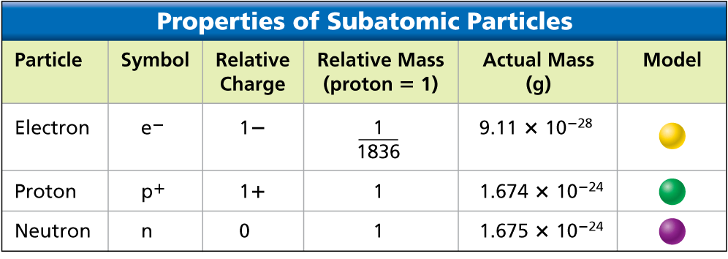
Answer: ____________________________________________________________________________ ___________________________________________________________________________________________________________________________________________________________________________. Scientists still do not have an instrument that can show the inside of an atom.

Here are some similarities and differences between protons, electrons, and neutrons.
  - Protons and neutrons have almost the same mass. About ______________________________ ____________________________________________________________________________
  - ____________________________________________________________________________ ____________________________________________________________________________.
  - ____________________________________________________________________________ ____________________________________________________________________________.
Atomic Number and Mass Number
How are atoms of one element different from atoms of other elements?
Answer: __________________________________________________________________________
Atomic Number
- The atomic number of an element is _______________________________________________ ______________________________________________________________________.
- _____________________________________________________________________________. Each hydrogen atom has one proton in its nucleus. Hydrogen is assigned the atomic number 1.
- _____________________________________________________________________________.
Each element has a different atomic number.
A The atomic number of __________________________________.
B The atomic number of __________________________________.
C The atomic number of __________________________________.
__________________________________, so each positive charge in an atom is balanced by a negative charge. That means the ___________________________________________________________________ ____________________________________________________________________.
  - Hydrogen has an atomic number of 1, so a hydrogen atom has 1 electron.
  - Sulfur has an atomic number of 16, so a sulfur atom has 16 electrons.
Mass Number
The mass number of an atom is ____________________________________________________________ ___________________________________________________. To find the number of neutrons in an atom, you need the mass number of the atom and its atomic number.

The atomic number of aluminum is 13. An atom of aluminum that has a mass number of 27 has 13 protons and 14 neutrons
Isotopes
What is the difference between two isotopes of the same element?
Answer: ____________________________________________________________________________ _____________________________________________________________________________________
Isotopes are ____________________________________________________________________________ _____________________________________________________________________________________
_____________________________________________________________________________________ ________________________. For example, oxygen has 3 isotopes: oxygen-16, oxygen-17, and oxygen-18.
All three oxygen isotopes can react with hydrogen to form water or combine with iron to form rust.
With most elements, ____________________________________________________________________ ____________________________________________________________________.
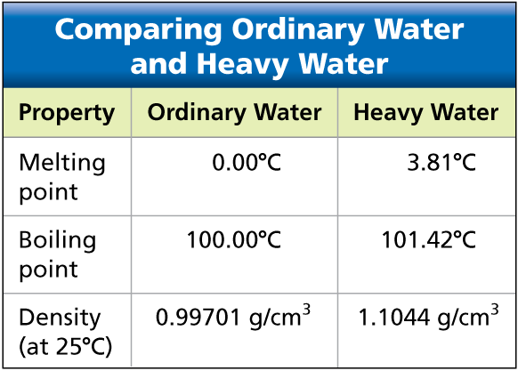
__________________________________. (Almost all hydrogen is hydrogen-1.) Hydrogen-2 has one neutron, and hydrogen-3 has two neutrons. Because a hydrogen-1 atom has only one proton, adding a neutron doubles its mass.
Water that contains hydrogen-2 atoms in place of hydrogen-1 atoms ______________________________. Hydrogen-2 atoms have twice the mass of hydrogen-1 atoms, so the properties of heavy water are different from the properties of ordinary water.

Assessment Questions
- In which way do isotopes of an element differ?
  - number of electrons in the atom
  - number of protons in the atom
  - number of neutrons in the atom
  - net charge of the atom
ANS: _________________
- Of the three subatomic particles that form the atom, the one with the smallest mass is the neutron.
True
False
ANS: _________________

Section 4.3 Modern Atomic Theory
Have you ever wondered what produces the different colors in a fireworks display?
_____________________________________________________________________________________ ___________________________________________________. Compounds containing the element strontium produce red light. Compounds containing barium produce green light.
Bohr's Model of the Atom
What can happen to electrons when atoms gain or lose energy?
As did Rutherford's atomic model, __________________________________________________________ ________________________________. But Bohr’s model focused on the electrons and their arrangement.
In Bohr’s model, ________________________________________________________________________ __________________, like planets around a sun. Each electron in an atom has a specific amount of energy.
Energy Levels
When an atom gains or loses energy, ___________________________________________________.
  - The possible energies that electrons in an atom can have are called ____________________.
  - An electron ___________________________________________________.
Answer: _________________________________________________________________________ _____________________________________________________________________________________.

An analogy for energy levels of electrons is a staircase.
  - The landing at the bottom of the staircase is the lowest level.
  - ____________________________________________________________________________.
  - The step height represents an energy difference between levels.
  - You can only move in whole numbers of stairs.
An electron ____________________________________________________________________________ ____________________________________________________________________.
The __________________________between energy levels determines the amount of energy gained or lost.
_____________________________________________________________________________________

.
Evidence for Energy Levels
Scientists __________________________________ when electrons absorb energy and move to a higher energy level ___________________________________________________ when the electron moves to a lower energy level. Light is a form of energy that can be observed.
The movement of electrons between energy levels explains the light you see when fireworks explode.
  - _____________________________________________________________________________.
  - When those electrons move back to lower energy levels, they release energy. _______________ ____________________________________________________________________.
  - ____________________________________________________________________ because no two elements have the same set of energy levels.
Electron Cloud Model
What model do scientists use to describe how electrons behave in atoms?
Answer: ____________________________________________________________________________ _____________________________________________________________________________________
Bohr’s model ___________________________________________________. Bohr correctly assigned energy levels to electrons, but electrons do not move like planets in a solar system.
Today, scientists _________________________________________________________________________ __________________________________. An electron cloud is __________________________________ _____________________________________________________________________________________
The electron cloud model replaced Bohr's vision of electrons moving in predictable paths.
_______________
_________________
The photographs provide an analogy for an electron cloud. When the propeller of an airplane is at rest, you can see the location of the blades. When the propeller is moving, you see only a blur that is similar to a drawing of an electron cloud.
What model do scientists use to describe how electrons behave in atoms?
An orbital is a __________________________________________________________________________ _________________. The electron cloud represents __________________________________.
Answer: ___________________________________________________________________________
For an analogy to the concept of an orbital, imagine a map of your school. Mark your exact location with a dot once every 10 minutes over a period of one week. The dots on your map are a model of your “orbital.” They describe your most likely locations.
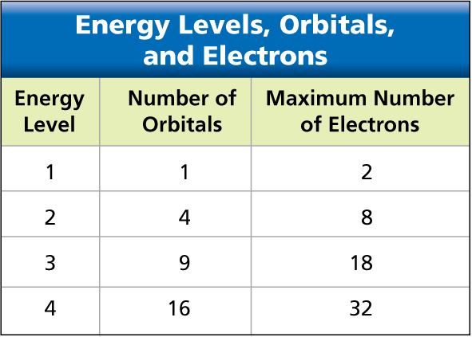
  - The places you visit the most would have the highest concentration of dots.
  - The places you visit the least would have the lowest concentration of dots.

The level in which an electron has the least energy—__________ _______________________________________. _____________ ____________________________________________________ ______________________________________________________________________________

Electron Configurations
What is the most stable configuration of electrons in an atom?
An electron configuration is ___________________________________________________________ ______________________________________________________________________________.
When all the electrons in an atom have the lowest possible energies, the atom is said to be in its __________________________.
Answer: _________________________________________________________________________ ______________________________________________________________________________
A lithium atom has three electrons.
  - In the ground state, two of the lithium electrons are in the orbital of the first energy level.
  - The third electron is in an orbital of the second energy level.
  - If a lithium _________________________________________________________________ ___________________________________________________________________________.
  - This configuration is referred to as an excited state. __________________________________ _________________________________________________________________
  - Eventually, the electron that was promoted to a higher energy level ______________________ _________________________________________________________________.
The ground state of a person is on the floor. A gymnast on a balance beam is like an atom in an excited state—not very stable.
When she dismounts, the gymnast will return to a lower, more stable energy level.

Assessment Questions
- According to Bohr’s model of the atom, which of the following can happen when an atom gains energy?
  - An atom returns to its ground state.
  - A neutron can be changed into a proton.
  - A proton can move to a higher energy level.
  - An electron can move to a higher energy level.
ANS: _____________
- How does the modern atomic theory describe the location of electrons in an atom?
  - Electrons move randomly in space around the nucleus.
  - Electrons can be described as a cloud based on probable locations.
  - Electrons orbit the nucleus in the same way that planets orbit the sun.
  - Electrons move in a spiral pattern if increasing distance from the nucleus.
ANS: _____________
- What is meant when an atom is said to be in its ground state?
  - There is no net charge on the atom.
  - The number of protons equals the number of neutrons.
  - The atom’s electrons all have the lowest possible energies.
  - It is the isotope with the least number of neutrons.
ANS: _____________

