Physical Science
Chapter 5 - The Periodic Table
Section 5.1 Organizing the Elements
In a video store, movies are in categories such as Action or Comedy. When scientists organized the elements, they had to decide what categories to use and where to place each element. _________________ _____________________________________________________________________________________ ____________________________________________________________________
The Search for Order
_________________, scientists had identified __________________________________, mainly metals, such as copper and iron. As the number of known elements grew, so did the need to organize them into groups based on their properties.
_____________________________________________________________________________________ ____________________________________________________________. For the next 80 years, scientists looked for different ways to classify the elements. But no system worked for all the known elements.
Mendeleev's Periodic Table
How did Mendeleev organize the elements in his periodic table?
Answer: ___________________________________________________________________________ _____________________________________________________________________________________
Mendeleev’s Proposal
_____________________________________________________________________________________ while playing the card game solitaire. In this game, the player sorts a deck of cards by suit and value.
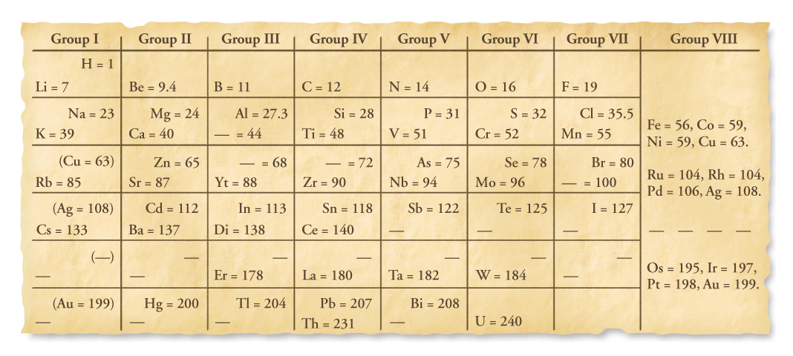
Mendeleev made a “deck of cards” of the elements, _____________________________________________ _________________ on each card. When Mendeleev ___________________________________________ _________________________________________________The key was to break the elements into rows.
The final arrangement was similar to a winning arrangement in solitaire, except that the columns were organized by properties instead of suits. ________________________ _____________________________ ______________________________ _____________________________________________________________________________
Mendeleev’s chart was a periodic table. A periodic table is ________________________________________________________________________ ____________________________________________________________________
Mendeleev’s Prediction
At the time Mendeleev made his table, _______________________________________________________ _____________________________________________________________________________________.
Mendeleev was able to offer the best explanation for how the properties of an element were related to its location in his table.
Mendeleev was confident that the _________________________________________________________ ___________________________________________________. He used the properties of elements located near the blank spaces in his table to predict properties for undiscovered elements.
Some scientists didn’t accept those predictions. Others used the predictions to help in their search for undiscovered elements.
Evidence Supporting Mendeleev's Table
What evidence helped verify the usefulness of Mendeleev’s table?
Answer: ___________________________________________________________________________ _____________________________________________________________________________________
Mendeleev ____________________________________________________________________. He gave the name eka-aluminum to the missing element one space below aluminum in the table. Mendeleev ____________________________________________________________________
  - be a _________________,
  - have a low melting point, and
  - have a density of _________________g/cm³.
In ____________________________________________________________________. He named the element gallium (Ga) in honor of France. (The Latin name for France is Gallia.) _________________
  - is a _________________,
  - has a melting point of _________________°C, and
  - has a density of _________________g/cm³.
Heat from a person's hand can melt gallium. In some traffic signals, there are tiny light emitting diodes (LEDs) that contain a compound of gallium.
Scientists _____________________________________________________________________________ _____________________________________________________________________________________.
  - The properties of gallium are remarkably similar to the predicted properties of eka-aluminum. Scientists concluded that ____________________________________________________________ ____________________________________________________________________.
  - The discovery of scandium (Sc) in 1879 and the discovery of germanium (Ge) in 1886 provided more evidence.

Assessment Questions
- In Mendeleev’s periodic table, elements with similar properties were grouped
  - in the same row.
  - in the same column.
  - in diagonal lines that run from top left to the bottom right.
  - in pairs of two.
ANS: _________________
- For which element did Mendeleev correctly predict the properties even before it had been discovered?
  - gallium
  - hydrogen
  - bromine
  - aluminum
ANS: _________________
Section 5.2 The Modern Periodic Table
The eight-note interval between any two notes on a keyboard with the same name is an octave. The sounds of musical notes that are separated by an octave are related, but they are not identical. In a similar way, _____________________________________________________________________________________ ____________________________________________________________________.
The Periodic Law
How is the modern periodic table organized?
Answer: __________________________________________________________________________ _____________________________________________________________________________________
_____________________________________________________________________________________ _____________________________________________________________________________________
The modern periodic table is based on ______________________________________________________.
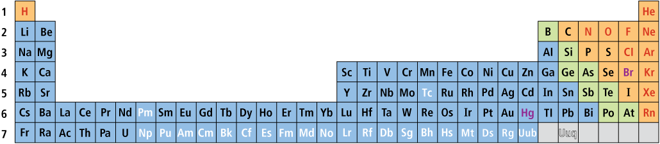
Periods
____________________________________________________________________ is a period.
  - Hydrogen, the first element in Period 1, ________________________________________________.
  - Lithium, the first element in Period 2, _________________________________________________.
  - Sodium, the first element in Period 3, _________________________________________________ ____________________________________________________________________.
  - This pattern ______________________________________________________________________ __________________________________ on the table.
Groups
____________________________________________________________________ is called a group.
  - The elements in a group ___________________________________________________, so members of a group in the periodic table ____________________________________________.
  - This ___________________________________________________ is the periodic law.
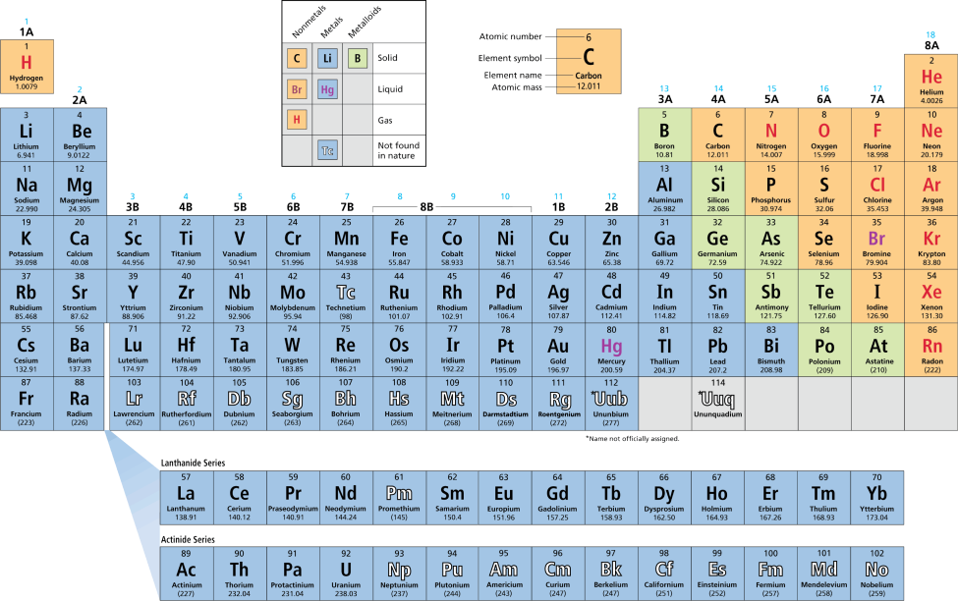
Atomic Mass
What does the atomic mass of an element depend on?
Answer: ____________________________________________________________________________ _____________________________________________________________________________________
Atomic Mass Units
The mass of an atom in grams is extremely small. In order to have a convenient way to compare the masses of atoms, scientists chose one isotope to serve as a standard.
  - Scientists assigned _________________________________________________________________ _____________________________________
______________
  - An atomic mass unit (amu) is defined as _____________________________________ __________________________________.
_____________
_____________
_____________
There are _____ pieces of information for each element.

Isotopes of Chlorine
In nature, ____________________________________________________________________________. The element chlorine has an atomic mass of 35.453 amu. Where does the number 35.453 come from?
  - There are ____________________________________________________________________.
  - An atom of ____________________________________________________________________.
  - An atom of ____________________________________________________________________.
Weighted Averages
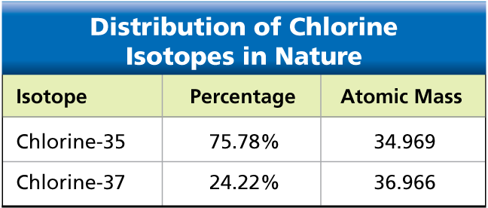
This table shows the atomic masses for the two naturally occurring chlorine isotopes. The _____________________ __________________________________. If you add the atomic masses of the isotopes and divide by 2, you get 35.967, not 35.453.

Classes of Elements
What categories are used to classify elements on the periodic table?
Answer: ___________________________________________________________________________.
The periodic table presents ________________________________________________________________.
  - _________: _____________ symbol, _________________ symbol, or _________________ symbol
  - _______________________: elements that __________________________________ symbol.
  - ______________________________: _________________ background, ______________________ background, or ___________________________ background
Metals
The _______________________________ on the periodic table ____________________________. Metals are ___________________________________________________________________________________
  - ___________________________________________________ at room temperature.
  - Most metals are __________________________________.
  - Many metals are __________________________________________________________________
A When magnesium reacts with oxygen, a dull layer forms on its surface. The layer can be removed to reveal magnesium’s shiny surface.
B Many telescope mirrors are coated with aluminum to produce a surface that reflects light extremely well.
The __________________________________________________________________________________. Transition metals are ____________________________________________________________________ _____________________________________________________________________________________.
  - Transition elements, such as copper and silver, were ______________________________________ ________________________________________________________________________________.
  - One property of many transition metals is their ___________________________________________ ____________________________________________________________________.
A compound of oxygen and the transition element erbium is used to tint the pink glass lenses.
Nonmetals
Nonmetals generally have properties opposite to those of metals.
  - Nonmetals are ____________________________________________________________________ ______________________________________________________________________.
  - Nonmetals have _________________–many nonmetals are ________________________________.
  - Nonmetals that are _________________________________________________________________. _________________If they are hit with a hammer, they __________________________________.
___________________________________________________. The gases in _______________________ ___________________________________________________ elements in the table. Some toothpastes use a compound of the nonmetal fluorine and the metal sodium to help prevent tooth decay.
Metalloids
Metalloid elements are located on the periodic table between metals and nonmetals.
  - Metalloids are ____________________________________________________________________ ____________________________________________________________________.
  - For example, a metalloid’s ability to conduct electric current varies with temperature. Silicon (Si) and germanium (Ge) are good insulators at low temperatures and good conductors at high temperatures.
Variations Across a Period
How do properties vary across a period in the periodic table?
Answer: Across a period from left to right, the elements become less metallic and more nonmetallic in their properties.
From left to right across Period 3, there are three metals (Na, Mg, and Al), one metalloid (Si), and four nonmetals (P, S, Cl, and Ar).
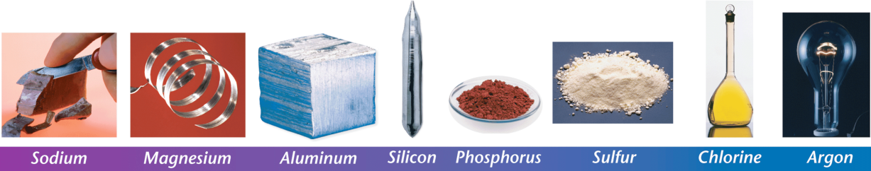
- Sodium ____________________________________________________________________.
- Magnesium ____________________________________________________________________.
- Aluminum does __________________________________, but it does react with oxygen.
- Silicon is ___________________________________________________.
- Phosphorus and sulfur ___________________________________________________________.
- Chlorine __________________________________.
- Argon __________________________________.
Assessment Questions
- What determines the atomic mass of an element?
  - the natural distribution of isotopes and the atomic numbers of those isotopes
  - the natural distribution of isotopes and the masses of those isotopes
  - the mass of the isotope of the element that has the most neutrons
  - the average number of protons in the element’s nucleus
ANS: _________________
- Which of the following is not characteristic of metals?
  - ductile
  - good electrical conductor
  - typically solid at room temperature
  - brittle
ANS: _________________
- Within a period of the periodic table, how do the properties of the elements vary?
  - Metallic characteristics increase from left to right.
  - Metallic characteristics decrease from left to right.
  - Reactivity increases from left to right.
  - Reactivity decreases from left to right.
ANS: _________________
- In the modern periodic table, elements are arranged in order of increasing atomic mass.
True
False
ANS: __________________________________
Section 5.3 Representative Groups
Why is hydrogen located on the left side of the periodic table with the active metals, even though it is a gas? _____________________________________________________________________________________ _________________. Hydrogen can be used as a fuel in automobiles because it is flammable.
Valence Electrons
Why do the elements in a group have similar properties?
Answer: ____________________________________________________________________ ____________________________________________________________________
A valence electron is ____________________________________________________________________
When the A groups in the periodic table are numbered from 1 through 8, ___________________________ _____________________________________________________________________________________.
  - Valence electrons play ___________________________________________________.
  - Properties vary across a period because the number of __________________________________ ___________________________________________________.
Elements in a group have _________________________________________________________________ __________________________________. The properties are __________________________________ _____________________________________________________________________________________.
Because hydrogen has a single valence electron, it is grouped with other elements, such as lithium, that have only one valence electron.
The Alkali Metals
What are some properties of the A groups in the periodic table?
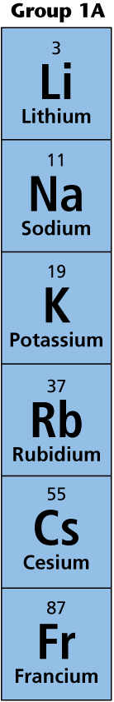
Answer: ___________________________________________________________________________ ____________________________________________________________________.
_______________________________________ are called alkali metals. These metals have __________________________________ and are __________________________________. Because they are so reactive, alkali metals are ______________________________________ ___________________________________________________.
____________________________________________________________________ and releases enough energy to ignite the hydrogen gas that is produced.
____________________________________________________________________to keep them from reacting with the oxygen and water vapor in air.
Cesium is so reactive that it is usually ____________________________________________ ___________________________________________________.
A Unlike most metals, the ___________________________________________________.
B When sodium reacts with water, ___________________________________________________ that is produced.
The Alkaline Earth Metals
__________________________________ are called alkaline earth metals. All alkaline earth metals have ___________________________________________________.
Metals in Group 2A are ___________________________________________________. The melting point of magnesium is 650°C, which is much higher than the melting point of sodium—98°C.
_____________________________________________________________________________________ _____________________________________________________________________________________

Magnesium
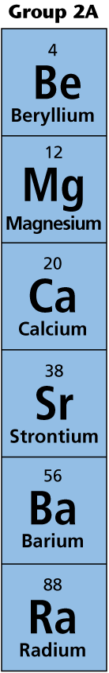
Magnesium plays __________________________________. The compound at the _________________ __________________________________, and at the ______________________________ ___________________________________________________.
A mixture of magnesium and other metals can be as strong as steel, but much lighter. The frames of bicycles and backpacks often contain magnesium.
Calcium
Calcium carbonate—___________________________________________________—is the main ingredient in ___________________________________________________.
Your _________________ may contain the compound ________________________________ because this hard substance can __________________________________.
Magnesium and calcium have essential biological functions, and they _________________ ____________________________________________________________________.
Chlorophyll molecules in spinach contain magnesium. An oyster shell and a pearl are both made from calcium carbonate. A plaster cast contains the compound calcium sulfate.
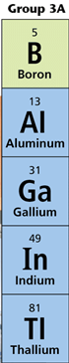
The Boron Family
Group 3A contains the metalloid boron, the well-known metal aluminum, and three less familiar metals (gallium, indium, and thallium).
All these elements have __________________________________.
____________________________________________________________________________
- Aluminum __________________________________ than sodium and magnesium
- Aluminum is ___________________________________________________________
- Aluminum is ___________________________________________________________
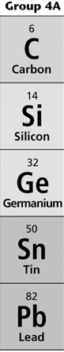
A compound of __________________________________ is ___________________________ that does not shatter easily when its temperature changes rapidly. ___________________________ is used to make _____________________________________ _______________________ that can go directly from the oven to the refrigerator.
The Carbon Family
Group 4A contains a nonmetal (carbon), two metalloids (silicon and germanium), and two metals (tin and lead). Each of these elements has __________________________________.
Notice that the _________________________________________________________________ _________________________. Germanium is a better conductor of electric current than silicon.
____________________________________________________________________________
Life on Earth would ___________________________________________________.
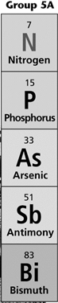
Reactions that occur in the cells of your ________________________________________ _____________________________________________.
Silicon is the second most abundant element in Earth’s crust. The clay used to produce this pottery contains silicon compounds called silicates.

The Nitrogen Family
Group 5A contains two nonmetals (nitrogen and phosphorus), two metalloids (arsenic and antimony), and one metal (bismuth).
Group 5A includes elements with _____________________________________. Nitrogen is a nonmetal gas, phosphorus is a solid nonmetal, and bismuth is a dense metal. All of the elements in Group 5A have __________________________________.
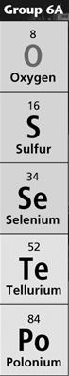
When air is cooled, the oxygen condenses before the nitrogen because nitrogen has a lower boiling point than oxygen. Much of the nitrogen obtained from air is __________ ________________________________________________________.
___________________________________________________________________________
The ________________________________________________________________________ ___________________________________________________________________________
The Oxygen Family
Group 6A has three nonmetals (oxygen, sulfur, and selenium), and two metalloids (tellurium and polonium). All the elements in Group 6A have __________________________________.
____________________________________________________________________________
Complex forms of life need oxygen to stay alive because ______________________________ ____________________________________________________________________
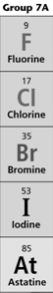
Ozone is another form of the element oxygen. At upper levels of atmosphere, ______________ ____________________________________________________________________
____________________________________________________________________ because it is found in large natural deposits.

The Halogens
The elements in Group 7A are called halogens. Each halogen has _________________. At room temperature, chlorine is ___________, bromine is ______________, and iodine is _____________.
_______________________________________________________________________________ __________________________________.
Halogens ____________________________________________________________________

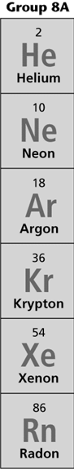
The Noble Gases
__________________________________are called noble gases. _____________________ _________________ Each of the __________________________________ valence electrons.
___________________________________________________________________________ ____________________________________________________________________
When electric current passes through noble gases, they emit different colors. Helium emits pink, neon emits orange-red, argon emits lavender, krypton emits white, and xenon emits blue.

Assessment Questions
- Why do elements in a group have similar chemical properties?
  - They have the same number of valence electrons.
  - They have the same ratio of protons to neutrons.
  - Their atomic masses are multiples of the least massive element of the group.
  - They have the same number of total electrons.
ANS: _________________
- Which Group 2A element would you expect to react most readily with water?
  - beryllium (Be)
  - calcium (Ca)
  - barium (Ba)
  - radium (Ra)
ANS: _________________
- In general, the metallic characteristics of A group elements within a period decreases from left to right.
True
False
ANS: _________________

