Physical Science
Chapter 7 Chemical Reactions

Section 7.1 Describing Reactions
Burning is ______________________. When a substance undergoes a chemical change, _______________ __________________________________________________________________.
Chemical Equations
What is the law of conservation of mass?
Answer: ____________________________________________________________________________ _______________________________________________________________________________________
A useful description of a chemical reaction tells you the substances present before and after the reaction.
  - ____________________________________________________________ are called reactants.
  - _____________________________________________________________ are called products.
Using Equations to Represent Reactions
During a chemical reaction, _______________________________________________________. You can summarize this process with a word equation.
_______________________________________________________
To describe the burning of charcoal, you can write reactants and products of the reaction in the following word equation.
_______________________________________________________
Write the reactants and products as chemical formulas.
_______________________________________________________
A chemical equation is __________________________________________________________________ ____________________________________________. You can read the equation C + O₂ → CO₂ as
  - “ Carbon and oxygen ___________________________________________ carbon dioxide,” or,
  - “_________________________________ carbon and oxygen ___________ carbon dioxide.”

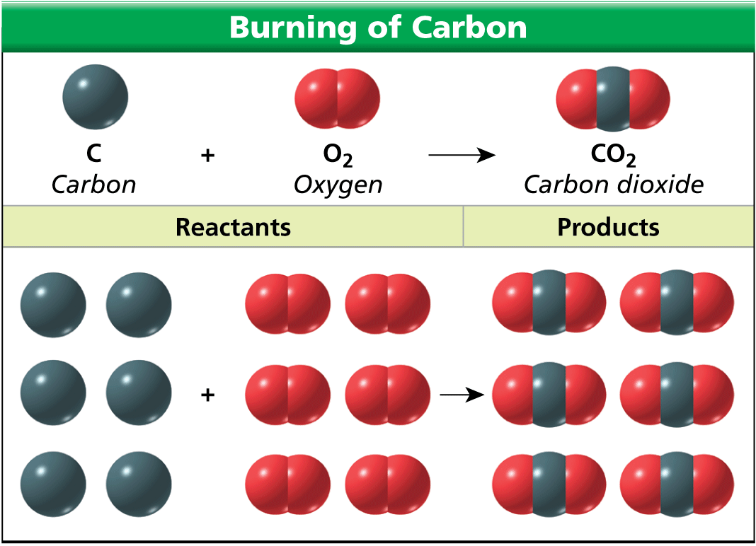
Conservation of Mass
During chemical reactions, __________________________ ________________________________________________. This principle is __________________________________
______________________When charcoal burns, the mass of the carbon dioxide produced is equal to the mass of the charcoal and oxygen that reacted.
Whether you burn one carbon atom or six carbon atoms, the equation used to describe the reaction is always the same.
Balancing Equations
Why must chemical equations be balanced?
Answer: ____________________________________________________________________________ _____________________________________________________________________________
You can balance a chemical equation by changing the coefficients, ________________________________ __________________________________________________________________.
When you change a coefficient, ____________________________________________________________ ________________________________________________________________________________
Water is a compound made up of the elements hydrogen and oxygen.
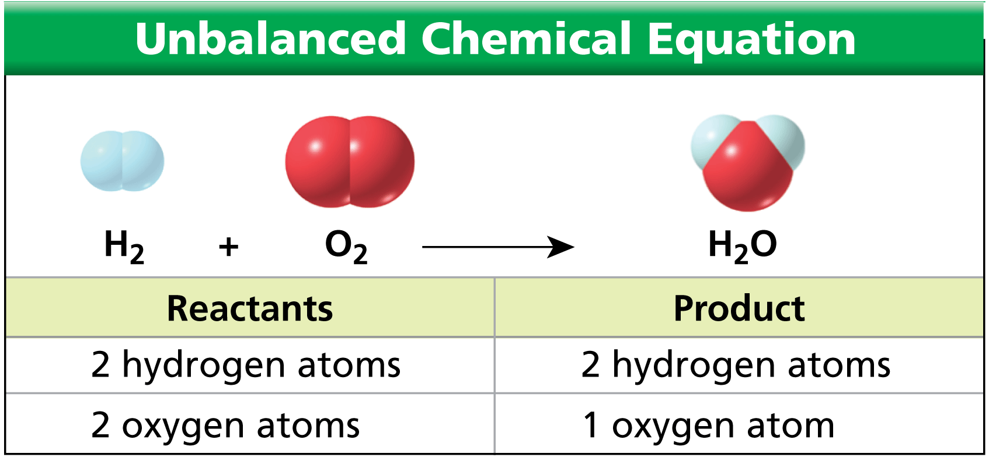

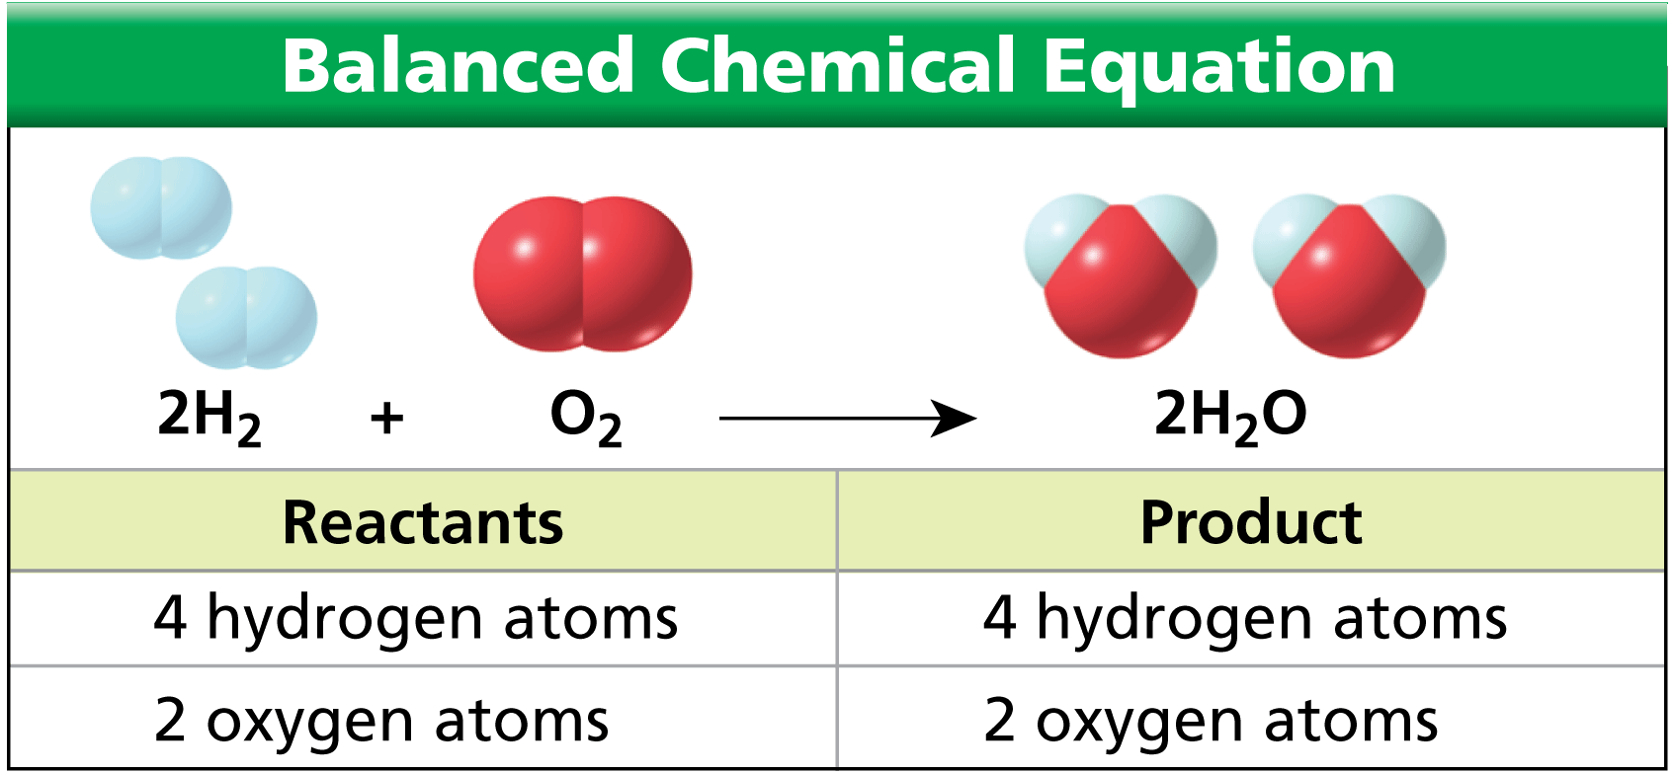

The chemical equation for the formation of water is now balanced.
  - _____________ of the balanced equation has ____ hydrogen atoms and ____ oxygen atoms.
  - According to the balanced equation, ________________________________________________ ______________________________________________________________________.
Balancing Chemical Equations
Write a balanced equation for the reaction between copper and oxygen to produce copper(II) oxide, CuO.
Read and Understand
What information are you given?
____________________________________________________________
Plan and Solve
Write a chemical equation with the reactants on the left side and the product on the right.
____________________________________________________________
This equation is not balanced. Change the coefficient of CuO in order to balance the number of oxygen atoms.
____________________________________________________________
Change the coefficient of Cu in order to balance the number of copper atoms.
____________________________________________________________
Look Back and Check
Is your answer reasonable?
_____________________________________________________________________________.
Describing Ionic Compounds
1. Hydrogen chloride, or HCl, is an important industrial chemical. Write a balanced equation for the production of hydrogen chloride from hydrogen and chlorine.
Answer: __________________________________________________
2. Balance the following chemical equations.
a. H₂O₂ → H₂O + O₂
b. Mg + HCl → H₂ + MgCl₂
Answer: a. __________________________________________________
b. __________________________________________________
3. Ethylene, C₂H₄, burns in the presence of oxygen to produce carbon dioxide and water vapor. Write a balanced equation for this reaction.
Answer: ____________________________________________________________
Counting with Moles
Why do chemists use the mole?
Answer: ______________________________________________________________________ ________________________________________________________________________________.
A mole (mol) is ______________________________________________________________________.
For instance, a mole of iron is 6.02 x 10²³ atoms of iron.
This number is known as ________________________________________.
You might count shoes by the pair, eggs by the dozen, or paper by the ream (500 sheets). __________ ____________________________________________________________ (6.02 × 1023 particles).
Molar Mass
______________________________ is called a molar mass_____________________________________ ________________________________________________________________________________.
  - The molar mass of carbon is 12.0 grams.
  - The molar mass of sulfur is 32.1 grams.
You calculate the molar mass of a compound by ___________________________________________ ________________________________________________________________________________.
  - A carbon dioxide molecule is composed of one carbon atom (__________) and two oxygen atoms (2 × 16.0 amu = ____________________).
  - Carbon dioxide has a molar mass of ____________________.

Mole-Mass Conversions
Once you know the molar mass of a substance, ____________________________________________ ____________________________________________________________________________________
The molar mass of CO₂ is 44.0 grams, which means that one mole of CO₂ has a mass of 44.0 grams. This relationship yields the following conversion factors.
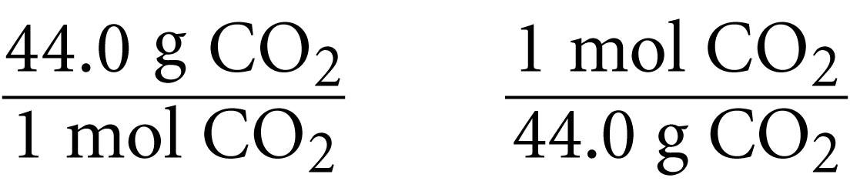

Suppose you have 55.0 grams of CO₂. To calculate how many moles of CO₂ you have, multiply the mass by a conversion factor.
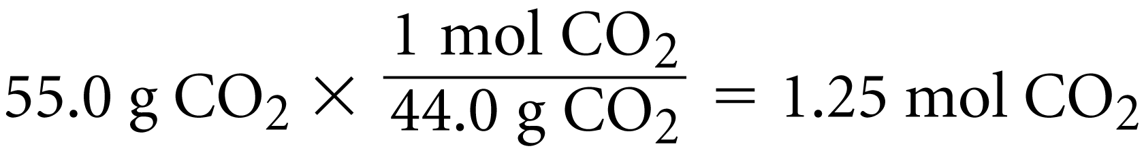

You can check your answer.
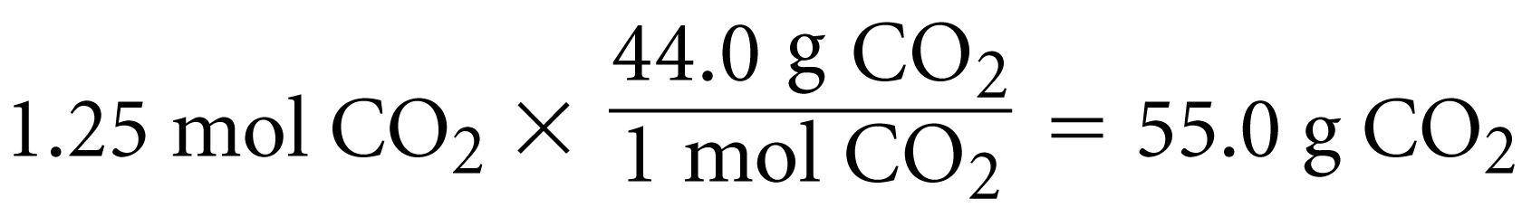

Chemical Calculations
How can you calculate the mass of a reactant or product in a chemical reaction?
Answer_____________________________________________________________________________ ______________________________________________________________________________________.
A cake recipe tells you how much of each ingredient to use for each cake. ______________________ _____________________________________________________________________________
In a balanced chemical equation, the number of atoms of each element on the left equals the number of atoms of each element on the right.
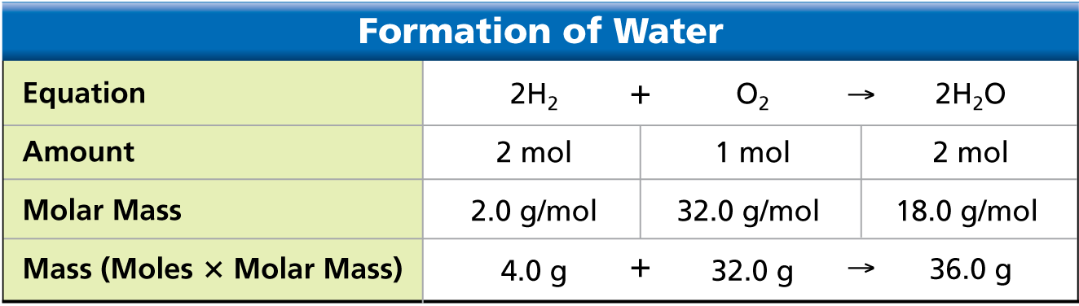

Converting Mass to Moles
To calculate how much oxygen is required to make 144 grams of water, begin with a balanced chemical equation for the reaction.
_______________________________________________________
  - Determine how many moles of water you are trying to make.
  - Convert the given mass of water into moles. 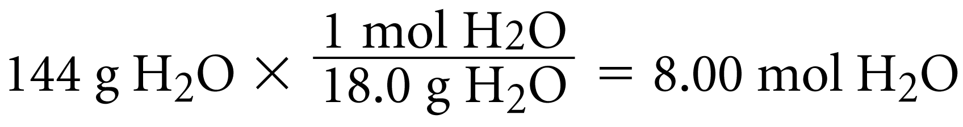
Using Mole Ratios
- Write the conversion factors, or mole ratios.
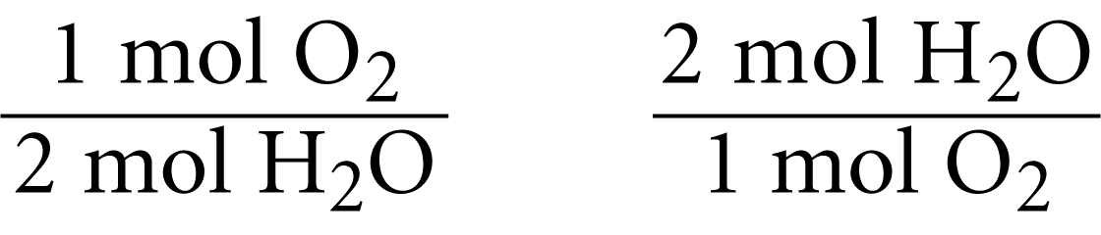

- Calculate how many moles of oxygen are required to produce eight moles of water.
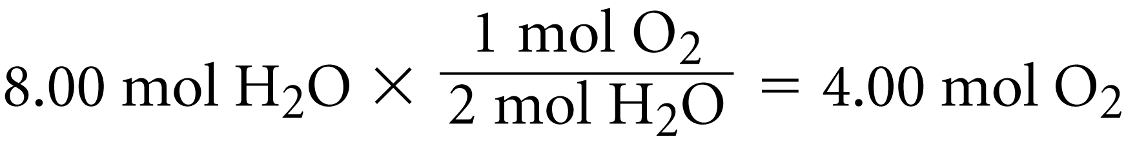

Converting Moles to Mass
- Convert moles of O2 to grams of O2 by using the molar mass of O2 as a conversion factor.
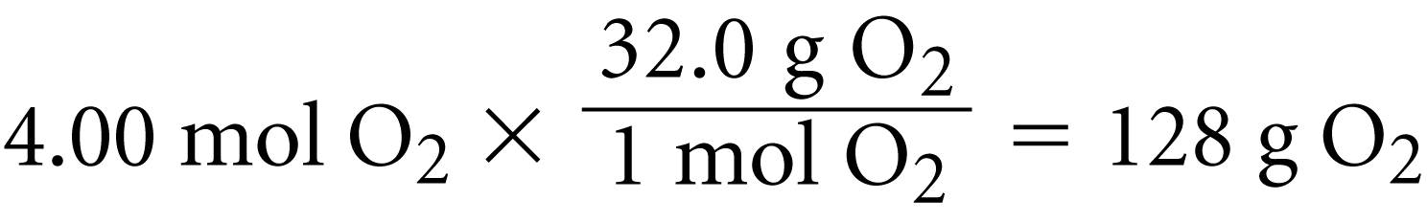

- To produce 144 grams of H2O, you must supply 128 grams of O2.
Assessment Questions
- Which of the following is a balanced chemical equation for the reaction of aluminum and ammonium perchlorate?
  - Al + NH₄ClO₄ —› Al₂O₃ + NH₄Cl
  - 4Al + 3NH₄ClO₄ —› 4Al₂O₃ + 3NH₄Cl
  - 8Al + NH₄ClO₄ —› 4Al₂O₃ + NH₄Cl
  - 8Al + 3NH₄ClO₄ —› 4Al₂O₃ + 3NH₄Cl
ANS: ___________
- How many moles of NaCl (molar mass = 58.5) are there in a 10-gram sample?
  - 58 mol
  - 5.8 mol
  - 0.17 mol
  - 0.28 mol
ANS: ___________
- In the reaction shown below, how many grams of hydrogen are produced when 10 moles of potassium react with water?
2K + 2H₂O —› 2KOH + H₂
  - 2.5 g
  - 5 g
  - 10 g
  - 20 g
ANS: ___________
- In the chemical equation below, the reactants are carbon dioxide and water.
CH₄ + 2O₂ —› CO2 +2H₂O
True
False
ANS: _________________________________

Section 7.2 Types of Reactions
The walls of this cave are limestone. When hydrochloric acid is dropped on limestone, a chemical reaction occurs that produces a gas. Geologists use this reaction to determine whether a rock sample contains the mineral calcium carbonate, CaCO₃.

Classifying Reactions
What are the general types of chemical reactions?
Answer: ___________________________________________________________________________ ______________________________________________________________________________________ _______________________________________________________.
Just as you can classify matter into different types, you can classify chemical reactions into different types.
Reactions are often classified _______________________________________________________ _______________________________________________________.
Synthesis
A synthesis reaction is __________________________________________________________________ __________________________________________________________________.
  - The reactants may be _______________________________________________________.
  - The product synthesized is _______________________________________________________.
  - The general equation for a synthesis reaction is
_________________________________
Sodium metal reacts vigorously with chlorine to form sodium chloride, NaCl.
____________________________________________
Another synthesis reaction is hydrogen and oxygen reacting to form water.
____________________________________________
Decomposition
A decomposition reaction is _______________________________________________________ _____________________________________________________________________________.
  - The reactant in a decomposition reaction _________________________________.
  - The products may be ____________________________________________.
  - The general equation for a decomposition reaction is
_________________________________
When electricity passes through water, the water decomposes into hydrogen gas and oxygen gas.
____________________________________________
Cement factories use a giant kiln, or oven, to heat a mixture of clay and limestone. The heat causes the calcium carbonate in the limestone to decompose into lime, CaO, and carbon dioxide.
____________________________________________
Single Replacement
A single-replacement reaction is _______________________________________________________ ____________________________________________. Single-replacement reactions have the general form
____________________________________________
As copper replaces silver in the silver nitrate solution in a single-replacement reaction, the solution turns blue, and silver crystals form on the wire.
_______________________________________________________
Potassium reacts with water in a single-replacement reaction that produces hydrogen gas and potassium hydroxide.
_______________________________________________________
The heat produced by this chemical reaction ____________________________________________ _________________________________.
Double Replacement
A double-replacement reaction is _______________________________________________________ __________________________________________________________________.
  - The general form of a double replacement reaction is
____________________________________________
  - _______________________________________________________. A replaces C, and C replaces A.
When potassium iodide solution is poured into a solution of lead(II) nitrate, a double-replacement reaction takes place.
Lead(II) iodide forms as a yellow precipitate. Potassium nitrate remains in solution.
_______________________________________________________
When geologists test the calcium carbonate content in a rock, they use a double-replacement reaction.
_______________________________________________________
The product carbonic acid,H₂CO₃, then decomposes into carbon dioxide gas and water.
_______________________________________________________
Combustion
A combustion reaction is _________________________________________________________________ __________________________________________________________________
The __________________________________________________________________. When methane burns in oxygen, a combustion reaction occurs.
_______________________________________________________
A Bunsen burner generates heat and light by the combustion of natural gas.
The reaction of hydrogen and oxygen is a combustion reaction.
____________________________________________
You could also classify this reaction as the synthesis of water. _________________________________ __________________________________________________________________
Reactions as Electron Transfers
How did the discovery of subatomic particles affect the classification of reactions?
Answer: __________________________________________________________________________ ______________________________________________________________________________________.
A reaction in which __________________________________________________________________is called an oxidation-reduction reaction, or _________________________________.
Oxidation
For a long time, people have known that metals react with oxygen.
Calcium reacts with oxygen and forms calcium oxide (CaO). _________________________________ __________________________________________________________________.
These types of synthesis _______________________________________________________, have been classified as oxidations.
Calcium oxide, or lime, is _________________________________________________________________ ______________________. In this reaction, the calcium is oxidized and the oxygen is reduced.
____________________________________________

Each neutral calcium atom loses two electrons and becomes a calcium ion with a charge of 2+.
_______________________________________________________
  - Any process in which ____________________________________________during a chemical reaction is called oxidation.
  - _______________________________________________________in order for an element to lose electrons.
Reduction
The process in which __________________________________________________ is called reduction.
As calcium atoms lose electrons during the synthesis of calcium oxide, the oxygen atoms gain electrons. As each neutral oxygen atom gains two electrons, it becomes an ion with a charge of 2–.
____________________
___________________________________________________________________________.
  - When ____________________electrons, __________ element ____________________.
  - A reactant is said ________________________________________. A reactant is __________ ________________________________________.
  - Oxidation-reduction reactions __________________________________________________ ______________________________. For example, in the synthesis of water, hydrogen is oxidized, and oxygen is reduced, but the transfer of electrons is only partial.

Assessment Questions
- Which of these statements best describes a double-replacement reaction?
  - Two different compounds exchange positive ions and form two new compounds.
  - An element takes the place of another element in a compound.
  - One compound breaks down into two or more simpler substances.
  - Two or more substances react to form a single substance.
ANS: __________
- Which of the following statements about oxidation-reduction reactions is true?
  - Oxidation-reduction reactions always involve a transfer of protons between atoms.
  - Oxidation is the process in which electrons are gained.
  - Oxidation and reduction always occur together.
  - Oxidation-reduction reactions always involve oxygen as one of the reactants.
ANS: __________

Section 7.3 Energy Changes in Reactions
A propane grill is the scene of a chemical reaction. The ________________________________________, and the __________________________________________________. However, the description of this reaction is ______________________________________________________________________.
Chemical Bonds and Energy
What happens to chemical bonds during a chemical reaction?
Answer: __________________________________________________________________________ _____________________________________________________________________________________.
The heat produced by a propane grill ______________________________.
When you write the chemical equation for the combustion of propane, you can include “heat” on the right side of the equation.
____________________________________________________________
Chemical energy is _____________________________________________________________________.
A propane molecule has ____________________ bonds. The ____________________of a propane molecule ____________________________________________________________.
Oxygen, carbon dioxide, and water molecules also have energy stored in their chemical bonds.
________________________________________________________________________________ __________________________________________________.
In the combustion of propane, the bonds in propane and oxygen molecules are broken, while the bonds in carbon dioxide and water molecules are formed.
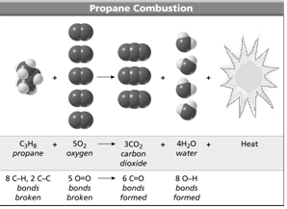
Breaking Bonds
In order for the combustion of propane to occur, ____________________________ _________________________________ ______________________________. The _________________________________ _________________________________ _________________________________.

Breaking chemical bonds requires energy. A spark provides enough energy to break the bonds of reacting molecules and get the reaction started.
Forming Bonds
For each molecule of propane burned, three molecules of carbon dioxide and four molecules of water are formed.
  - __________ C=O double bonds and __________ O—H single bonds are formed.
  - The formation of chemical bonds ____________________.
  - The ______________________________________________________________________ ____________________________________________________________.
Exothermic and Endothermic Reactions
What happens to energy during a chemical reaction?
Answer: ______________________________________________________________________.
Exothermic Reactions
A ______________________________________________________________________ is called an exothermic reaction.
In exothermic reactions, the ________________________________________as the products form __________________________________________________ to break the bonds in the reactants.
Combustion is __________________________________________________. When 1 mole of propane reacts with 5 moles of oxygen, 2220 kJ (kilojoules) of heat is released.
C₃H₈ + 5O₂ → 3CO₂ + 4H₂O + 2220 kJ
In an exothermic reaction, ____________________________________________________________ ______________________________________________________________________.
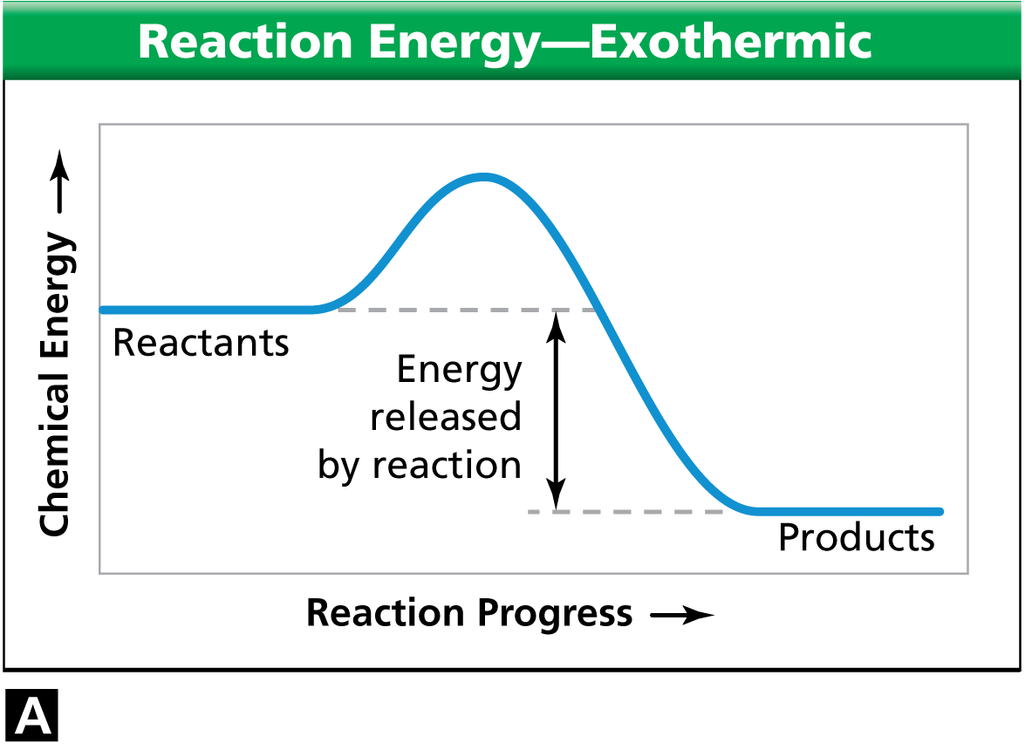
In a chemical reaction, the chemical energy reaches a ________ ________________________________________ into products.
  - This peak ________________________________ ________________________________________ ____________________ of the reactants.

  - Particles __________________________________ ______________________________, or the reaction will not occur.
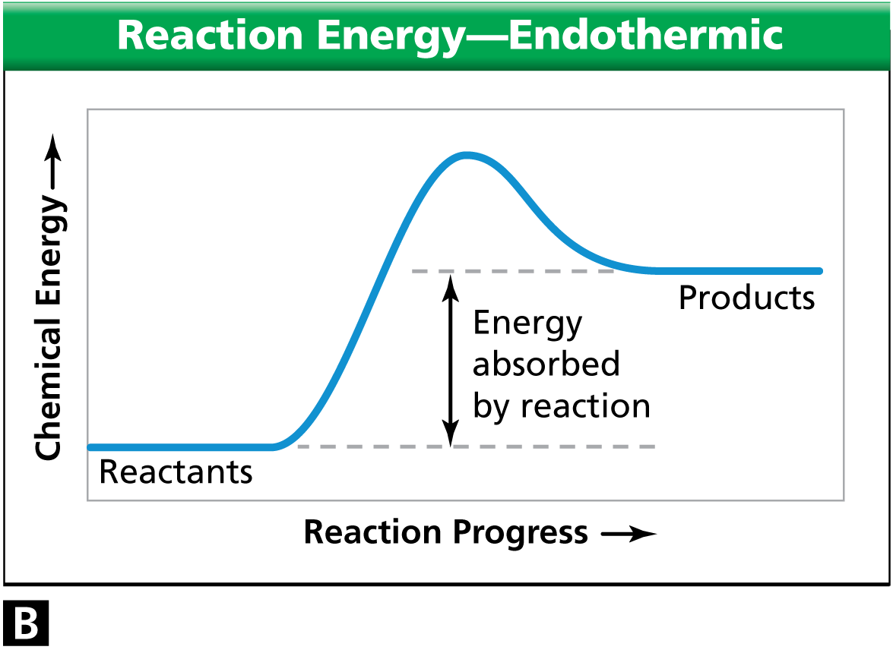
Endothermic Reactions
A __________________________________________________ _______________________ is called an endothermic reaction.
In an endothermic reaction, _____________________________ __________________________by the formation of the products.

In an endothermic reaction, the energy of the products is greater than the energy of the reactants.

At about 450°C, mercury(II) oxide decomposes into oxygen gas and liquid mercury. The ____________________________________________________________is an endothermic reaction.
2HgO + 181.7 kJ → 2Hg + O₂
The orange-red powder in the bottom of the test tube is mercury (II) oxide. When the powder decomposes, oxygen escapes from the test tube. Mercury collects in droplets on the sides of the tube.
In an exothermic reaction____________________________________________________________ ______________________________. In an endothermic reaction, ______________________________ ________________________________________________________________________________.
In both cases, ______________________________________________________________________. This principle is known as ____________________________________________________________.
Assessment Questions
- During a chemical reaction, an input of energy is always required to
  - break chemical bonds in a molecule.
  - build chemical bonds as a molecule forms.
  - separate products from reactants.
  - change reactants to the liquid phase so they can react.
ANS: __________
- In an exothermic reaction, the total chemical energy of the products added to the energy released by the reactions is
  - less than the energy of the reactants.
  - equal to the chemical energy of the reactants.
  - greater than the chemical energy of the reactants.
  - not related to the chemical energy of the reactants.
ANS: __________
- Combustion is always an exothermic reaction.
True
False
ANS: ____________________

Section 7.4 Reaction Rates
You may have heard of athletes “burning Calories” when they exercise.
A Calorie is ____________________________________________________________. The average banana contains about 100 Calories.
If you eat a banana, you provide your body with about 100 Calories to burn. ____________________ ________________________________________________________________________________.
A much faster way of releasing the energy contained in a banana is to burn it—outside the body—in a combustion reaction.
________________________________________ released ___________________________________
Reactions Over Time
What does a reaction rate tell you?
Answer: ______________________________________________________________________.
A reaction rate is ______________________________________________________________________.
Any change that happens over a period of time can be expressed as a rate.
The reaction rate is ______________________________________________________________________ ________________________________________________________________________________.
Factors Affecting Reaction Rates
What factors cause reaction rates to change?
Answer: ______________________________________________________________________ ________________________________________________________________________________.
The reaction rate of a chemical reaction __________________________________________________.
  - If the collisions occur more frequently, then the reaction ____________________.
  - If the collisions occur less frequently, then the reaction ____________________.
  - Reaction rates ____________________________________________________________.
Temperature
Generally, an ______________________________________________________________________ ____________________, while a decrease in temperature will decrease the reaction rate.
You store milk in a refrigerator to slow down the reactions that cause the milk to spoil. The rate of spoiling decreases if the milk is kept cold.
Increasing the temperature of a substance __________________________________________________ ____________________________________________________________.
Particles ____________________________________________________________ and more likely to react. If the number of collisions that produce reactions increases, ______________________________ ________________________________________.
Surface Area
The __________________________________________________, the larger is its surface area.
  - __________________________________________________that involve reacting particles.
  - With more collisions, __________________________________________________.
This fire was a combustion reaction between grain dust and oxygen. The rate of combustion was very rapid __________________________________________________of the grain dust.

Stirring
Stirring reactants ____________________________________________________________.
In a washing machine, particles of detergent react with particles of the stains on clothes. A washing machine speeds up the reaction ____________________________________________________________.
Concentration
Concentration refers to ____________________________________________________________. You can change the reaction rate by changing the concentration of the reactants.
The ______________________________ that are present in a given volume, the ____________________ ______________________________ involving those particles. The reaction ____________________.
The dye solution in the left beaker is more concentrated than the solution in the right. Increasing the concentration of the dye increases the rate of color change in the material.
For gases, __________________________________________________.
The ______________________________of a gaseous reactant, the ______________________________, and the ____________________________________________________________.
Catalysts
A catalyst is ______________________________________________________________________ ____________________________________________________________.
Chemists often ______________________________________________________________________ ____________________________________________________________.
One of the steps involved in making sulfuric acid is the reaction of sulfur dioxide with oxygen to form sulfur trioxide. This reaction happens very slowly without a catalyst such as vanadium(V) oxide.
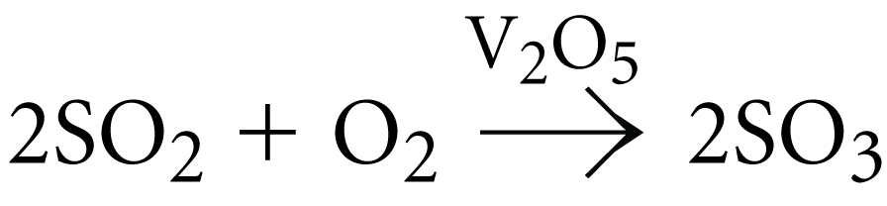

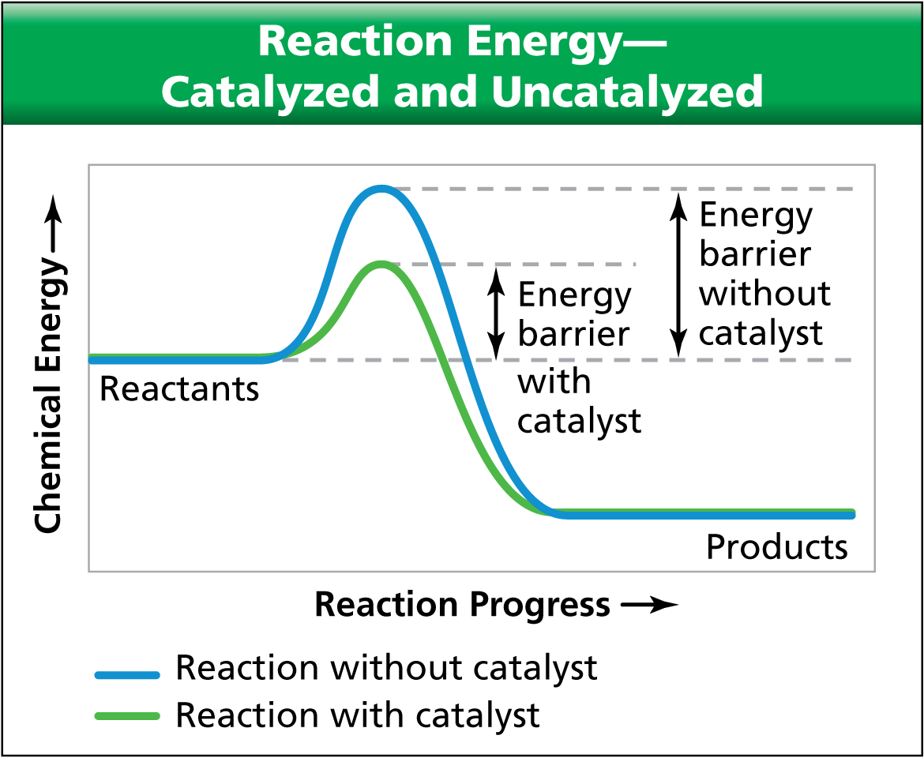
The catalyst is __________________________ ____________________, so it is ___________ _____________________________________.
The catalyst lowers the amount of energy required for effective collisions between reacting particles.
The catalyst lowers the amount of energy required for effective collisions between reacting particles.

Assessment Questions
- Which of the following changes will decrease the rate of a chemical reaction?
  - increasing the temperature
  - grinding a reactant into a fine powder
  - stirring the reaction mixture
  - decreasing the concentration of one of the reactants
ANS: ____________________
- A reaction rate is the rate at which reactants change into products over time.
True
False
ANS: ____________________

Section 7.5 Equilibrium
Suppose that every time a car passes by a toll booth in one direction, another car passes through in the opposite direction. Then, the number of cars on either side of the toll plaza is constant.
Types of Equilibria
Under what conditions do physical and chemical equilibria occur?
Answer: ______________________________________________________________________ ________________________________________________________________________________.
Equilibrium is ______________________________________________________________________ ________________________________________ Balanced traffic at a toll bridge is a model for a system in equilibrium.
When ______________________________________________________________________, a physical equilibrium is reached.
Physical Equilibrium
Liquid water left in a closed container eventually reaches equilibrium with its vapor when the rate of evaporation equals the rate of condensation.
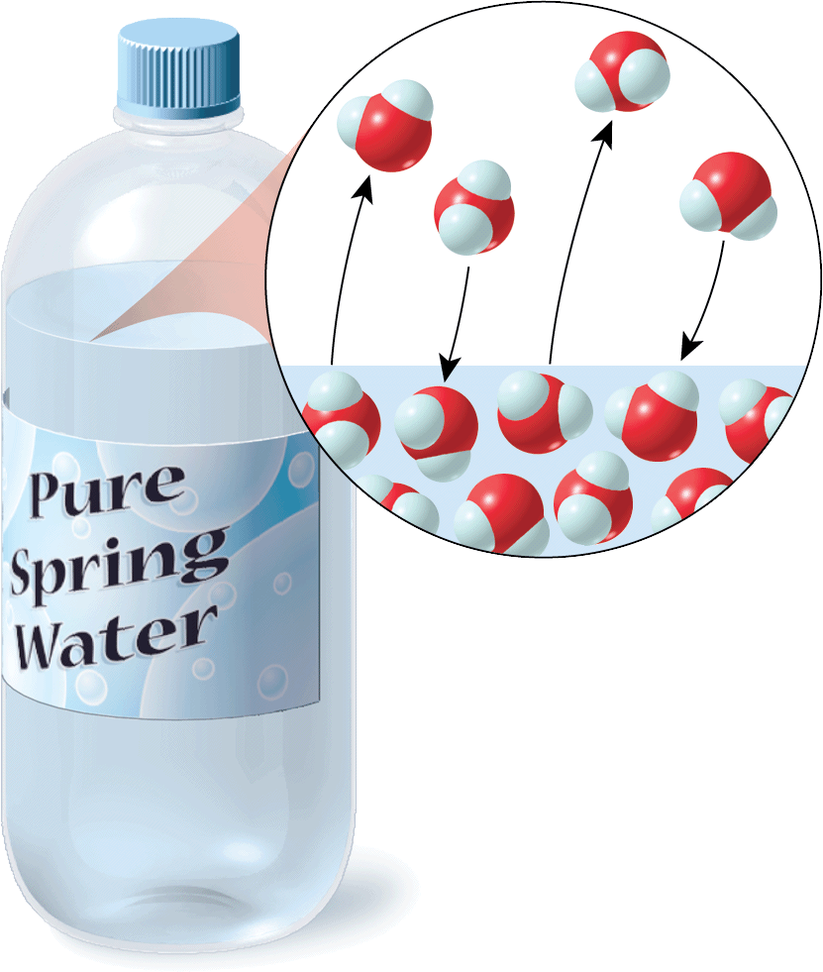
Liquid water in equilibrium with water vapor can be described by this equation.
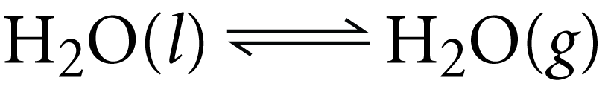

(l) stands for liquid and (g) stands for gas.
The pair of arrows in this equation indicates that ____________________ ____________________________________________________________.
Chemical Equilibrium
________________________________________________________________________________ ________________________________________________________________________________.
Most reactions are reversible to some extent.
A ______________________________is a reaction in which the conversion of reactants into products and conversion of products into reactants can happen simultaneously.
In the synthesis of sulfur trioxide, the forward reaction produces sulfur trioxide. Some molecules of sulfur trioxide change back into the reactants by the reverse reaction.
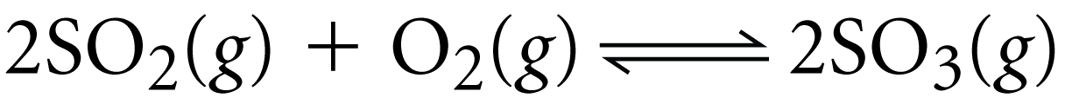
During chemical equilibrium, ____________________________________________________________ ______________________________________________________________________.
Factors Affecting Chemical Equilibrium
How do equilibrium systems respond to change?
Answer: ______________________________________________________________________ ________________________________________________________________________________.
This rule was first observed by Henri Le Châtelier. Today, the rule is known as ____________________ ______________________________.
The making of ammonia is an example of a process in which chemists apply Le Châtelier’s principle.
If a system containing nitrogen, hydrogen, and ammonia is in equilibrium, you ____________________ ________________________________________________________________________________.
Temperature
In the equation for the synthesis of ammonia, heat is written as a product.
  - The ________________________________________.
  - In the ________________________________________, heat is a reactant, so the decomposition of ammonia is ______________________________.
According to Le Châtelier’s principle, if you ______________________________to the system, the equilibrium would shift in the direction that removes heat from the system.
The system would ________________________________________, which is endothermic. By increasing the temperature, you would __________________________________________________.
Pressure
According to Le Châtelier’s principle, if you increased the pressure, the equilibrium would shift in the direction that decreases the pressure of the system.
In order ______________________________, the system would ______________________________ ______________________________. __________________________________________________ ________________________________________________________________________________
Concentration
Le Châtelier’s principle tells you that __________________________________________________ by removing ammonia from the system, the __________________________________________________ ____________________________________________________________.
In order to produce ammonia, the system would favor the forward reaction.
Operating an ammonia plant at relatively low temperature, high pressure, and low ammonia concentration maximizes the amount of ammonia produced.
Assessment Questions
- In a chemical reaction that is at equilibrium, which of the following is true?
  - All of the reactants have been converted to products.
  - The reaction stops even though some reactants remain.
  - Forward and reverse reactions occur at the same rate.
  - All of the products are gases.
ANS: __________
- In the chemical reaction below, how could you shift the equilibrium toward water?
  - increase the temperature
  - increase the pressure
  - decrease the amount of oxygen
  - add steam to the mixture
ANS: __________

