Physical Science
Chapter 11 Motion
Section 11.1 Distance and Displacement
How fast is the butterfly moving? What direction is it moving?
To describe motion, you must ____________________________________________________________ ________________________________________. You must also ____________________ at a certain time.
Choosing a Frame of Reference
What is needed to describe motion completely?
A frame of reference is __________________________________________________________________ ____________________________________________________________.
Answer: ___________________________________________________________________________ ______________________________________________________________________.
How Fast Are You Moving?
How fast the passengers on a train are moving _________________________________________________ ____________________ chosen to measure their motion.
Relative motion is ______________________________________________________________________.
  - As the train moves past a platform, people standing on the platform will see ___________________ ________________________________________.
  - When the people on the train look at one another, ________________________________________ ______________________________ at all.
To someone riding on a speeding train, others on the train don’t seem to be moving.
Which Frame Should You Choose?
- When you sit on a train and look out a window, a treetop may help you see how fast you are moving relative to the ground.
- If you get up and walk toward the rear of the train, looking at a seat or the floor shows how fast you are walking relative to the train.
- ________________________________________________________________________________ ______________________________________________________________________.
Measuring Distance
How are distance and displacement different?
Answer: __________________________________________________________________________ ______________________________________________________________________________________ ______________________________________________________________________.
Distance is __________________________________________________. When an object moves in a straight line, the distance is the length of the line connecting the object’s starting point and its ending point.
  - The SI unit for measuring distance is ______________________________.
  - For ________________________________________, it is more common to make measurements in __________________________________________________.
  - Distances that are ______________________________ are measured ____________________.
Measuring Displacements
To describe an object’s position relative to a given point, ________________________________________ __________________________________________________. Displacement provides this information.
Think about the motion of a roller coaster car.
  - The length of the path along which the car has traveled is distance.
  - Displacement is ___________________________________________________________________ ____________________________________________________________.
  - After _______________________ around the track, the car’s ______________________________.
Combining Displacements
How do you add displacements?
A vector is ______________________________________________________________________.
Answer: ______________________________________________________________________.
Displacement is ______________________________ of a vector.
  - The magnitude can ________________________________________.
  - __________________________________________________ are used to represent vectors. The length of the arrow shows the magnitude of the vector.
  - Vector addition is the ____________________________________________________________.
Displacement Along a Straight Line
When two displacements, represented by two vectors, have the same direction, you can add their magnitudes.
If two displacements are in opposite directions, the magnitudes subtract from each other.
- ________________________________________________________________________________ __________________________________________________.
- ________________________________________________________________________________ __________________________________________________.
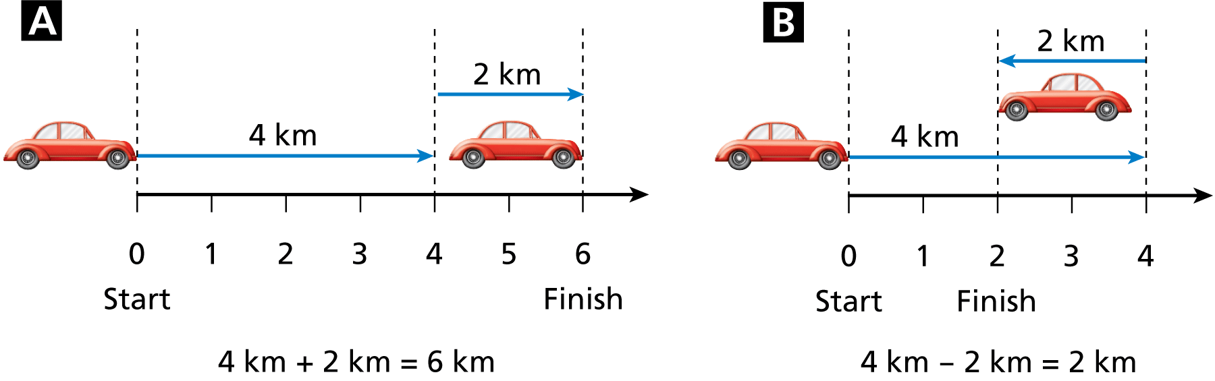

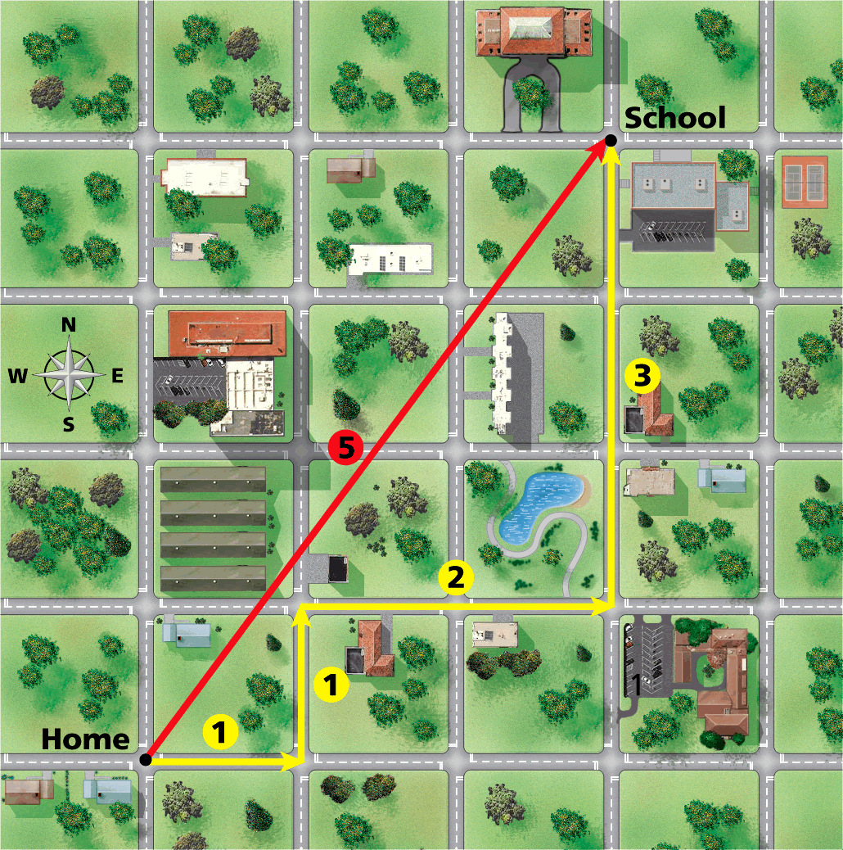
Displacement That Isn’t Along a Straight Path
When two or more displacement vectors have different directions, they _________________________________________________________ ______________________________.
Measuring the resultant vector _____________________________ ______________________________________________________ __________from the boy’s home to his school is two blocks less than the distance he actually traveled.
The boy walked a total distance of 7 blocks. This is the sum of the magnitudes of each vector along the path.
The vector in red is called the resultant vector, which is ________________________________________.
The resultant vector ______________________________________________________________________.

Assessment Questions
- A car is driving down the highway. From which frame of reference does it appear to not be moving?
  - standing at the side of the road
  - a car driving at the same speed but going the opposite direction
  - sitting inside the car
  - an airplane flying overhead
ANS: __________

- The SI unit of distance that would be most appropriate for measuring the distance between two cities is the
  - meter.
  - centimeter.
  - kilometer.
  - mile.
ANS: __________

- If you walk across town, taking many turns, your displacement is the
  - total distance that you traveled.
  - distance and direction of a straight line from your starting point to your ending point.
  - distance in a straight line from your starting point to your ending point.
  - direction from your starting point to your ending point.
ANS: __________
- You travel 30 miles west of your home and then turn around and start going back home. After traveling 10 miles east, what is your displacement from your home?
  - 20 km
  - 20 km west
  - 40 km
  - 40 km west
ANS: __________

Section 11.2 Speed and Velocity
The speed of an in-line skater is usually described in meters per second. The speed of a car is usually described in kilometers per hour.
Speed
How are instantaneous speed and average speed different?
Answer: ___________________________________________________________________________ ________________________________________________________________________________.
Speed is ______________________________________________________________________________ ________________________________________.
The SI unit of speed is __________________________________________________.
Two ways to express the speed of an object are ________________________________________________.
Average Speed
Sometimes it is useful to know how fast something moves for an entire trip, even though its speed may change during the trip.
Average speed, is ______________________________________________________________________ ______________________________.

Calculating Average Speed
While traveling on vacation, you measure the times and distances traveled. You travel 35 kilometers in 0.4 hour, followed by 53 kilometers in 0.6 hour. What is your average speed?
Read and Understand
What information are you given?

Plan and Solve
What unknown are you trying to calculate?

What formula contains the given quantities and the unknown?

Replace each variable with its known value.

Look Back and Check
Is your answer reasonable?
______________________________________________________________________.
Speed
1. A person jogs 4.0 kilometers in 32 minutes, then 2.0 kilometers in 22 minutes, and finally 1.0 kilometer in 16 minutes. What is the jogger’s average speed in kilometers per minute?
Answer:

2. A train travels 190 kilometers in 3.0 hours, and then 120 kilometers in 2.0 hours. What is its average speed?
Answer:

Instantaneous Speed
Sometimes you need to know how fast you are going at a particular moment.
Instantaneous speed, ___________________________________________________________________.
The ______________________________ in a car measures the __________________________________.
Note the scale markings are given both in km/h and miles per hour, mph.
Graphing Motion
How can you find the speed from a distance-time graph?
Answer: ______________________________________________________________________.
A distance-time graph is a good way to describe motion.
Slope is _______________________________________________________________________________ ________________________________________.
A ______________________________ on a distance-time graph indicates a ____________________.
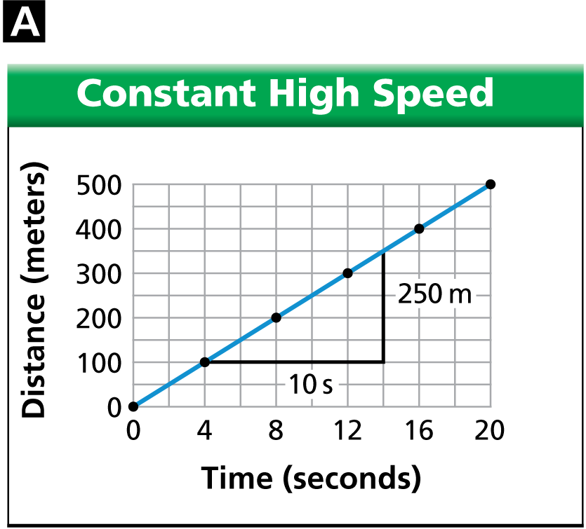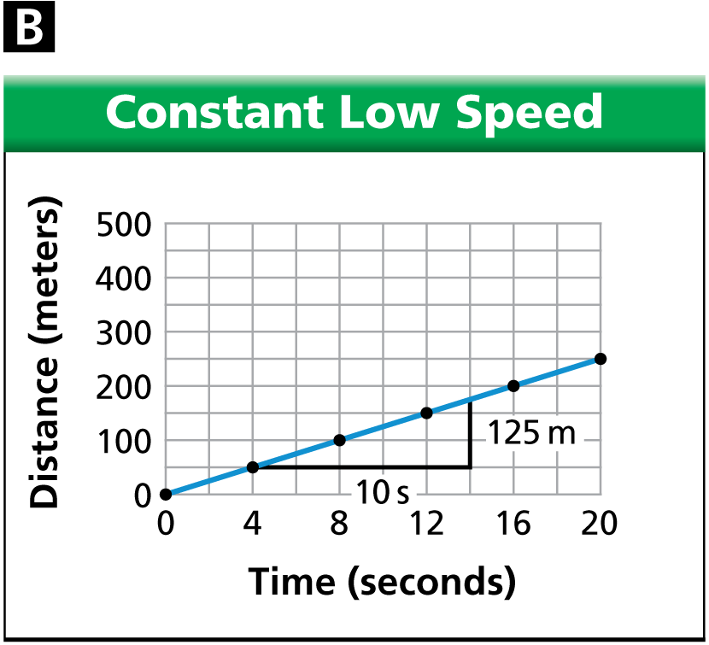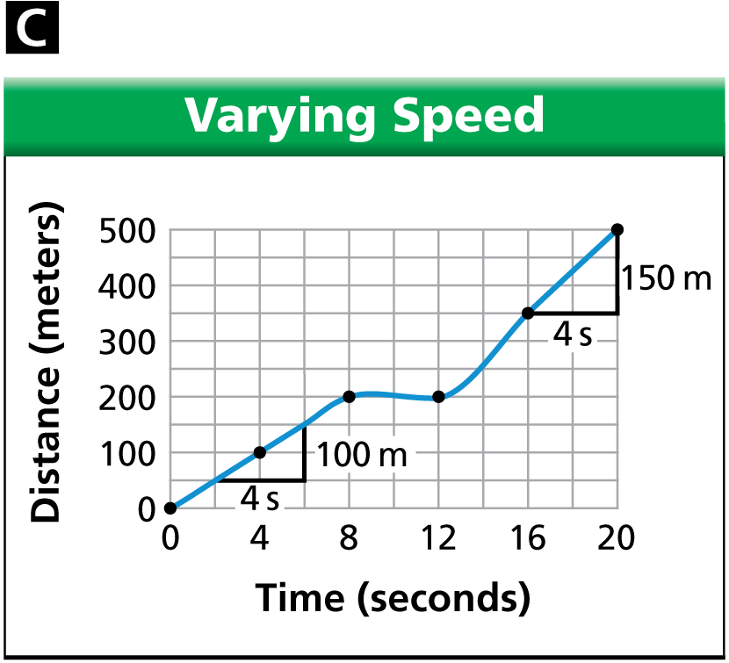

Velocity
How are speed and velocity different?
Answer: ______________________________________________________________________ ____________________________________________________________.
Sometimes knowing only the speed of an object isn’t enough. You also _____________________________ __________________________________________________.
Together, _______________________________________________________________ are called velocity.
A cheetah’s speed may be as fast as 90 km/h. To describe the cheetah’s velocity, you must also know the direction in which it is moving.
Vectors can be ____________________________________________________________.
  - Vectors of varying lengths, each vector corresponding to the velocity at a particular instant, can represent motion.
  - A ____________________ represents a _____________________________, and a __________ ______________________________.
  - Vectors point in ________________________________________________________________ ____________________________________________________________.
As the sailboat’s ________________________________________________________________________ ____________________________________________________________.
Combining Velocities
How do velocities add?
Answer: ______________________________________________________________________.
Sometimes the motion of an object ___________________________________________________________.
If a boat is moving on a flowing river, the velocity of the river relative to the riverbank and the velocity of the boat relative to the river combine.
They yield the velocity of the boat relative to the riverbank.
The velocity of the boat relative to the riverbank is a combination of the relative velocities of the boat and the river.
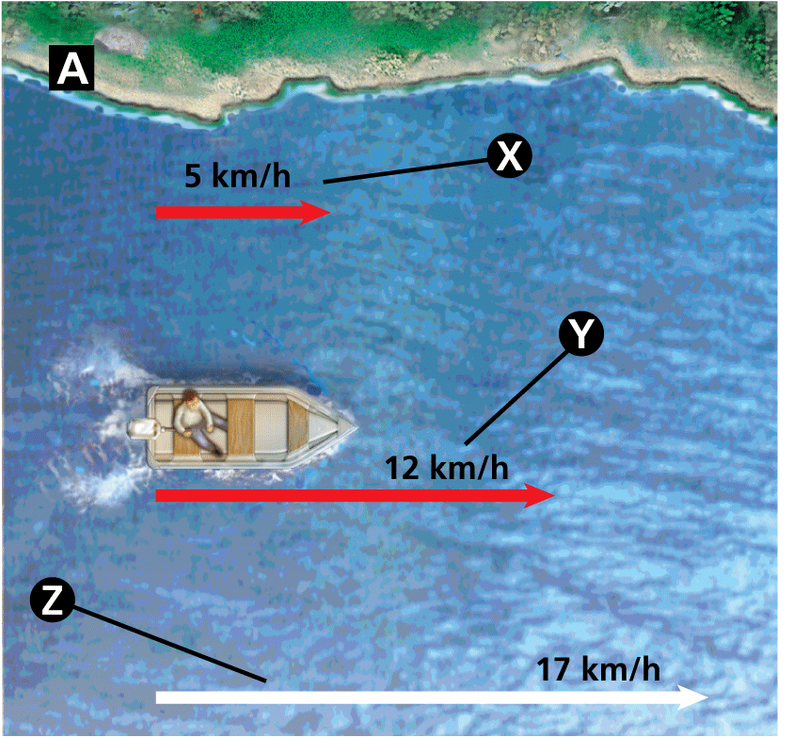
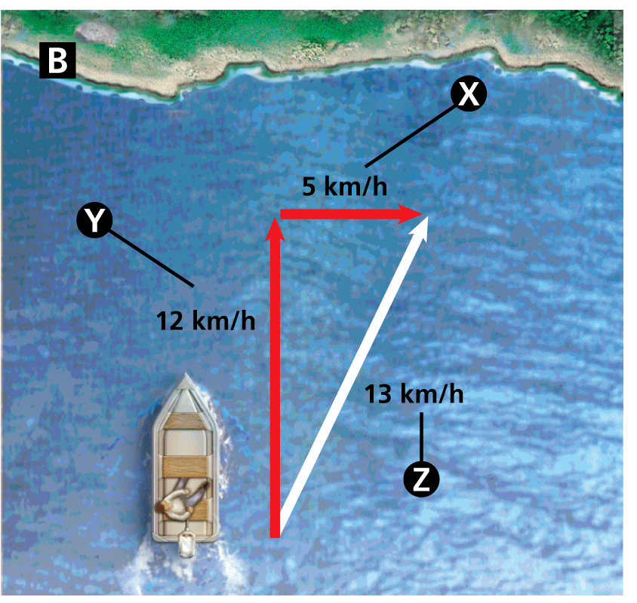
Assessment Questions
- A woman jogs 10 kilometers in one hour, stops at a restaurant for one hour, and then walks 10 kilometers in two hours. What is her average speed for the outing?
  - 0.2 km/h
  - 4 km/h
  - 5 km/h
  - 10 km/h
ANS: __________
- Lisa plotted time on the x-axis of a line graph and distance on the y-axis. What does the slope of her graph represent?
  - total distance traveled
  - velocity
  - speed
  - displacement
ANS: __________
- Lisa plotted time in seconds on the x-axis of a line graph and distance in centimeters on the y-axis. Her plot showed a straight line from (0,0) to (10, 20). What is the speed?
  - 0.5 cm/s
  - 2 cm/s
  - 10 cm/s
  - 20 cm/s
ANS: __________
- Two velocities of an object are combined by using
  - division of the larger velocity by the smaller velocity.
  - addition of the two speeds.
  - vector addition.
  - numeric addition.
ANS: __________
- A kayak is moving across a stream that is flowing downstream at a velocity of 4 km/h. The kayak’s velocity is 3 km/h. What is the magnitude of the kayak’s velocity relative to the river bank?
  - 1.3 km/h
  - 5 km/h
  - 7 km/h
  - 12 km/h
ANS: __________
- The SI unit for speed of an airplane is miles per hour.
True
False
ANS: ______________________________
Section 11.3 Acceleration
The basketball constantly changes velocity as it rises and falls. ______________________________ ________________________________________________________________________________
What is Acceleration?
How are changes in velocity described?
____________________________________________________________ is called acceleration.
Answer: ______________________________________________________________________ ______________________________________________________________________
Changes in Speed
- In science, ______________________________________________________________________.
- Acceleration can be caused __________________________________________________________ ______________________________________________________________________.
- Deceleration is ____________________________________________________________.
Free fall is ________________________________________________________ ________________________________________. The unit for velocity is meters per second. The unit for acceleration, then, is meters per second per second. This unit is typically written as ________________________________________.
Objects falling near Earth’s surface accelerate ___________________________ ________________________________________.
________________________________________________________________ ____________________ downward by 9.8 meters per second.
The change in the stone’s speed is ______________________________________ __________________________________________________.
Changes in Direction
Acceleration can be the result of ____________________________________________________________ ____________________, for example, riding a bicycle around a curve.
A horse on the carousel is traveling at _______________________________________________________ ______________________________________________________________________.
Changes in Speed and Direction
Sometimes motion is characterized by _______________________________________________________.
Passengers in ___________________________________________________ experience rapidly changing acceleration.
The car may enter a long curve at the same time that it slows. The car is accelerating both because it is changing direction and because its speed is decreasing.
A ______________________________ produces acceleration due to changes in both speed and direction.
Constant Acceleration
The ____________________ of an object moving ____________________________________________ ____________________ the object is experiencing ________________________________________.
  - Constant acceleration is __________________________________________________.
  - An airplane’s acceleration may be constant during a portion of its takeoff.
________________________________________ during takeoff _________________________________ __________________________________________________ that is in a constant direction.
Calculating Acceleration
How can you calculate acceleration?
Answer: ______________________________________________________________________ ______________________________________________________________________
Acceleration is the rate at which velocity changes. Vi is ____________________, vf is __________ ____________________, and t is ______________________________.

If the velocity increases, the acceleration is positive. If the velocity decreases, the acceleration is negative.
  - If you are coasting downhill on a bicycle, ______________________________________________ ________________________________________.
  - If you continue coasting on level ground, ______________________________________________ ________________________________________.
Acceleration and velocity are ______________________________.
  - To determine a change in velocity, __________________________________________________.
  - If the motion is in a ____________________________________________________________, and acceleration is the ____________________________________________________________.
Calculating Acceleration
A ball rolls down a ramp, starting from rest. After 2 seconds, its velocity is 6 meters per second. What is the acceleration of the ball?
Read and Understand
What information are you given?

Plan and Solve
What unknown are you trying to calculate?

What formula contains the given quantities and the unknown?

Plan and Solve
Replace each variable with its known value.

Look Back and Check
Is your answer reasonable?

Describing Ionic Compounds
1. A car traveling at 10 m/s starts to decelerate steadily. It comes to a complete stop in 20 seconds. What is its acceleration?
Answer: ______________________________________________________________________
2. An airplane travels down a runway for 4.0 seconds with an acceleration of 9.0 m/s². What is its change in velocity during this time?
Answer: ______________________________________________________________________
3. A child drops a ball from a bridge. The ball strikes the water under the bridge 2.0 seconds later. What is the velocity of the ball when it strikes the water?
Answer: ______________________________________________________________________
4. A boy throws a rock straight up into the air. It reaches the highest point of its flight after 2.5 seconds. How fast was the rock going when it left the boy’s hand?
Answer: ______________________________________________________________________
(The minus sign indicates that the velocity is in the direction opposite the acceleration.)

Graphs of Accelerated Motion
How does a speed-time graph indicate acceleration?
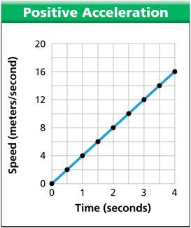
Answer: ______________________________________________________________________.
You can use a graph to calculate acceleration. ___________________________ ____________________________________________________________.
The slope is ______________________________________________________ ______________________________, which is equal to the acceleration.
The skier’s acceleration is positive. The acceleration is 4 m/s².
Speed-Time Graphs
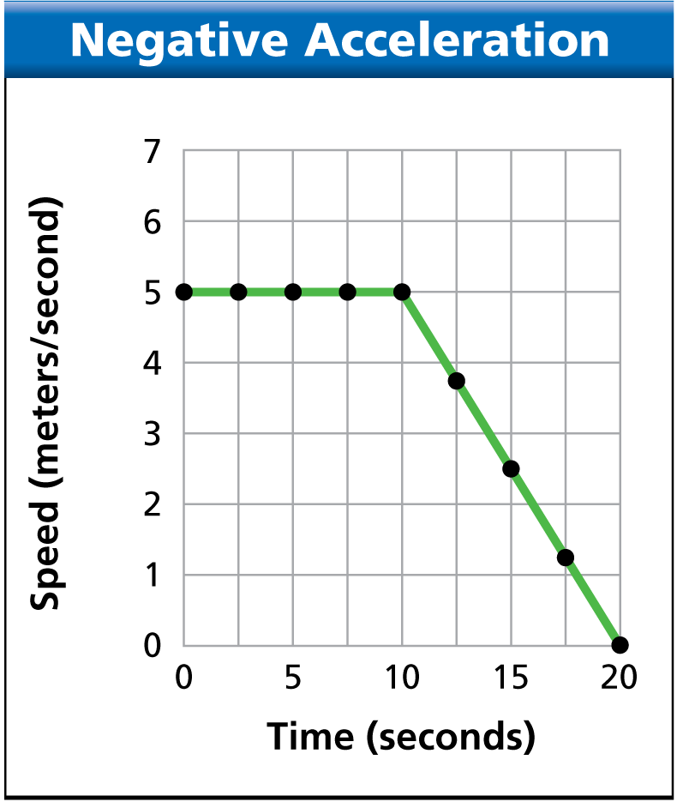
__________________________________________________represented on a speed–time graph by ________________________________________. The slope of the line is the acceleration.
The graph is an example of a ________________________________________ ____________________________________________________________.
Constant negative acceleration decreases speed.
  - On a speed-time graph of a bicycle slowing to a stop, _________________ ____________________________________________________________.
  - The ________________________________________________, so the slope of the line is negative.
The biker moves at a constant speed and then slows to a stop.
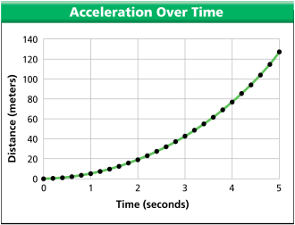
Distance-Time Graphs
Accelerated motion is represented by a curved line on a distance-time graph.
In a nonlinear graph, _______________________________________________ ________________________________________.
__________________________________________________________________ ________________________________________. The data in this graph are for a ball dropped from rest toward the ground.
Compare the slope of the curve during the first second to the slope during the fourth second. ____________ __________________________________________________________________________.
Instantaneous Acceleration
What is instantaneous acceleration?
Answer: ______________________________________________________________________ ________________________________________________________________________________.
Acceleration is ______________________________, and motion is ______________________________ .
  - Acceleration involves a change in velocity or direction or both, so ____________________ ____________________________________________________________.
  - The vector’s _____________________________________________________________________.
  - For an object that is ____________________________________________________________.
Assessment Questions
- What is acceleration?
  - the rate at which speed increases
  - the time an object’s velocity increases
  - the rate at which displacement changes
  - the rate at which velocity changes
ANS: __________
- A sports car can accelerate from 0 m/s to 28 m/s in four seconds. What is the acceleration of the car?
  - 24 s
  - 7 m/s
  - 27 m/s
  - 27 m/s
ANS: __________
- If you were to sketch a displacement-time graph and a speed-time graph for an object experiencing constant acceleration, what would they look like?
  - Both graphs would be linear, with the displacement-time graph being steeper.
  - Both graphs would be linear, with the speed-time graph being steeper.
  - Both graphs would be nonlinear.
  - The speed-time graph would be linear; the displacement-time graph would be nonlinear.
ANS: __________
- Which of the following is an example of negative acceleration?
  - Mike starts riding his bike and uses the pedals to go from 0 km/h to 20 km/h.
  - Mike pedals up a hill and gradually slows from 20 km/h to 5 km/h.
  - Mike sits on his bike at the top of the hill and rests.
  - Mike coasts downhill without pedaling, going from 0 km/h to 15 km/h.
ANS: __________
- The acceleration at a specific point on a distance-time graph is the
  - instantaneous acceleration.
  - momentary acceleration.
  - positive acceleration.
  - numerical acceleration.
ANS: __________
- If an object experiences a steady velocity change in a straight line, it is undergoing constant acceleration.
True
False
ANS: ______________________________

