**Physical Science**

**Chapter 12 Forces and Motion**

**Section 12.1 Forces**

The wind pushes against the man and his umbrella. The push from the wind is a force.

**What is a Force?**

**How do forces affect the motion of an object?**

A **force** is ____________________________________________________________________________.

Answer: __________________________________________________________________________ _____________________________________________________________________________________.

**Measuring Force**

You may have measured forces using a spring scale. The stretch of the spring in the scale ______________ ________________________________________________________________________________.

**Units of Force**

One **newton** (N) is ______________________________________________________________________ ________________________________________________________________________________.

**Representing Force**

Arrows can represent a force. The lengths of the arrows show relative amounts of force.

**Combining Forces**

**How do forces affect the motion of an object?**

Answer: ___________________________________________________________________________ ________________________________________________________________________________.

___________________________________________________________________________ ________________________________________________________________________________.

The **net force** is ______________________________________________________________________ ________________________________________.

* + Forces in the ____________________________________________________________.
  + Forces in ________________________________________________________________.

**Balanced Forces**

Balanced forces are ______________________________________________________________________.

An ________________________________________________________________________________ to produce a net force of zero.

The two groups pull with ____________________________________________________________. The forces combine to make a ________________________________________.

C:\Users\Bert\AppData\Local\Microsoft\Windows\Temporary Internet Files\Content.IE5\5H8HYR62\MC900334314[1].wmf

**Unbalanced Forces**

An unbalanced force is a force that results when the net force acting on an object is not equal to zero.

Forces can add together or subtract from one another.

**Friction**

**What are the four main types of friction?**

**Friction** is ___________________________________________________________________________ ________________________________________________________________________________.

Answer: __________________________________________________________________________ ______________________________________________________________________

**Static Friction**

**Static friction** is ______________________________________________________________________.

Static friction always _______________________________________________ to that of the applied force.

**Sliding Friction**

**Sliding friction** is ______________________________________________________________________ ____________________________________________________________.

Sliding friction is less than static friction.

1. Static friction–the potted tree does not move.
2. Sliding friction–when the tree moves, sliding friction acts to oppose the direction of motion.

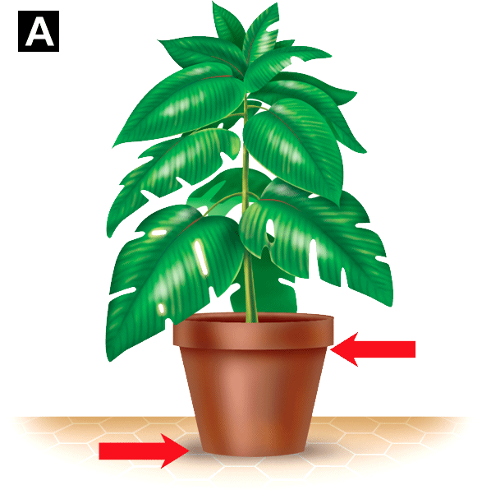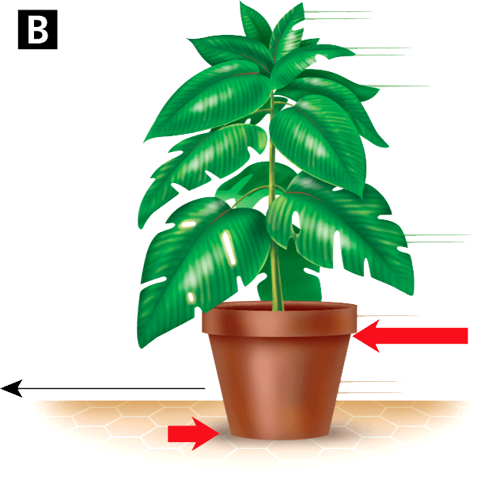

**Rolling Friction**

**Rolling friction** is ______________________________________________________________________.

The force of rolling friction is about ________________________________________________________ ________________________________________.

________________ in these wheels greatly reduce friction by replacing sliding friction with rolling friction.

**Fluid Friction**

* **Fluid friction** _____________________________________________________________________.
* ________________________________________________________________________________ as **air resistance.**
* Fluid _____________________________________ of the object moving through the fluid increases.

**Gravity**

**In what direction does Earth’s gravity act?**

Answer: ___________________________________________________________________________.

**How do gravity and air resistance affect a falling object?**

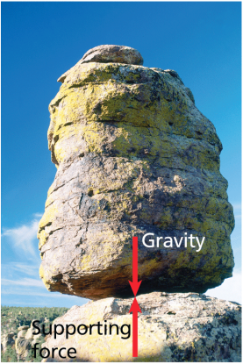 Answer: ___________________________________________________________________________ _________________________________________________________________.

**Gravity** is ________________________________________________________.

* + Gravity is _________________________________________________.
  + Gravity ___________________________________________________.

Earth exerts an attractive, downward force on this boulder. The supporting rock exerts an upward force on the boulder. The forces are balanced.

**Falling Objects**

* 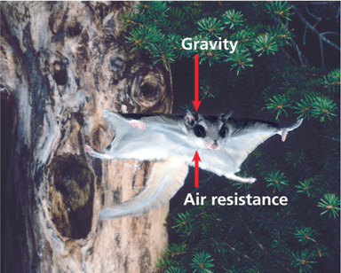Both ___________________________________________________ ____________________of a falling object.
* As objects fall to the ground, they ___________________________.
* **Terminal velocity** is ______________________________________ _______________________________________________________.

This flying squirrel takes advantage of air resistance to slow its fall and increase the distance covered in the jump.

**Projectile Motion**

**Why does a projectile follow a curved path?**

Answer: ___________________________________________________________________________ ________________________________________________________________________________.

A thrown ball follows ______________________________.

**Projectile motion** is ______________________________________ __________________________________________________.

__________________________________________________ are the only forces acting on a projectile.

1. 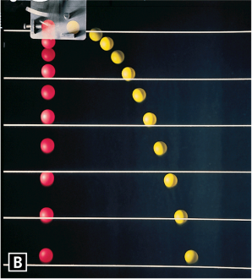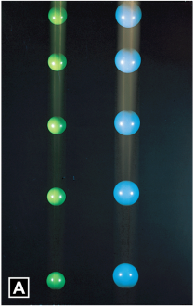Their ________________________________________ the blue and green balls ________________________________________.
2. The yellow ball is ________________________________________ __________________________________________________.

**Assessment Questions**

1. If an object is at rest, which of the following statements must be true?
   1. There are no forces acting on the object.
   2. There is no friction acting on the object.
   3. The forces acting on the object are unbalanced.
   4. The net force acting on the object is zero.

ANS: __________

1. Which of the following is not a type of friction?
   1. static friction
   2. sliding friction
   3. fluid friction
   4. pull friction

ANS: __________

1. In which direction does Earth’s gravitational force act?
   1. opposite the direction of motion
   2. downward toward the center of Earth
   3. upward away from the center of Earth
   4. in the direction of motion

ANS: __________

1. A ball thrown into the air follows a projectile course due to the initial velocity and the
   1. force of gravity.
   2. effect of air resistance.
   3. motion of Earth beneath it.
   4. mass of the ball.

ANS: __________

1. The SI unit for force is 1 kg•m/s2, also called one kepler.   
   True  
   False

ANS: ______________________________

**Section 12.2 Newton's First and Second Laws of Motion**

Galileo’s work helped correct misconceptions about force and motion that had been widely held since Aristotle’s time.

**Aristotle, Galileo, and Newton**

It took about ______________________________________________________________________ ________________________________________________________________________________.

**Aristotle**

Aristotle made scientific discoveries through __________________________________________________ __________________________________________________.

Aristotle incorrectly proposed that __________________________________________________________.

**Galileo**

Galileo Galilei studied ___________________________________________________________________.

* + He rolled balls down wooden ramps.
  + He concluded that ____________________________________________________________ ________________________________________________________________________________.

**Newton**

Newton built on the work of scientists such as Galileo.

* + Newton ______________________________________________________________________.
  + He then introduced his __________________________________________________.

Isaac Newton published his work on force and motion in the book entitled ____________________*.*

**Newton's First Law of Motion**

**How does Newton’s first law relate change in motion to a zero net force?**

Answer: ___________________________________________________________________________ ________________________________________________________________________________.

Unless an unbalanced force acts, ___________________________________________________________.

Unless an unbalanced force acts, ___________________________________________________________ ________________________________________________________________________________.

**Inertia** is ______________________________________________________________________________.

This crash sequence illustrates inertia. The test dummy continues its forward motion as the car slows and stops.

**Newton's Second Law of Motion**

**How does Newton’s second law relate force, mass, and acceleration?**

Answer: __________________________________________________________________________ ________________________________________________________________________________.

The acceleration of an object is ____________________________________________________________.

The acceleration of an object also depends upon its mass.

**Mass** is a measure of the inertia of an object.

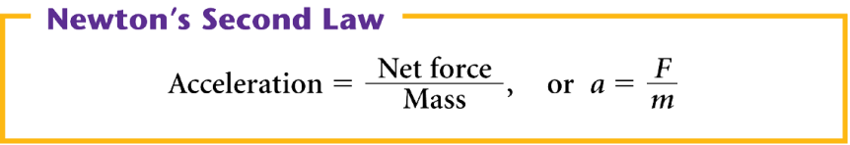

The acceleration of an object is always in the same direction as the net force.

When a net force acts in the direction opposite to the object’s motion, the force produces a deceleration.

**Newton’s Second Law**

An automobile with a mass of 1000 kilograms accelerates when the traffic light turns green. If the net force on the car is 4000 newtons, what is the car’s acceleration?

**Read and Understand**

*What information are you given?*

**Plan and Solve**

*What unknown are you trying to calculate?*

*What formula contains the given quantities and the unknown?*

**Plan and Solve**

*Replace each variable with its known value and solve.*

**Look Back and Check**

*Is your answer reasonable?*

**Math Practice**

**1.** A boy pushes forward a cart of groceries with a total mass of 40.0 kg. What is the acceleration of the cart if the net force on the cart is 60.0 N?

Answer: ______________________________________________________________________

**2.** What is the upward acceleration of a helicopter with a mass of 5000 kg if a force of 10,000 N acts on it in an upward direction?

Answer: ______________________________________________________________________

**3.** An automobile with a mass of 1200 kg accelerates at a rate of 3.0 m/s2 in the forward direction. What is the net force acting on the automobile? (*Hint:* Solve the acceleration formula for force.)

Answer: _______________________________________________________________________

**4.** A 25-N force accelerates a boy in a wheelchair at 0.5 m/s2. What is the mass of the boy and the wheelchair? (*Hint:* Solve Newton’s second law for mass.)

Answer: ____________________________________________________________

____________________________________________________________

Acceleration depends ____________________________________________________________. The same force causes the single cart to accelerate eight times faster than the chain of eight carts.

**Weight and Mass**

**How are weight and mass related?**

Answer: ____________________________________________________________________________ ________________________________________________________________________________.

Mass and weight are _____________________________________________________________________.

* + Mass is ______________________________________________________________________.
  + **Weight** is ____________________________________________________________________.
  + Weight is _____________________________________________________________________.

____________________is a different form of Newton’s Second Law, __________________________*.*

The ________________________________________________________________________________.

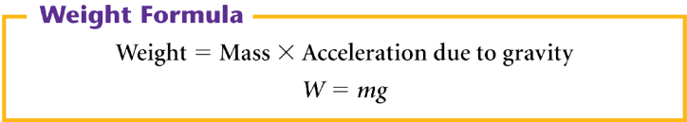

If an astronaut has a mass of 112 kilograms, what is his weight on Earth where the acceleration due to gravity is 9.8 m/s2?

Weight = Mass × Acceleration due to gravity

= ________________________________________

= ________________________________________

On the moon, the acceleration due to gravity is ________________________________________________.

* + The astronaut weighs only about one sixth as much on the moon as on Earth.
  + The __________ of the astronaut ____________________ on the moon and on Earth.

Astronaut on Earth Astronaut on Moon  
Mass = 88.0 kg, Weight = 863 N Mass = 88.0 kg, Weight = 141 N

**Assessment Questions**

1. What is inertia?
   1. the force of gravity acting on an object
   2. forces of friction slowing an object’s motion
   3. the mass of an object
   4. the tendency of an object to resist change in its motion

ANS: __________

1. A 3600-N force causes a car to accelerate at a rate of 4 m/s2. What is the mass of the car?
   1. 600 kg
   2. 900 kg
   3. 14,400 kg
   4. 1200 kg

ANS: __________

1. How would your mass and weight change if you were on the moon’s surface?
   1. They wouldn’t change.
   2. Your mass would remain constant, and your weight would increase.
   3. Your mass and weight would decrease.
   4. Your mass would remain constant, and your weight would decrease.

ANS: __________

**Section 12.3 Newton's Third Law of Motion and Momentum**

When this bumper car collides with another car, two forces are exerted. Each car in the collision exerts a force on the other.

**Newton's Third Law**

**What is Newton’s third law of motion?**

Answer: ________________________________________________________________________ ________________________________________________________________________________.

**Action and Reaction Forces**

* The force your bumper car exerts on the other car is ______________________________.
* The force the other car exerts on your car is ________________________________________.
* These two forces are ____________________________________________________________.

Suppose you press your hand against a wall.

* + Your __________________________________________________ on the wall.
  + The ____________________________________________________________ against your hand.

**Action-Reaction Forces and Motion**

A ______________________________________________________________________ is an action force.

The ____________________________________________________________________ through the water.

__________________________________________________ propel the swimmer through the water. The swimmer pushes against the water, and the water pushes the swimmer.

**Action-Reaction Forces Do Not Cancel**

For the swimmer, why do the action and reaction forces not cancel each other and produce a net force of zero?

______________________________________________________________________________________.

**Momentum**

**What is needed for an object to have a large momentum?**

**Momentum** is ______________________________________________________________________.

Answer: ___________________________________________________________________________ ____________________________________________________________.

An object with large momentum is harder to stop than an object with small momentum.

The momentum for ____________________________________________________________.

____________________ is measured ________________________________________.

____________________ is measured in ________________________________________.

______________________________ is measured ________________________________________.



Which has more momentum, a 0.046-kilogram golf ball with a speed of 60.0 meters per second, or a 7.0-kilogram bowling ball with a speed of 6.0 meters per second?

Momentumgolf ball = ______________________________________________________________________

Momentumbowling ball = ____________________________________________________________________

______________________________________________________________________________________.

**Conservation of Momentum**

**How is momentum conserved?**

A closed system means ___________________________________________________________________.

Answer: ___________________________________________________________________________ ________________________________________________________________________________.

Objects within a closed system ____________________________________________________________.

According to the **law of conservation of momentum,** ________________________________________ ________________________________________________________________________________

In each collision, the total momentum of the train cars does not change—momentum is conserved.

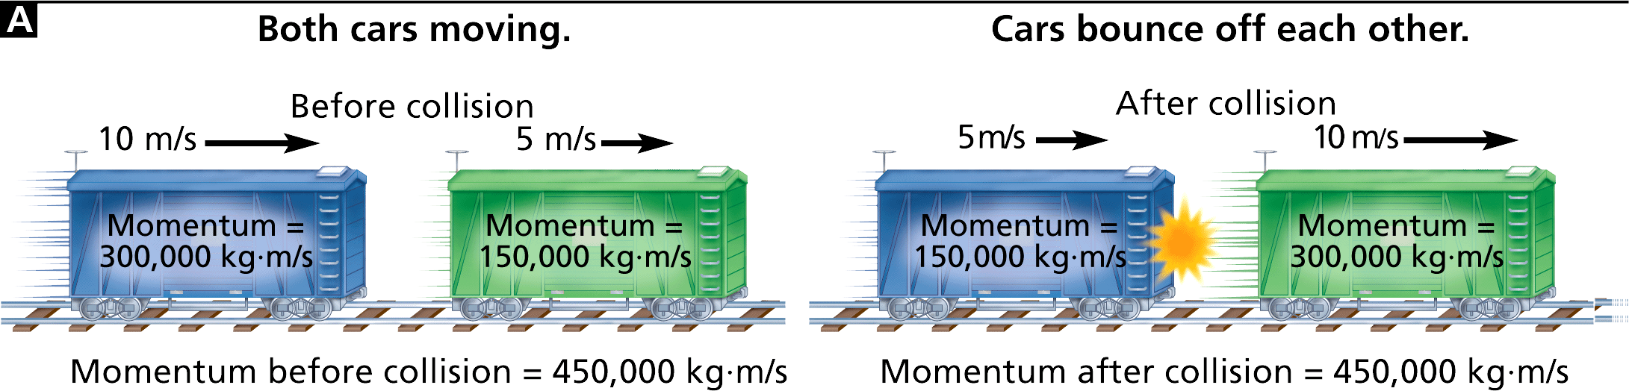

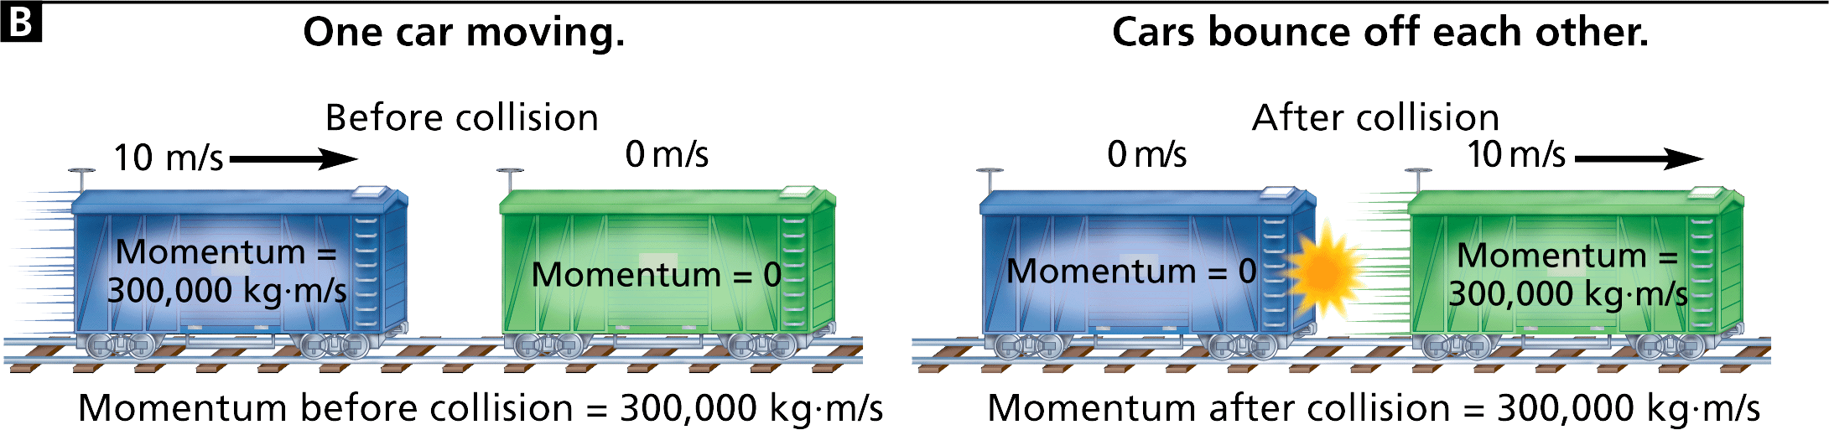

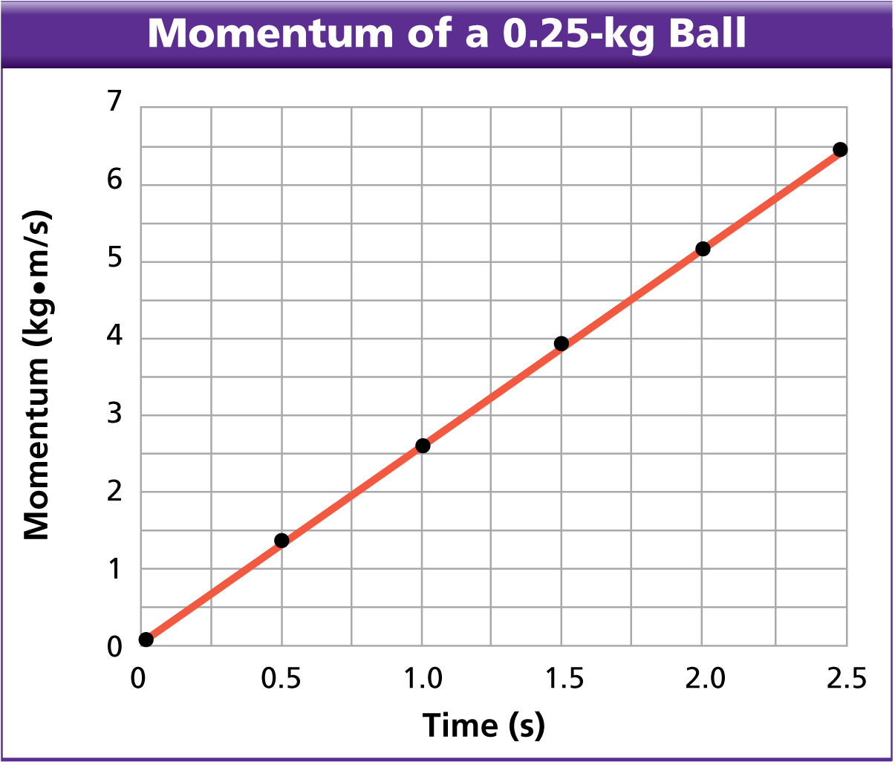 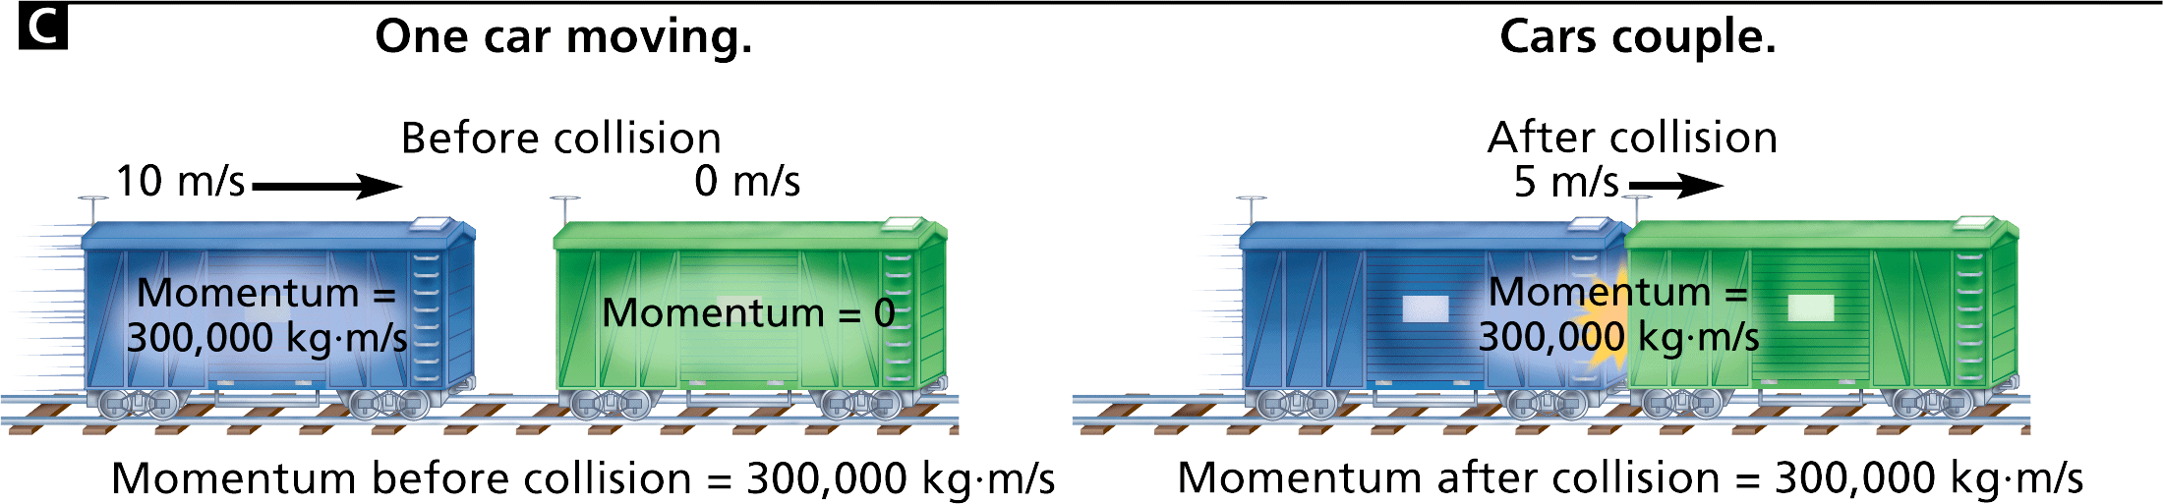

A class studied the speed and momentum of a 0.25-kilogram ball dropped from a bridge. The graph shows the momentum of the ball from the time it was dropped until the time it hit the river flowing below the bridge.

1. **Applying Concepts** At what time did the   
   ball have zero momentum? Describe this point in the ball’s motion.
2. **Using Graphs** At what time did the ball have the greatest momentum? What was the peak momentum value?
3. **Calculating** What is the ball’s speed after 1.25 seconds?   
   (*Hint:* Use the graph and the momentum formula.)

**Assessment Questions**

1. A stationary figure skater pushes off the boards around an ice skating rink and begins gliding backward, away from the boards. Which law explains why the figure skater moves backward?
   1. the law of conservation of energy
   2. the law of inertia
   3. Newton’s second law
   4. Newton’s third law

ANS: __________

1. A red puck with Velcro on its side is sliding toward a stationary blue Velcro puck of the same mass. The pucks will stick together upon contact. After contact, how will the red puck’s velocity compare to its initial velocity? (In this collision the law of conservation of momentum is obeyed, and friction is ignored.)
   1. The red puck’s velocity is the same as before.
   2. The red puck’s velocity is the same magnitude but in the opposite direction.
   3. The red puck’s velocity is half its initial velocity and in the same direction.
   4. The red puck’s velocity is double its initial velocity and in the opposite direction.

ANS: __________

**Section 12.4 Universal Forces**

An artist’s depiction of a planet’s surface shows a world very different from Earth.

Certain universal forces are present.

Observations of planets, stars, and galaxies strongly suggest ______________________________________ exist throughout the universe.

* + __________________________________________________
  + __________________________________________________
  + __________________________________________________
  + __________________________________________________

Universal forces ______________________________________________________________________.

* + The particles ____________________________________________________________.
  + Force is ______________________________________________________________________.

**Electromagnetic Forces**

**What force can attract and repel?**

Answer: ______________________________________________________________________ ____________________________________________________________.

________________________________________ are two different aspects of the electromagnetic force.

**Electromagnetic force** is ____________________________________________________________.

**Electric Forces**

Electric forces ______________________________________________________________________.

* + Objects with __________________________________________________ one another.
  + Objects with __________________________________________________ one another.

Clothes often acquire electric charges in the dryer.

Clothes with __________________________________________________ together.

**Magnetic Forces**

Magnetic forces act on

* + ____________________________________________________________,
  + ____________________________________________________________
  + ____________________________________________________________.

Magnets have ____________________________________________________________.

* + Two poles that are __________________________________________________ each other.
  + Two poles that are __________________________________________________ each other.

A magnetic force of attraction holds the two train cars together.

**Nuclear Forces**

**What force holds the nucleus together?**

Answer: ______________________________________________________________________ ________________________________________________________________________________

The ________________________________________________________________________________ ______________________________ that acts among the protons in the nucleus.

The _________________________ is involved in _____________________________________________.

**Strong Nuclear Force**

The **strong nuclear force** is a ____________________________________________________________ ________________________________________________________________________________.

* + It ___________________________—approximately the __________________________ (10–15 m).
  + It is __________________________________________________ of repulsion at these distances.

**Weak Nuclear Force**

The **weak nuclear force** is ____________________________________________________________.

The weak nuclear force _____________________________, less than the range of the strong nuclear force.

**Gravitational Forces**

**What is Newton’s law of universal gravitation?**

Answer: ______________________________________________________________________ __________________________________________________.

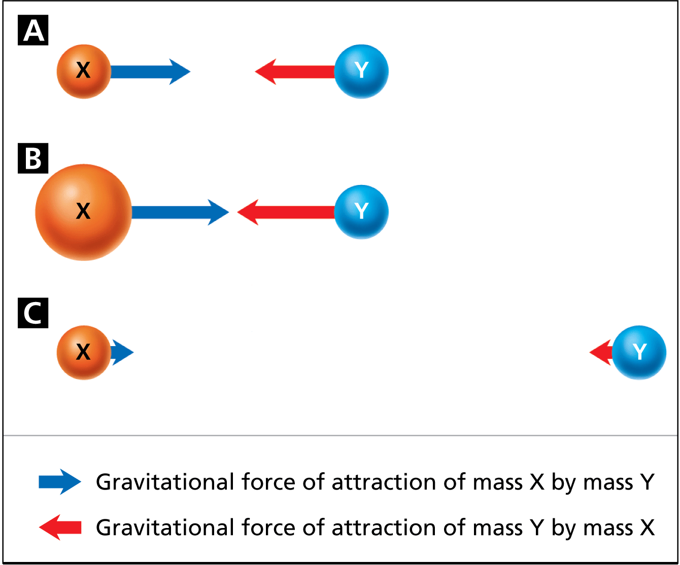**Gravitational force** is ________________________________________ ____________________________________________________________.   
Gravitational force ________________________________________.

**Gravity Acts Over Long Distances**

The gravitational force between two objects is ____________________ ________________________________________.

Gravitational force ____________________________________________ ________________________________________ between the objects.

Gravity is ______________________________, but it is the _____________________________________ ____________________________________________________________.

**The Earth, Moon, and Tides**

The ______________________________________________________________________ from Earth.

Earth’s ________________________________________________________________________________ ________________________________________ around Earth.

A **centripetal force** is ____________________________________________________________________ ________________________________________________________________________________.

The moon’s inertia and the gravitational pull of Earth result in ____________________________________.

The gravitational pull from the moon ________________________________________–one on the ______ ______________________________, the other on the ________________________________________.

As Earth rotates once per day beneath these two bulges, ________________________________________ ________________________________________________________________________________.

**Satellites in Orbit**

An artificial satellite _____________________________________________________________________ ______________________________________________________________________.

Satellites in a low orbit are ________________________________________________________________ ____________________________________________________________ Earth’s atmosphere.

**Uses of Satellites**

Hundreds of artificial satellites orbit for many functions:

* + monitoring Earth’s ______________________________
  + creating ________________________________________ of Earth’s surface
  + using telescopes to ______________________________
  + studying ______________________________
  + receiving and transmitting ________________________________________

Satellites are used to receive and transmit electromagnetic waves over great distances.

**Assessment Questions**

1. What are the only forces that can both attract and repel?
   1. electromagnetic forces
   2. centripetal forces
   3. strong nuclear forces
   4. gravitational forces

ANS: __________

1. The nucleus of an atom is held together primarily by the
   1. strong force and weak force.
   2. strong force and gravity.
   3. weak force and electromagnetic force.
   4. electromagnetic force and strong force.

ANS: __________

1. Which of the following statements about gravitational forces is false?
   1. They are the weakest universal forces.
   2. They act between any two objects.
   3. They become stronger as the distance between two objects increases.
   4. They become weaker as the mass of either two objects decreases.

ANS: __________

1. A center-directed force that continuously changes the direction of an object’s motion, making it move in a circle, is called the radial force.  
     
   True  
   False

ANS: ______________________________