Physical Science
Chapter 14 Work, Power, and Machines

Section 14.1 Work and Power
The weight lifter applies a large force to hold the barbell over his head.
Because the barbell is motionless, ____________________ is done on the barbell.
What is Work?
When does a force do work?
Answer: ___________________________________________________________________________.
For a force ____________________ on an object, ______________________________________________ ____________________ as the object moves. _________________________________________________.
Any part of a force that does not act in the direction of motion does no work on an object.
Work is done when ______________________________________________________________________ ____________________. Work is done when the weightlifter exerts an upward force to raise the barbell.
Work Requires Motion
The weight lifter does no work on the barbell as he holds it over his head. The ________________________ ______________________________________________________________________.
Work Depends on Direction
- If all of the force acts in the same direction as the motion, _________________________________.
- If part of the applied force acts in the direction of motion, _________________________________.
- If none of the force is applied in the direction of the motion, _______________________________.
- All of the force does work on the suitcase.
- The horizontal part of the force does work.
- The force does no work on the suitcase.

Calculating Work

Units of Work
When using SI units in the work formula, the ___________________________, and __________________.
The joule (J) is the ________________________. A joule is equal to ______________________________.
Using the Work Formula
A weight lifter raises a 1600-newton barbell to a height of 2.0 meters.
  - Work = Force × Distance
  - Work = __________________________________________________
  - Work = __________________________________________________

What is Power?
How are work and power related?
Answer: ______________________________________________________________________.
Doing work at __________________________________________________. To increase power, you can ____________________________________________________________, or you can ________________ __________________________________________________.
Work is required to move snow from one location to another. A person using a shovel and a person using a snow blower can both do the work needed to remove the snow.
The snow blower can ____________________________________________________________________.
Because the snow blower can remove more snow in less time, it ___________________________________ than hand shoveling does.

Calculating Power

When using SI units in the power formula, ________________________________________ (J), and ________________________________________ (s).
The ________________________________________ (W), which is equal to ____________________ ______________________________.
Math Skills
You exert a vertical force of 72 newtons to lift a box to a height of 1.0 meter in a time of 2.0 seconds. How much power is used to lift the box?
Read and Understand
What information are you given?
Force = ____________________ Distance = ____________________ Time = __________________
Plan and Solve
What formula contains the given quantities and the unknown?

Plan and Solve
Replace each variable with its known value and solve.

Look Back and Check
Is your answer reasonable?

Math Practice
1. Your family is moving to a new apartment. While lifting a box 1.5 m straight up to put it on a truck, you exert an upward force of 200 N for 1.0 s. How much power is required to do this?
Answer:

2. You lift a book from the floor to a bookshelf 1.0 m above the ground. How much power is used if the upward force is 15.0 N and you do the work in 2.0 s?
Answer:

3. You apply a horizontal force of 10.0 N to pull a wheeled suitcase at a constant speed of 0.5 m/s across flat ground. How much power is used? (Hint: The suitcase moves 0.5 m/s. Consider how much work the force does each second and how work is related to power.)
Answer:

James Watt and Horsepower
Another ____________________________________________________________. One horsepower (hp) is ____________________________________________________________.
James Watt (1736-1819) was looking for __________________________________________________ ________________________________________ he had designed. Horses were a logical choice for comparison as they were the most commonly used source of power in the 1700s.
The horse-drawn plow and the gasoline-powered engine are both capable of doing work at a rate of __________________________________________________.
Assessment Questions
- In which of the following cases is work being done on an object?
  - pushing against a locked door
  - suspending a heavy weight with a strong chain
  - pulling a trailer up a hill
  - carrying a box down a corridor
ANS: ____________________
- A tractor exerts a force of 20,000 newtons to move a trailer 8 meters. How much work was done on the trailer?
  - 2,500 J
  - 4,000 J
  - 20,000 J
  - 160,000 J
ANS: ____________________
- A car exerts a force of 500 newtons to pull a boat 100 meters in 10 seconds. How much power does the car use?
  - 5000 W
  - 6000 W
  - 50 W
  - 1000 W
ANS: ____________________
- One horsepower is a unit of power equal to
  - 0.746 W.
  - 1.0 W.
  - 746 W.
  - 2,000 W.
ANS: ____________________

Section 14.2 Work and Machines
All cars come equipped with simple machines designed to make changing a tire a fairly easy task.
Machines Do Work
How do machines make work easier?
A machine is ___________________________________________________________________________.
Answer: ____________________________________________________________________________ __________________________________________________________________________________________________________________________________________________________________________.
Increasing Force
Turning the jack handle allows the man to raise the car.
Each complete rotation of a jack handle applies a small force over a large distance.
  - A small force exerted over a large distance becomes ______________________________________ __________________________________________________.
  - Each rotation lifts the car only __________________________________________________.
Increasing Distance
A rower pulls an oar through ______________________________. The end of the oar in the water moves through ________________________________________. The increased travel of the oar through the water requires the rower to exert a greater force.
A machine that ________________________________________through which you exert a __________ ____________________________________________________________
Changing Direction
Some machines change the direction of the applied force. Pulling back on the handle of the oar causes its other end to move in the opposite direction.
Machines can __________________________________________________________________________ ________________________________________________________________________________.
Work Input and Work Output
How are work input and work output related for a machine?
Answer: ___________________________________________________________________________ __________________________________________________
The oars of the boat ______________________________ that increase the distance over which the force acts.
Work Input to a Machine
- The _________________________________ is the input force.
- The distance the input force acts through is the _______________________.
- The work input equals ____________________________________________________________.
For an oar, the input force is the force exerted on the handle, and the input distance is the distance the handle moves.
The work input is ____________________________________________________________.
Work Output of a Machine
- The ________________________________________ is called the output force.
- The distance the output force is exerted through is the ______________________________.
- The work output of a machine is __________________________________________________ ________________________________________.
The output work of the oars results from the ________________________________________ so that the ____________________________________________________________.
Although nearly equal, the ____________________________________________________________. ______________________________ use some amount of input ______________________________.
The only way to increase the work output is to increase the amount of work you put into the machine. ____________________________________________________________________________________!
Assessment Questions
- What is the output distance of a machine that requires 2 newtons of force exerted over 6 meters and whose output force is 4 newtons?
  - 2 meters
  - 3 meters
  - 6 meters
  - 12 meters
ANS: ____________________
- The work output of a machine is always greater than the work input to the machine.
True
False
ANS: ________________________________________
Section 14.3 Mechanical Advantage and Efficiency
A nutcracker is a machine that converts the input force applied to it into a larger force capable of cracking a nut.
Because it increases force, the nutcracker has _________________________________________________.
Mechanical Advantage
How does the actual mechanical advantage of a machine compare to its ideal mechanical advantage?
The mechanical advantage of a machine is __________________________________________________.
Answer: ___________________________________________________________________________ ________________________________________________________________________________.
Actual Mechanical Advantage
The ________________________________________________________________________________ __________________________________________________ is the actual mechanical advantage.
The actual mechanical advantage (AMA) equals ____________________________________________.
A loading ramp is a machine used to move heavy items into a truck.
The mechanical advantage of a ramp with __________________________________________________ __________________________________________________.
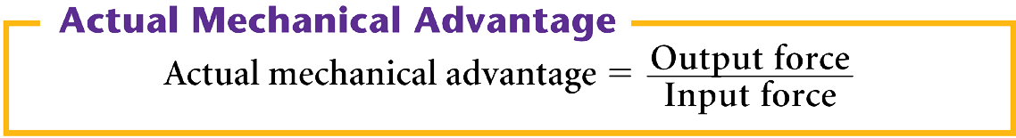

Ideal Mechanical Advantage
The ideal mechanical advantage (IMA) of a machine is ________________________________________ ________________________________________________________________________________.
Because friction reduces mechanical advantage, engineers often design machines that _________________ __________________________________________________.
Calculating Mechanical Advantage
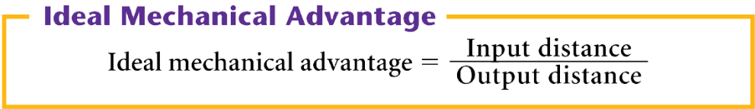

The cable supporting the gondola forms ______________________________________________________ ____________________. The inclined plane is used to move people up to the top of the mountain.
The gondola uses the inclined plane formed by its supporting cable to more easily move people uphill.
  - The increased horizontal distance ________________________________________ the vertical gain in height __________________________________________________
  - The inclined cable gives the gondola _______________________________________________.
Calculating IMA - Math Skills
A woman drives her car up onto wheel ramps to perform some repairs. If she drives a distance of 1.8 meters along the ramp to raise the car 0.3 meter, what is the ideal mechanical advantage (IMA) of the wheel ramps?
Read and Understand
What information are you given?

Plan and Solve
What unknown are you trying to calculate?

Plan and Solve
What formula contains the given quantities and the unknown?

Replace each variable with its known value and solve.

Look Back and Check
Is your answer reasonable?

Math Practice
1. A student working in a grocery store after school pushes several grocery carts together along a ramp. The ramp is 3 meters long and rises 0.5 meter. What is the ideal mechanical advantage of the ramp?
Answer: IMA = ____________________________________________________________
IMA = ____________________________________________________________
2. A construction worker moves a crowbar through a distance of 0.50 m to lift a load 0.05 m off of the ground. What is the IMA of the crowbar?
Answer: IMA = ____________________________________________________________
IMA = ____________________________________________________________
3. The IMA of a simple machine is 2.5. If the output distance of the machine is 1.0 m, what is the input distance?
Answer: Input distance = ____________________________________________________________
Input distance = ____________________________________________________________
Efficiency
Why is the efficiency of a machine always less than 100 percent?
The ________________________________________________________________________________ is the efficiency of a machine.
Answer: __________________________________________________________________________ ________________________________________________________________________________
Efficiency is usually expressed as a percentage.
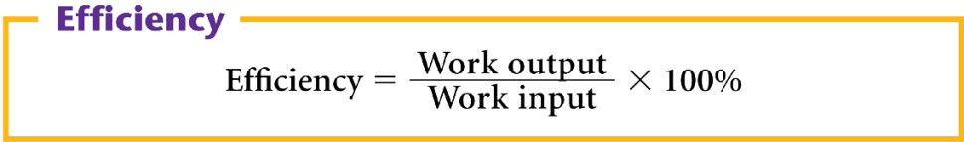

For example, if the efficiency of a machine is 75 percent, then you know that 75 percent of the work input becomes work output.
If a machine requires 10.0 J of work input to operate, then the work output is 75% of 10.0 J.
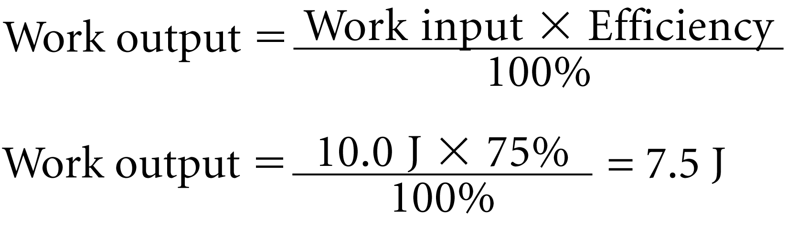

___________________________________________________________________________ of a machine.
Roller bearings reduce the friction of the rotating wheels because ______________________________ __________________________________________________.
To further reduce the rolling friction, the roller bearings are also ______________________________.
Engineers analyze the flow pattern of a smoke trail to determine the ______________________________ ______________________________ acting on the vehicle. Engineers use these data to optimize a vehicle's shape for maximum fuel efficiency.
Assessment Questions
- Which statement about the actual mechanical advantage of a machine is true?
  - The actual mechanical advantage is greater than one if the input force is greater than the output force.
  - The actual mechanical advantage of a machine is greater than its ideal mechanical advantage when the output force is greater than the input force.
  - The actual mechanical advantage of a machine is always less than its ideal mechanical advantage.
  - The actual mechanical advantage of a machine is never affected by friction.
ANS: ____________________
- If a lever raises a large rock 0.1 meters when the other end of the lever moves downward 2 meters, what is the ideal mechanical advantage of the lever?
  - 0.05
  - 0.5
  - 2
  - 20
ANS: ____________________
- A machine is used to accomplish 300 J of work. If the efficiency of the machine is 60 percent, what is the necessary work input?
  - 180 J
  - 360 J
  - 500 J
  - 750 J
ANS: ____________________
- The efficiency of any machine is less than 100% because of losses due to friction.
True
False
ANS: ________________________________________

Section 14.4 Simple Machines
The output of one device acts as the input of the next.
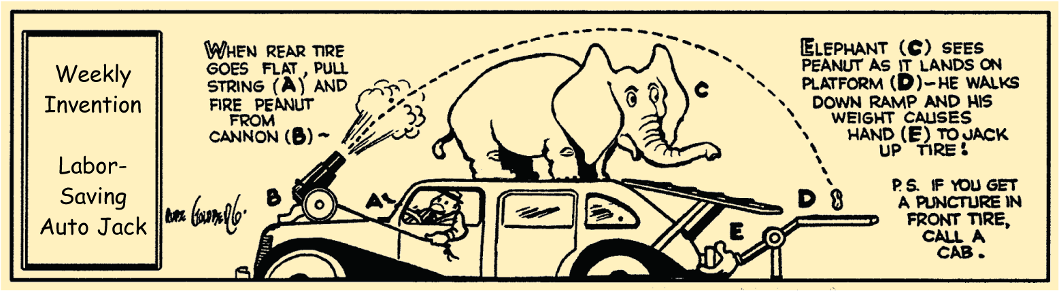
What are the six types of simple machines?
Answer: ______________________________________________________________________ ________________________________________________________________________________.
Levers
What determines the mechanical advantage of the six types of simple machines?
Answer: ______________________________________________________________________ ________________________________________________________________________________
A lever is ______________________________________________________________________ ________________________________________________________________________________.
The ____________________________________________________________ is the fulcrum.
The input arm of a lever is ____________________________________________________________ __________________________________________________.
The output arm is ______________________________________________________________________ ____________________________________________________________.
Levers are classified into __________________________________________________ on the locations of the input force, the output force, and the fulcrum.
First-Class Levers
The fulcrum of a first-class lever is _____________________________________ ____________________________________________________________.
Depending on the fulcrum position, the mechanical advantage can be __________ ____________________________________________________________.
The __________________________________________________ is being used as a first-class lever with a mechanical advantage greater than 1.
Second-Class Levers
- In a second-class lever, the ______________________________________ __________________________________________________.
- The input distance is ________________________________________.
- The mechanical advantage of a second-class lever is _________________ ____________________.
The ____________________________ has its output force located between the input force and the fulcrum.
Third-Class Levers
- The input force of a third-class lever ______________________________ __________________________________________________.
- The output distance over which the third-class lever exerts its force is ____________________________________________________________.
- The mechanical advantage of a third-class lever is _______________________________________.
The output distance of the __________________ is greater than the input distance the hands move through.
Wheel and Axle
To calculate the ideal mechanical advantage of the wheel and axle, ______________________________ (or diameter) ______________________________________________________________________ (or diameter) ______________________________________________________________________.
A wheel and axle is a simple machine that consists of ________________________________________ ________________________________________________________________________________.
The ________________________________________ and the ____________________________________ __________. The wheel and the axle __________________________________________________.
The input force can be exerted on the wheel or the axle.
  - If the force is applied to the wheel, __________________________________________________ than the output distance. The mechanical advantage ______________________________.
  - If the force is applied to the axle, __________________________________________________ than the input distance. The mechanical advantage is ________________________________________.
A wheel and axle is a type of simple machine consisting of two disks or cylinders with different radii.

Inclined Planes
The ideal mechanical advantage of an inclined plane is ________________________________________ ________________________________________________________________________________.
An inclined plane is _____________________________________________________________________ __________________________________________________.
  - The distance traveled is ________________________________________.
  - The change in ____________________ of the ramp ______________________________________.
  - The mechanical advantage of an inclined plane is ______________________________.
This ________________________________________ acts like an inclined plane.
Wedges and Screws
A ____________________of a given length __________________________________________________ ______________________________ than a thick wedge of the same length.
Screws with ______________________________________________________________________ ideal mechanical advantage.
Wedges
A wedge is a ______________________________________________________________________ ____________________________________________________________.
A wedge has a mechanical advantage ________________________________________.
The wedge consists of two inclined planes that slope toward each other. The inclined planes force the wood fibers apart as the wedge is driven into the log.
Screws
A screw is ____________________________________________________________.
For two screws of the same length, the one whose threads are closer together ____________________ ____________________________________________________________.
A screw has a mechanical advantage ________________________________________.
A screw is a simple machine made up of an inclined plane wrapped around a cylinder.
Pulleys
The ideal mechanical advantage of a pulley or pulley system is ____________________________________ ________________________________________ being lifted.
A pulley is a simple machine that consists of __________________________________________________.
  - Pulleys produce an ____________________________________________________________ ____________________________________________________________force.
  - The mechanical advantage of a pulley can be ________________________________________.
A pulley moves a large fabricated part through a factory.
Fixed Pulleys
A fixed pulley is __________________________________________________. The ____________________ of the exerted force ____________________by a fixed pulley, but the __________________________________________________.
The ideal mechanical advantage of a fixed pulley is ____________________.
A fixed pulley changes only the direction of the input force.
Movable Pulley
A movable pulley is ________________________________________ rather than to a fixed location.
  - ________________________________________ pull up with the same force.
  - The movable pulley has a ________________________________________.
Movable pulleys __________________________________________________ of the input force.
Pulley System
A large mechanical advantage can be achieved by ____________________ __________________________________________________into a pulley system.
  - The mechanical advantage ________________________________________ __________________________________________________.
  - The ideal mechanical advantage of a pulley system ____________________ _________________________________________________ being lifted.
Pulley systems are made up of both fixed and movable pulleys.

Pulley System Performance
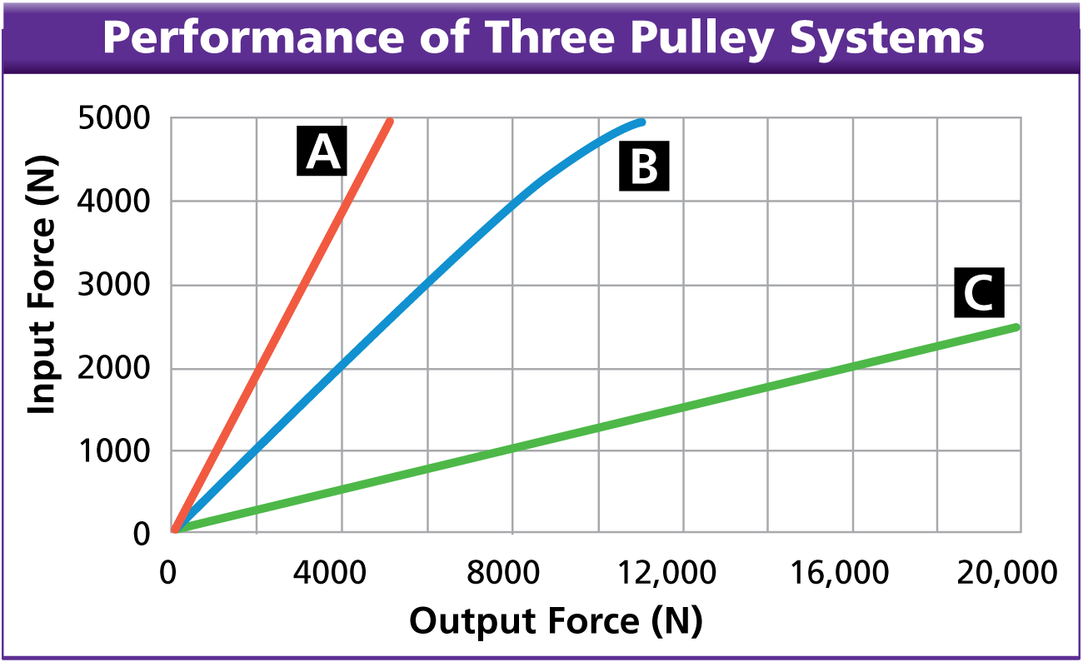
A shipyard has many different pulleys and pulley systems in use. The pulleys are used to move large, heavy, fabricated ship sections through the manufacturing process. During an annual safety and performance inspection of three of the company’s systems, a facility engineer collected the data shown in the graph. The data give the measured output forces for a range of given input forces.
- Using Graphs What system requires the smallest input force to lift a 2500-N load?
Answer:
- Calculating Determine the actual mechanical advantage for each of the systems for a 2000-N input force.
Answer:

- Applying Concepts Which of the three systems shown in the graph consists of a single fixed pulley? Explain how you know.
Answer:

- Inferring Describe what happens to system B’s output force as the input force increases above 4000 N. How does this affect the mechanical advantage of the system at higher loads? Offer a possible cause for the performance shown in the graph.
Answer:

- Applying Concepts Using the mechanical advantage value from Question 2, determine the output force of system A for an input force of 8000 N.
Answer:

Compound Machines
- A compound machine is ____________________________________________________________ ______________________________________. Most of the machines you use are compound machines.
- The edges of a pair of scissors are ______________________________. The blades and the handles together ________________________________________.
- Cars, washing machines, and clocks are __________________________________________________of simple machines.
This watch consists of a series of machines.
The ________________________________________________________________________________ machine in the series.
Assessment Questions
- A bar that is rotating about a fixed point is called a
  - fulcrum.
  - lever.
  - wedge.
  - compound machine.
ANS: ____________________
- A 3-meter-long ramp is used to lift a piano to a moving truck, which is 1 meter off the ground. What is the ideal mechanical advantage of the ramp?
  - 1
  - 2
  - 3
  - 33
ANS: ____________________
- A machine, such as a bicycle, that combines many simple machines is known as a complex machine.
True
False
ANS: ________________________________________

