Physical Science
Chapter 13 Forces in Fluids

Section 13.1 Fluid Pressure
Because the theater seat exerts a supporting force over a larger area, it is more comfortable than the bicycle seat.
Pressure
How is pressure calculated?
Answer: ___________________________________________________________________________.
Pressure is ____________________________________________________________________________.

  - The unit of force is ________________________________________.
  - The unit of area is ____________________________________________________________.
  - The ______________________________ is the pascal (Pa). A pascal is ___________________ __________________________________________________.
If the area of a box touching the ground is 1.5 square meters, and its weight is 2700 newtons, what pressure does the box exert on the ground?

Pressure in Fluids
How does water pressure change with depth?
Answer: ____________________________________________________________________________ ______________________________________________________________________________________.
A fluid is ______________________________________________________________________________.
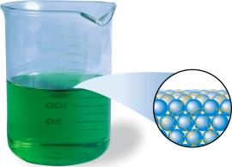
  - Both ________________________________________ are fluids.
  - __________________________________________________ are examples of fluids.
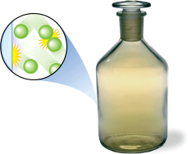
- Particles in a __________________________________________________ ________________________________________ past one another.
- Particles in a __________________________________________________ ________________________________________with another particle or object.
Water in a glass is in contact with the walls and bottom of the glass, and it __________ __________________________________________________.
For a fluid that is not moving, ________________________________________ are the two factors that ______________________________________________________________________.
Each vase holds a different amount of liquid. The liquid levels are all the same because ________________ ____________________________________________________________.
Planetary Atmospheres
The __________________________________________________ is known as its atmosphere. __________ ____________________in our solar system have ________________________________________. The ____________________________________________________________________ at the planet’s surface.

Exploring Boiling Points of Chlorocarbons
- Interpreting Tables Which planet listed in the table has the greatest atmospheric pressure?
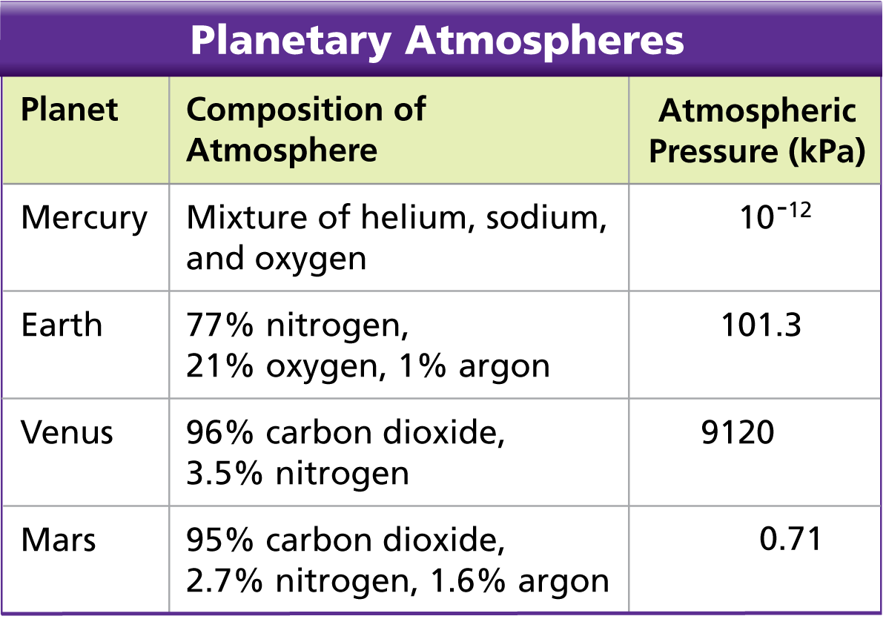
Answer: ________________________________________
- Interpreting Tables What chemical substance exists in all but one of the atmospheres?
Answer: ________________________________________
- Converting Units The bar is another unit of pressure (1 bar = 101.3 kPa). Convert each of the given pressures into bars.
Answer: ____________________________________________________________________________
- Using Formulas How much force is exerted on a 2.00-square-meter area of Venus’s surface?
Answer: Pressure = ______________________________;
Force = ________________________________________;
Force = ______________________________________________________________________
- Predicting On which planet would a balloon filled with a given quantity of helium have the smallest volume?
Answer: ____________________________________________________________________________ ________________________________________________________________________________.
Air Pressure and the Atmosphere
How does air pressure change with altitude?
Answer: ______________________________________________________________________.
Earth’s atmosphere exerts pressure of about 101 kPa at sea level. Why aren't you crushed by air pressure?
________________________________________________________________________________ ________________________________________________________________________________.
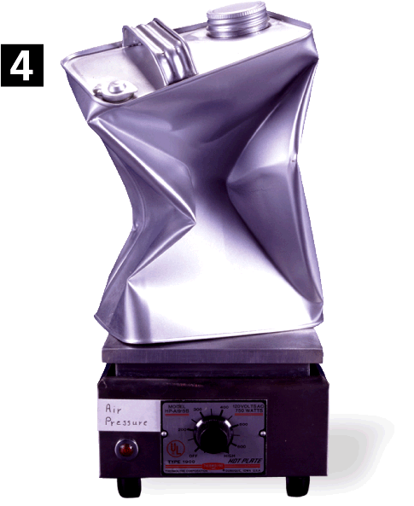
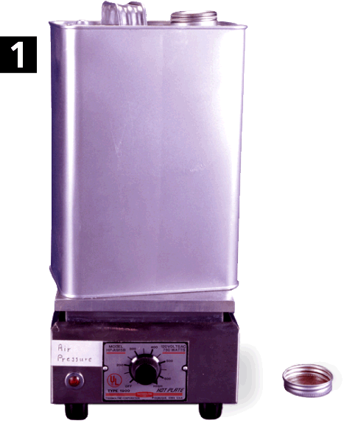
A can containing a small amount of water is heated until the water boils. Then the can is capped. As the can cools, the pressure inside the can becomes less than the pressure outside the can. ____________________ ________________________________________.

Assessment Questions:
- A gymnast standing on one hand (area 0.02 m2) pushes down on the ground with a force of 600 N. How much pressure does the gymnast exert on the ground?
  - 3000 Pa
  - 30,000 Pa
  - 12 Pa
  - 1200 Pa
ANS: __________
- The SI unit for pressure, equal to 1 N/m2, is called the
  - atmosphere.
  - foot-pound.
  - pascal.
  - watt.
ANS: __________
- The pressure exerted by a stationary fluid is determined by
  - the area of surface containing the fluid and the type of fluid.
  - the weight and volume of the fluid.
  - the type of fluid and its depth.
  - the shape of the container and the weight of the fluid.
ANS: __________
- Which of the following statements about fluid pressure is false?
  - Pressure increases as depth increases.
  - The pressure at a given depth is constant.
  - The pressure in a fluid is exerted downward.
  - Liquids and gases exert pressure.
ANS: __________
- Why do mountain climbers on very high peaks need cylinders of oxygen as they approach the summit?
  - The tops of the mountains extend out of the atmosphere.
  - The pressure of air decreases as altitude increases.
  - Air on the mountaintops is too cold to breathe.
  - Air pressure at high altitudes is too great for normal breathing.
ANS: __________

Section 13.2 Forces and Pressure in Fluids
The fast-moving stream of air from the blow dryer creates a column of low-pressure air.
The table tennis ball is suspended in an area of low pressure.
Transmitting Pressure in a Fluid
How does Pascal’s principle describe the transmission of pressure through a fluid?
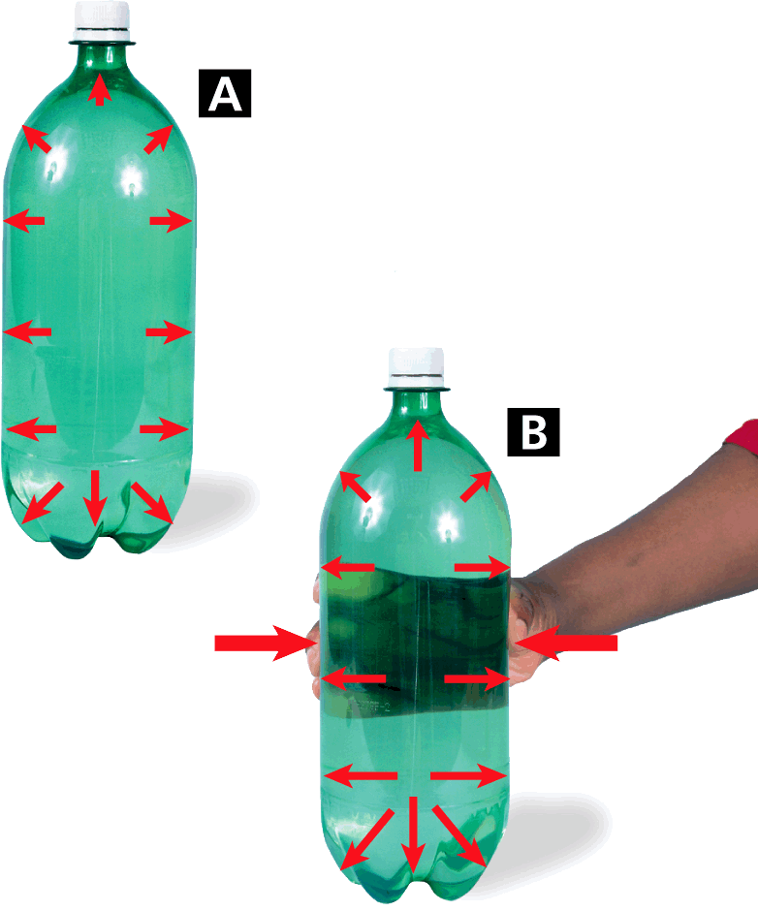
Answer: _________________________________________________________________________ _______________________________________________________________________________.
Pascal’s Principle
- The forces exerted against the walls of the container are __________ ________________________________________.
- When squeezed, the ________________________________________ __________________________________________________.
At any given depth, equal pressures act against all points on the inside of the bottle.
When the bottle is squeezed, the ____________________________________________. The pressure ____________________________________________________________.
Hydraulic Systems
How does a hydraulic system work?
A hydraulic system is ____________________________________________________________ ________________________________________________________________________________.
Answer: ______________________________________________________________________ ________________________________________________________________________________.
The truck uses ____________________________________________________________. The ________ ________________________________________ produces the ______________________________.
When an input force is applied to the small piston in a hydraulic system, the piston pushes against the fluid sealed in the system.
  - The pressure produced by the small piston is ________________________________________ ____________________________________________________________.
  - Because the output pressure ______________________________________________________.
Bernoulli's Principle
How is the speed of a fluid related to the pressure within the fluid?
Answer: ______________________________________________________________________ ________________________________________________________________________________.
Try this simple experiment.
  - Hold a sheet of paper by its top corners.
  - Position the paper directly in front of your mouth.
  - Blow over the top surface of the paper.
  - The far end of the paper lifts upward.
As the air blows across the top of the paper, __________________________________________________.
  - The motionless ________________________________________________________________.
  - The _________________________________________________________________________.

Wings and Lift
Bernoulli’s principle _____________________________________________________________________.
  - Air traveling over the ___________________________________________________________ __________________________________________________.
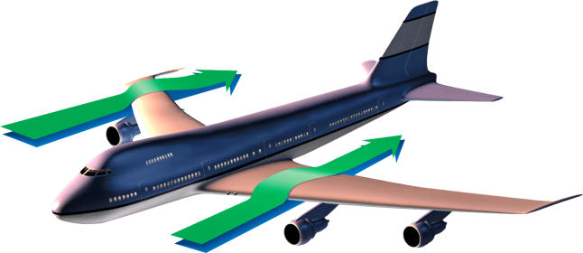
  - The pressure difference between the top and the bottom of the wing ____________________ ____________________________________________________________.
Air flowing over the top of the wing is __________________________________ __________________________________________________.
The wings of ________________________________________ way as an airplane wing. Unlike airplane wings, birds can ________ ____________________________________________________________.
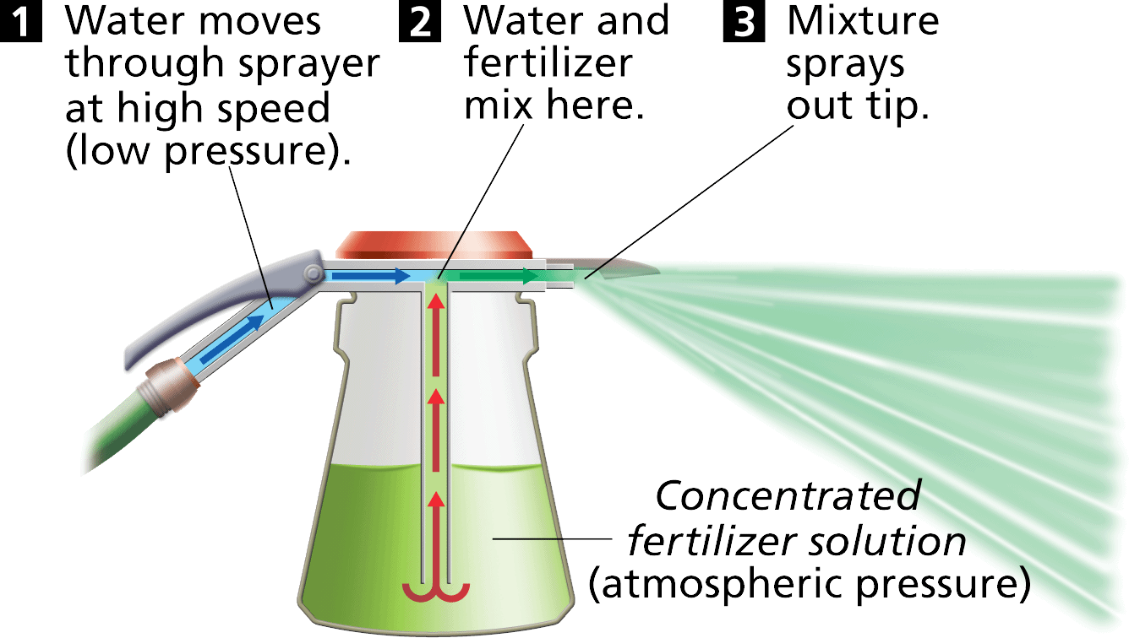
The __________________________________________________ on a race car ____________________ _______________________________________________.
Spray Bottles
Pressure differences between the solution chamber and the moving stream of water ______________________________ _________________________________________________.

Assessment Questions:
- A water balloon can explode if squeezed tightly between two hands. Just prior to exploding, at what point of the balloon is the pressure exerted by the water greatest?
  - It’s greatest at the top of the balloon (point furthest from the ground).
  - It’s greatest at the bottom of the balloon (point nearest the ground).
  - It’s greatest at the points of contact between the balloon and the two hands.
  - The pressure exerted by the water is the same at all points of the balloon.
ANS: __________
- A 5-N input force of a hydraulic system corresponds to a 40-N output force. If the area of the small piston is 11 cm2, what is the area of the large piston?
  - 8 cm
  - 255 cm
  - 288 cm
  - 2200 cm²
ANS: __________
- According to Bernoulli’s principle, as the speed of a moving fluid increases, the pressure within the fluid increases.
True
False
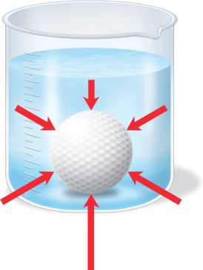
ANS: ________________________________________
Section 13.3 Buoyancy
The forces from pressure acting on ________________________________________ ______________________________________________________________________.
This produces a net force—________________________________________—that acts upward on the ball.
Buoyant Force
What is the effect of buoyancy on the apparent weight of an object?
Buoyancy is ______________________________________________________________________.
Answer: ______________________________________________________________________.
__________________________________________________ experiences buoyancy.
  - Water ____________________________________________________________.
  - ___________________________________ on the bottom of the object ____________________ ____________________from pressure ______________________________on the top.
  - This __________________________________________________, is called the buoyant force.
Archeimedes’ Principle
According to Archimedes’ principle, __________________________________________________ ________________________________________________________________________________.
  - A submerged object ____________________________________________________________ __________________________________________________.
  - A floating object displaces _______________________________________________________
Density and Buoyancy
How can you determine if an object will float or sink in a fluid?
Answer: __________________________________________________________________________ ________________________________________________________________________________.
________________________________________________________________________________ ________________________________________________________________________________.
Two forces act on every object in a fluid—__________________________________________________.
  - The ______________________________________________________________ on the object.
  - The ______________________________________________________________________ ____________________________________________________________ on the object.
Suspended
An ____________________________________________________________ as the fluid it is submerged in ______________________________________________________________________ in the fluid.
  - The ______________________________ acting on the suspended object exactly __________ __________________________________________________.
  - Submarines and some fish are able to ______________________________ in water partly ____________________________________________________________.
Sinking
When a ship’s ______________________________________________________________________.
As a sinking ________________________________________, the ship displaces less water, and ______________________________________________________________________.
Floating
A solid piece of steel sinks in water. A heavy steel ship floats because of the shape of its hull.
The hull is shaped so that it displaces a large volume of water, creating a large buoyant force.
The ______________________________________________________________________.

Objects also float more easily in dense fluids.
  - The ______________________________ is, the ______________________________________. The greater displaced weight results in a ________________________________________.
  - This is why it is ____________________________________________________________. The dense salty water produces a larger buoyant force when displaced by the person's body.
The exposed green and red stripes on the ship’s hull indicate that the ship is riding high in the water. If the cargo ship were completely loaded, it would need to displace more water in order to float.
Assessment Questions:
- According to Archimedes’ principle, the buoyant force acting on an object is equal to
  - the weight of the object.
  - the pressure exerted by the fluid at the point of contact with the object.
  - the pressure exerted at the bottom of the fluid.
  - the weight of the fluid displaced by the object.
ANS: __________
- How much fluid is displaced by an object that is floating, partially submerged, in a fluid?
  - a volume of fluid equal to the volume of the object
  - a volume of fluid equal to the volume of the submerged part of the object
  - a mass of fluid equal to the mass of the object
  - a mass of fluid equal to the mass of the submerged part of the object
ANS: __________
- An unknown substance is suspended in water. What can be concluded about the substance’s density?
  - The substance’s density is greater than water’s density.
  - The substance’s density is less than water’s density.
  - The substance’s density is equal to water’s density.
  - Nothing can be concluded about the substance’s density.
ANS: __________

- A 10,000-N ship is floating in the Great Salt Lake, whose salty water is denser than pure water. What is the buoyant force acting on the ship?
  - 1000 N
  - 8000 N
  - 10,000 N
  - 12,000 N
ANS: __________

