Make Some Graphs!
Use the data from problems we have done in class to make some graphs! After you read the experiment & variables (if provided or figure them out!), decide which type of graph to use, and then make the graph. Be sure to label your graph.

HOW TO CHOOSE WHICH TYPE OF GRAPH TO USE? When to Use . . .
. . . a Line graph. Line graphs are used to track changes over short and long periods of time. When smaller changes exist, line graphs are better to use than bar graphs. Line graphs can also be used to compare changes over the same period of time for more than one group.
. . . a Pie Chart. Pie charts are best to use when you are trying to compare parts of a whole. They do not show changes over time.
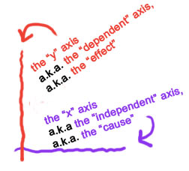
. . . a Bar Graph. Bar graphs are used to compare things between different groups or to track changes over time. However, when trying to measure change over time, bar graphs are best when the changes are larger.
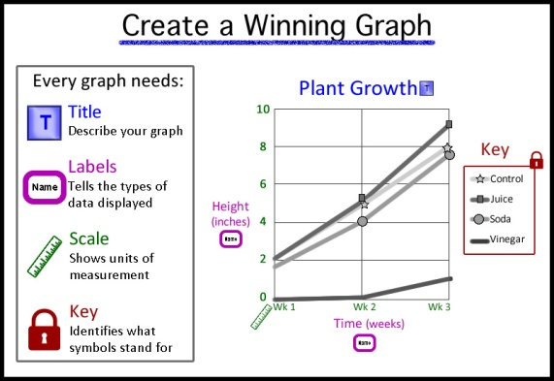

Labeling Your Graph: Be sure to include: title, units, legend, label both x & y axis’s

Squidward’s Symphony
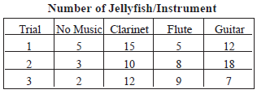
Squidward’s Symphony Squidward loves playing his clarinet and believes it attracts more jellyfish than any other instrument he has played. In order to test his hypothesis, Squidward played a song on his clarinet for a total of 5 minutes and counted the number of jellyfish he saw in his front yard. He played the song a total of 3 times on his clarinet and repeated the experiment using a flute and a guitar. He also recorded the number of jellyfish he observed when he was not playing an instrument. The results are shown in the chart.
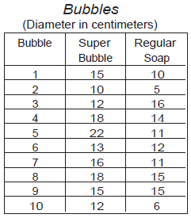
What is the independent variable? Instrument
What is the dependent variable? Number of jellyfish

Super Bubbles
Super Bubbles Patrick and SpongeBob love to blow bubbles! Patrick found some Super Bubble Soap at Sail-Mart. The ads claim that Super Bubble Soap will produce bubbles that are twice as big as bubbles made with regular bubble soap. Patrick and SpongeBob made up two samples of bubble solution. One sample was made with 5 oz. of Super Bubble Soap and 5 oz. of water, while the other was made with the same amount of water and 5 oz. of regular bubble soap. Patrick and SpongeBob used their favorite bubble wands to blow 10 different bubbles and did their best to measure the diameter of each one. The results are shown in the chart

What is the independent variable? Type of bubble solution
What is the dependent variable? Size (diameter) of the bubble

Marshmallow Muscles
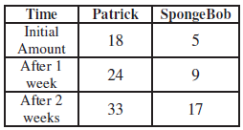
Larry was told that a certain muscle cream was the newest best thing on the market and claims to double a person’s muscle power when used as part of a muscle-building workout. Interested in this product, he buys the special muscle cream and recruits Patrick and SpongeBob to help him with an experiment. Larry develops a special marshmallow weight-lifting program for Patrick and SpongeBob. He meets with them once every day for a period of 2 weeks and keeps track of their results. Before each session Patrick’s arms and back are lathered in the muscle cream, while Sponge Bob’s arms and back are lathered with the regular lotion.

What is the independent variable? Muscle cream
What is the dependent variable? Amount of marshmallows lifted (strength)

Super Snails

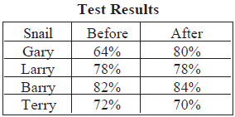
Gary is not the smartest snail in Bikini Bottom and believes he can improve his brain power by eating Super Snail Snacks. In order to test this hypothesis, he recruits SpongeBob and several snail friends to help him with the experiment. The snails ate one snack with each meal every day for three weeks. SpongeBob created a test and gave it to the snails before they started eating the snacks as well as after three weeks. Analyze the data in the chart and determine whether or not the Super Snail Snacks create smarter snails!

What is the independent variable?
What is the dependent variable?

Mice Babies

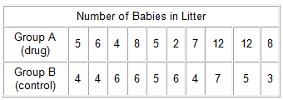
An experiment studies the effects of an experimental drug on the number of offspring a mother mouse has. 10 female mice are given the drug and then impregnated. The number of mice in their litters is compared to the litters of mice that did not take the drug.

What is the independent variable?
What is the dependent variable?

