Biochemistry Terms

**Organic molecules** are the molecules made of carbon which exist in all living things. **Carbon** is an element that bonds easily with other atoms and forms the basis for all living organisms and tissues. There are four categories of organic molecules: Carbohydrates, lipids, proteins and nucleic acids. Each kind of organic molecule is built from a single type of building block, called a **monomer**. For example, the building block of carbohydrates is glucose. When these building blocks are joined together, they form a large molecule (**polymer**), just as bricks join together form a wall. For example, sugars join together form a carbohydrate.

Carbohydrates

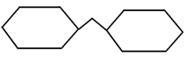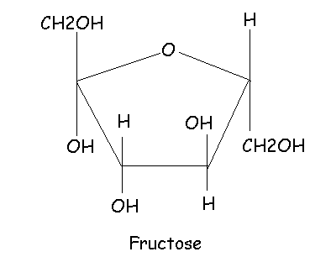**Carbohydrates** are sugars that are made from plant matter and provide quick energy to cells. They are made from carbon, hydrogen and oxygen. Their building block is a single sugar a **monosaccharide**. Sugars (monosaccharides) usually look like rings of carbon like the one at the right. When two monosaccharides, or sugars, combine, they form a **disaccharide**. When more than two monosaccharides join together, a **polysaccharide** is formed. There are three kinds of carbohydrate polysaccharides. The first is **starch,** which is used to store energy in plants. Potatoes, pasta and rice are rich in starch. The second is **glycogen**, which stores energy in animals. The third is **cellulose**, which provides structure to plants, like tree bark.

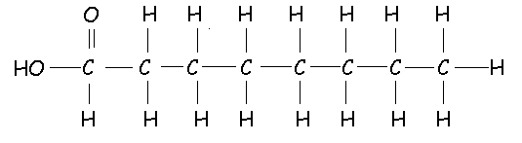Lipids

**Lipids** include fats and oils, and are important because they store long-term energy in the body. The building blocks of lipids are the **fatty acids**, which is a chain of carbons with hydrogen attached to each side (see the picture at the right). Saturated fats have two hydrogens attached to each carbon, have a straight chain, and make up unhealthy fats like butter and Crisco. Unsaturated fats are missing one or more hydrogen (so the carbons have to form double bonds), have a kinky chain, and make up healthy fats, like fish oil and olive oil. Lipids are **soluble** in oil, which means that they dissolve evenly in oil. However, when mixed with water, the lipid will float on top to form a separate layer. Because they won’t dissolve in water, they are said to be **insoluble** in water. Carbohydrates, on the other hand, are soluble in water and insoluble in oil.

Proteins

**Proteins** are organic molecules that form muscles, enzymes, and do much of the work in the body. The building block of protein is the **amino acid**. Amino acids join together with a bond called a **peptide bond**. There are about 20 different kinds of amino acids. When groups of amino acids are joined together, a protein is formed. The protein that is created depends on which of the 20 amino acids are joined together.

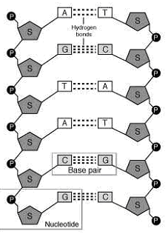

Nucleic Acids

The fourth kind of organic molecules are **nucleic acids**, which include DNA and RNA. **DNA** is like an instruction book that tells the cells how to survive and how to create more proteins. **RNA** is just a copy of DNA. The monomer (building block) of nucleic acids is the **nucleotide**. Nucleotides consist of three parts: a five-carbon sugar, a phosphate group and a nitrogen base. The sugar and the phosphate form the rails of the molecules and the base forms the rungs that connect the rails. A nucleotide is shown at the right as the section of DNA enclosed in a box. The DNA molecule to the right has 12 nucleotides.