Chapter 6 Biomes and Aquatic Ecosystems
6.1 Defining Biomes
Objectives:
- Explain how biomes are characterized
- Describe how net primary production varies among biomes

- Earth’s major Biomes
  - Groups of ______________________________ ecosystems that share _____________________ and __________________________ conditions
  - 10 primary biomes: tropical rain forest, dry savanna, ______________________, temperate rain forest, temperate forest, temperate grassland, ____________________, boreal forest, ________________________

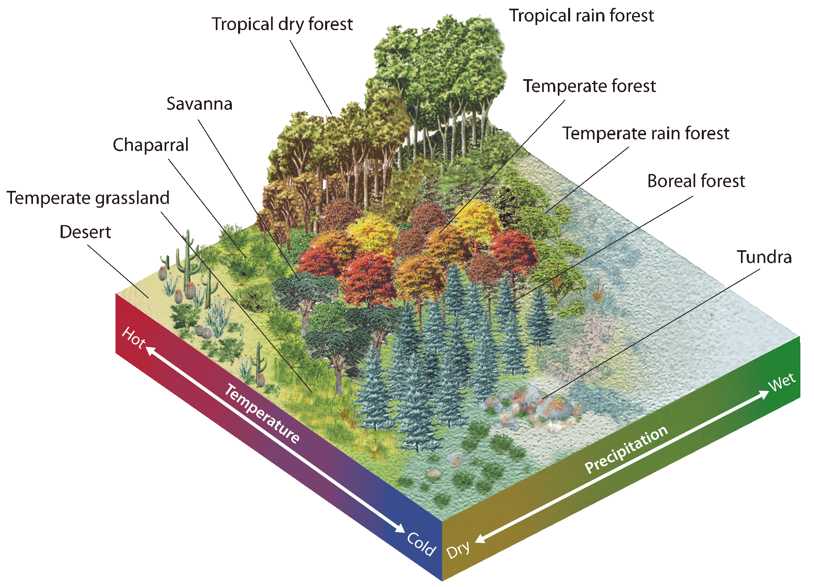

- Question (Refer to Figure 1 pg. 165)
  - What are some abiotic and biotic factors in the areas we live in?

  - What biome do you think we live in?

  - What biomes are near where we live?

  - What patterns do you notice in the location of biomes?

- Climate and Climatographs
  - __________________________: average conditions, including temperature and precipitations, over long periods of time in a given area.
  - __________________________: day to day conditions in Earth’s atmosphere
  - __________________________: diagrams that summarize an area’s average monthly temperature and precipitation
  - Each ______________________ has a set of _____________________________ adapted to its particular climate conditions

- Question (refer to Figure 2 pg. 165)
  - In Harare, Zimbabwe during what months is the rainy season?

  - During what months is the dry season?

  - What biome is Harare in (see pg. 163 for its location)?

- Concept Check
  - What factors are used to characterize biomes?

  - What’s the difference between an ecosystem and a biome?

- Biomes and Net Primary Production
  - _____________________ primary production: the rate at which primary producers undergo ____________________________________.
  - ____________________ primary production: the amount of organic matter (biomass) that remains after primary producers use some to carry out ____________________________ ____________________________________.
  - ____________________________ vary in their net primary productivity, the rate at which primary producers convert energy to ____________________________.
  - ______________________, ____________________ biomes generally have higher net primary productivity than cold, dry biomes.

6.2 Biomes
Objectives:
- Explain how organisms are adapted to the conditions of their biomes.

- Tropical Rain Forest
  - Temperature: year round _________ temperatures
  - Precipitation: ___________m per ___________
  - Soil : nutrient-______________
  - Plants:______________, ________________ leaves and _________________ roots.
  - Animals __________ animal species of any biome and animals tend to be
__________________________

- Tropical Dry Forest
- Temperature: ____________ year round
- Precipitation: highly ______________
- Trees: Most are ___________________, meaning they lose their _________________
and cease _________________ part of the year.
- Plants/Animals: Exhibit adaptations such as ________________,
______________________, and ________________________ that allow then to survive
the ___________ season.

- Savanna
- Precipitation: Less than _________________ but more than _____________________.
Has a distinct _______________________________.
- Landscape: __________________ interspersed with groups of ___________________.
- Plants: Adapted to __________ conditions. Tend to be __________________________.
- Animals: ________________ to find water, or burrow when water is _______________.

- Desert
- Temperature: Varies widely from _________ to ____________.
- Precipitation: Less than ______________ per year.
- Plants: Have ___________ leaves, store water in their ____________________, have
shallow _______________.
- Animals: Get most of their water from _____________________________ and tend to
be ___________________.

- Temperate Rain Forest
- Temperature: Year round ___________________ temperatures.
- Precipitation: _______________ rainfall
- Location: ______________ _____________________ of the U.S.
- Plants: Don’t lose leaves _____________________ (conifers), forest floor covered in ______________.
- Animals: _________________ thrive here.

- Temperate Forest
- Temperature: ___________ winters, _____________ summers
- Precipitation: _________________ spread throughout the year.
- Soil: Nutrient ____________ from annual _________________________.
- Plants: ________________ leaved and _____________________.
- Animals: Migrate, hibernate, or store food to __________________________________.

- Temperate Grassland (Prairie)
- Temperature: _____________________ seasonal temperatures.
- Precipitation: Moderate ______________________ precipitation
- Soil: Nutrient _______________
- Plants: No __________ only _______________ because of lack of precipitation.
- Animals: Adapted to deal with lack of _________________.

- Chaparral
- Temperature: Highly ___________________ conditions.
- Precipitation: Wet _________________ and ________________ summers.
- Plants: _______________ resistant, thick waxy __________________, thick
_______________, and deep ___________________.
- Animals: Many animals burrow or are nocturnal to avoid ________________.

- Boreal Forest (Taiga)
- Temperature: long cold __________________ and short cool ____________________
- Soil: nutrient _________________
- Plants: _____________________ trees adapted to _______________ conditions.
- Animals: low ________________. Some stay only during warm season. Those that stay
year round have _____________________.

- Tundra
- Temperature: Cold, dark _______________ and sunny, cool ___________________
- Location: High __________________ in ______________________________________
- Soil: Permafrost which is _________________ soil that is frozen year round.
- Plants: No tall _______________. ________________ and _________________ common.
- Animals: Most ___________________to tundra during summer. Few live here

_____________________.

- YOUR riddle about a biome:

- A classmates riddle about biomes:

Section 6.3 Aquatic Ecosystems
Objectives:
- Describe the criteria ecologists use to classify aquatic ecosystems.
- List the major categories of freshwater ecosystems.
- Explain the ecological importance of estuaries.
- List the 3 major zones of the ocean.

- ________% of Earth’s surface is covered by water.

- Describing Aquatic Ecosystems:
  - _________________________________: the amount of dissolved salt present in water. Ecosystems are classified as _____________________ ______________________, ____________________________________________, or _________________________________ depending on salinity.
  - Photosynthesis tends to be limited by ______________________ availability, which is a function of ________________________ and water ______________________.
  - Aquatic ecosystems are either ________________________ or ____________________________.
  - Aquatic ecosystem zones; ________________________, __________________________, _____________________________.

- Freshwater Ecosystems: Ponds, lakes, Inland Seas
  - Salinity is less than _______________ ppt (parts per thousand)
  - Ponds and lakes are similar, except in __________________, but inland seas contain organisms adapted for _______________ water.
  - Ponds and lakes are divided horizontally into zones: ___________________ and _______________________.
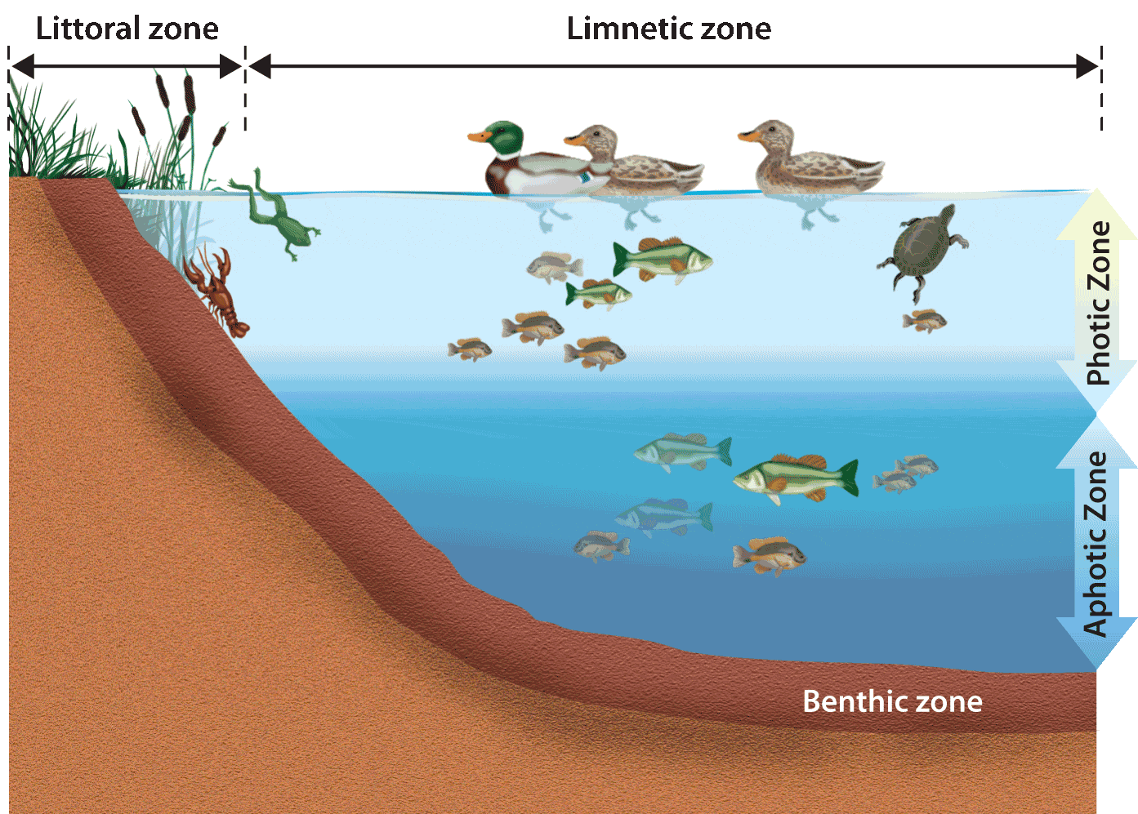

- Freshwater Ecosystems: Wetlands
  - Areas of land _________________________ with water at least part of the year.
  - Include freshwater ___________________________, swamps, ______________________, and fens
  - Wetlands prevent ____________________________, recharge __________________________, filter ________________________________, and provide ______________________________.

- Freshwater Ecosystems: Rivers and Streams
  - Bodies of surface water that __________________ downhill, eventually reaching an _________________________ or inland sea.
  - ______________________________: the area of land drained by a river and its tributaries.
  - Characteristics, such as dissolved oxygen, ___________________________, water speed, organisms, and others, change from __________________ to ____________________________.

- Estuaries
  - Occur where a _____________ flows into the ocean or an ___________ sea.
  - ______________________ estuaries are ________________________ ecosystems; organisms must tolerate wide salinity and temperature ranges.
  - Coastal estuaries are home to saltwater _________________________ and mangrove forests.
  - Like _________________________, estuaries help prevent _____________________ and soil _______________________ as well as provide habitats.

- Oceans (salt water ecosystem)
- Currents are driven by water temperature and density differences,
________________, and _____________.
- Surface winds and ________________________ generate vertical currents that transport ______________________ and ___________________________.
- Horizontal ocean zones: ____________________________, ____________________________, and ______________________ __________________________
- Vertical ocean zones: _________________________, ______________________________, _________________________________

- Ocean Ecosystems
- Intertidal: Highly _________________, extreme range of __________________, moisture and salinity.
- Neritic: Productive _________________ forests and coral reefs provide
________________ and help protect ______________________ from erosion.
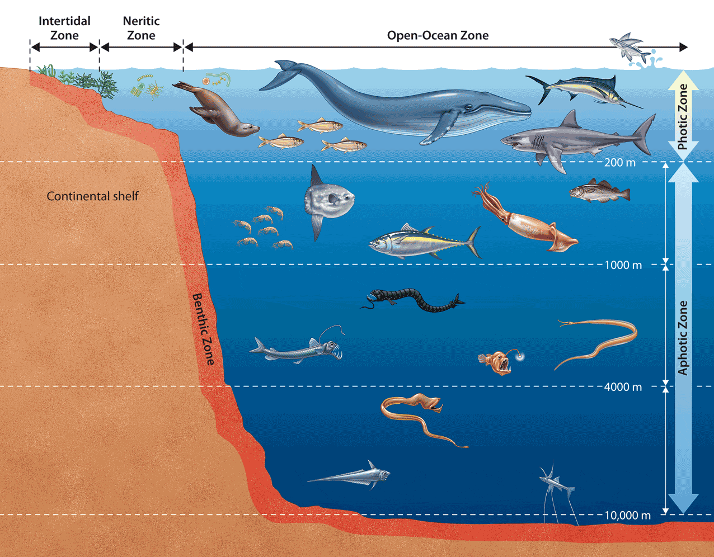
- Open ocean:____________ productivity due to low ____________ penetration; ________________________ base of food chain; deep sea organisms and __________________________ vent communities.

