Marine Energy Pyramid
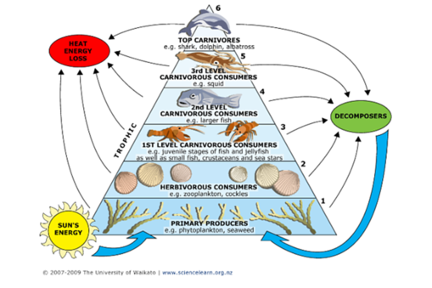

Source: www.sciencelearn.org.nz/Contexts/Life-in-the-Sea/Science-Ideas-and-Concepts/Marine-food-webs

