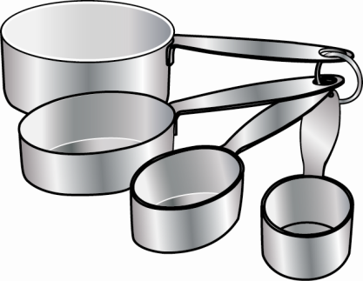**Station 1**

**Sam was baking several batches of chocolate fudge for a bake sale. He only had 4 cups of confectioner’s sugar left. Each batch of chocolate fudge needed $\frac{2}{3}$ cups of confectioner’s sugar. How many batches of fudge could Sam make with this amount of confectioner’s sugar?**

* Using the confectioner’s sugar from the large bowl, measure out 4 cups.
* Place 4 cups of confectioner’s sugar in a separate bowl.
* Now find a $\frac{2}{3}$ measuring cup. If you do not have one, you could use a $\frac{1}{3}$ measuring cup and adjust accordingly.
* Measure $\frac{2}{3}$ cup, tally on your Four Square to keep track and put the confectioner’s sugar back in the original large bowl.
* Keep measuring confectioner’s sugar to determine how many times you can measure $\frac{2}{3}$ cup from 4 cups.

***KEEP THE AREA NEAT!***

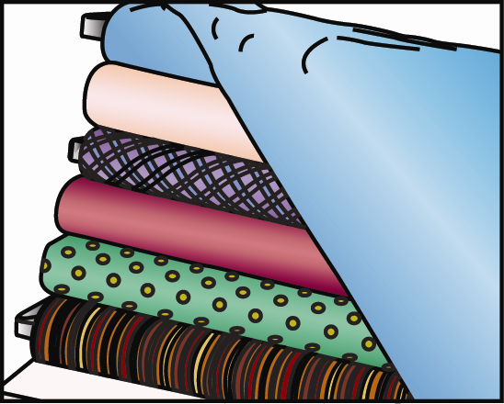**Station 2**

**Miranda was sewing pillows for her new couch. Each pillow required $\frac{3}{4}$ yards of fabric. She had $3\frac{3}{4}$ yards of fabric, how many pillows could she make? Use the string that was measured out. The length is $3\frac{3}{4}$ feet.**

Remember that we can substitute inches for feet. For this activity we will substitute feet for yards.

* Measure  of a foot and cut that piece.
  + How many inches is  of a foot?

(*Hint: We know that there are 12 inches in a foot. We need four groups according to the denominator. Each of the four groups will contain 3 inches. The numerator tells us we need three of those 3-inch groups, or 9 inches.)*

* Put that piece aside and measure another  of a foot.
* Keep measuring the string to determine how many times you cut $\frac{3}{4}$ from $3\frac{3}{4}$.

***KEEP THE AREA NEAT!***

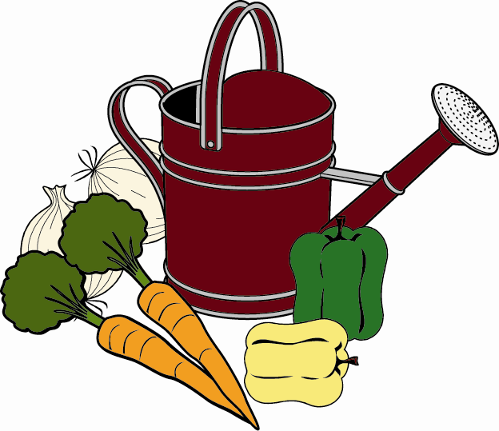**Station 3**

**Chris wanted to feed his newly planted vegetables. The directions said to mix $1\frac{1}{2}$ fluid ounces of plant food for each gallon of water. There were 18 fluid ounces of liquid plant food in the bottle. How many gallons of water are necessary to use all of the plant food?**

Here is a handy conversion: 2 tablespoons = 1 fluid ounce

(One-half fluid ounce would be half of 2 tablespoons, or 1 tablespoon. So $1\frac{1}{2}$ fluid ounces is 3 tablespoons.)

* Measure out 18 fluid ounces of water from the bucket with a measuring cup and place it in a bowl.
* From the bowl of water, measure out $1\frac{1}{2}$ fluid ounces (or 3 tablespoons), tally on your Four Square to keep track, and put the water back into the bucket.
* Keep measuring the water from the bowl to determine how many times you can measure $1\frac{1}{2}$ fluid ounces from 18 fluid ounces of water.

***KEEP THE AREA DRY!***

***KEEP THE AREA NEAT!***