Graphing Inequalities (KEY)
To graph a linear inequality in two variables, follow these steps:
- Use inverse operations to isolate the variable y.
- Temporarily replace the inequality symbol with an equals sign and graph the resulting line on a coordinate plane.
  - If the original inequality symbol is < or >, the line should be dashed.
  - If the original inequality symbol is ≤ or ≥, the line should be solid.
- Choose a test point and substitute its x and y values into the original inequality. (It is often easiest to choose (0, 0) for your test point!)
  - If the resulting inequality is true, shade the region containing the test point.
  - If the resulting inequality is false, shade the region not containing the test point.

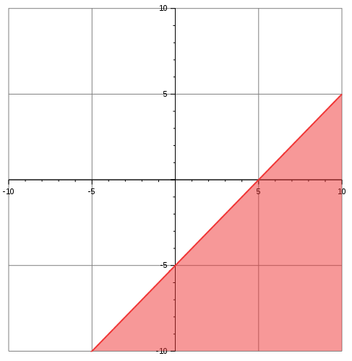
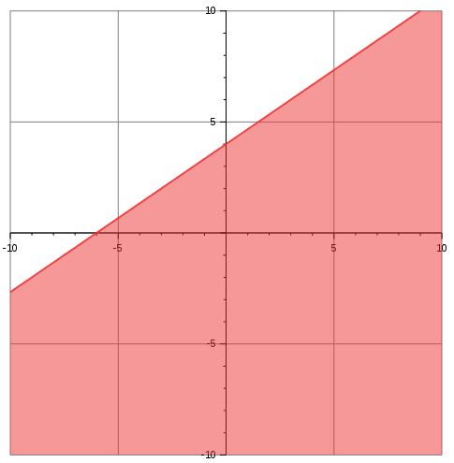
Graph the following inequalities.

- $y<\frac{2}{3}x+4$
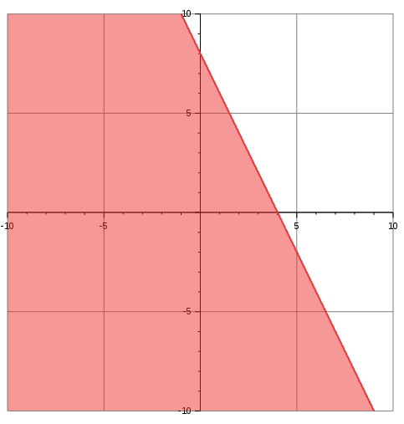
- 6x + 3y ≤ 24
- x – y > 5
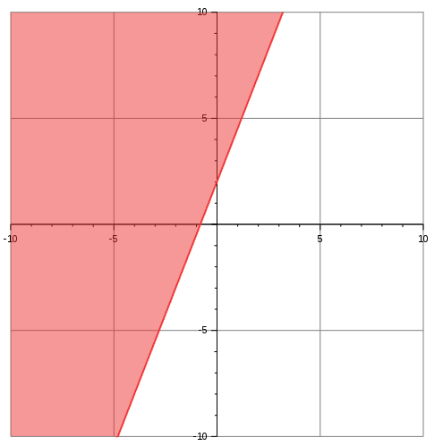
- 4y – 10x ≥ 8

- A movie theater sells adult tickets for $10.00 and child tickets for $6.25. Each night, the theater has a goal of selling at least $2,500 in movie tickets.

  - Let x represent the number of adult tickets sold and y represent the number of child tickets sold. Write an inequality showing how many of each type of ticket must be sold per night in order for the theater to reach its goal.
10x + 6.25y ≥ 2500

  - Graph the inequality.
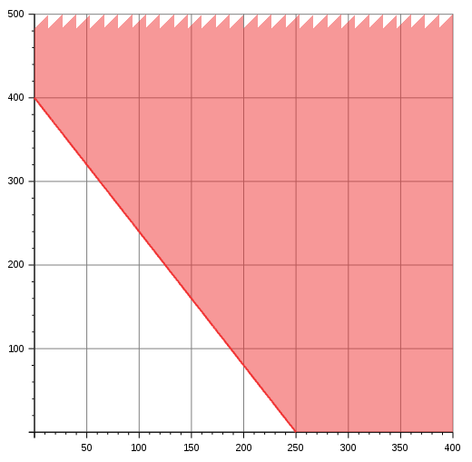

  - If the theater sells 125 adult tickets and 200 child tickets, will it meet its nightly sales goal? Yes.
    - Explain how you can use your graph from part b to answer this question.
The point (125, 200) is on the line of the graph. In this case, the line is included in the solution set, so (125, 200) is a possible solution.

    - Explain how you can use your inequality from part a to answer this question.
Substituting (125, 200) into the original inequality yields 2500 ≥ 2500. This is a true statement; therefore (125, 200) is included in the solution set.

