Expansion Work Name_______________________

- Describe a proportional relationship that relates to the field of science. Provide a graph of the relationship and identify points on the line, including the unit rate. Explain the meaning of the points.

- Write a word problem that includes a proportional relationship. Use a graph to show the solution to the problem. Explain how the unit rate may be used to find the solution.

- Does the point (1, 2) on the graph of the equation represent the unit rate? Explain.

Expansion Work - KEY
- Student responses will vary.
Kevin takes 15 mL of antibiotic per day. The cumulative amount of antibiotic he has taken is proportional to the number of days that have passed. A graph of this relationship is shown below.
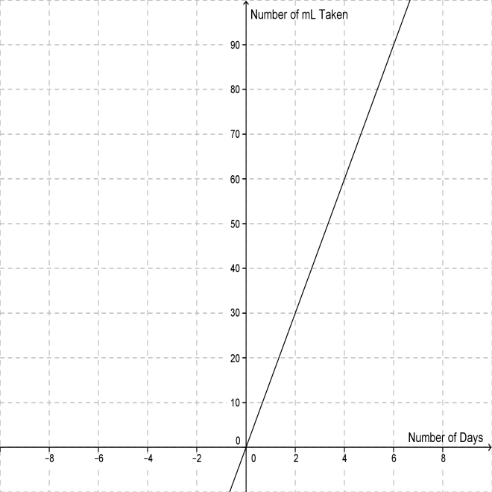
The origin is (0, 0), which indicates that he has taken 0 mL of antibiotic after 0 days. The unit rate is represented by the point, (1, 15), which indicates that he has taken 15 mL of antibiotic at the end of Day 1. Therefore he takes 15 mL of antibiotic each day. The point, (2, 30), indicates that he has taken a total of 30 mL after two days. The point, (4, 60), indicates that he has taken a total of 60 mL after four days.

- Student responses will vary.
Martin spends $20 every week on laundry. How much will he have spent on laundry after 25 weeks? The graph of this proportional relationship is shown below.
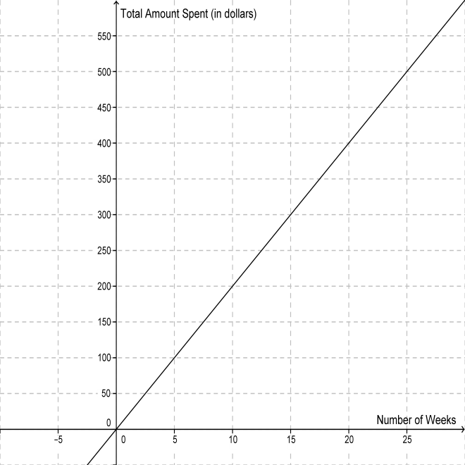
The point (25, 500) shows the solution to be $500. The x-value of 25 represents the number of weeks and the y-value of 500 represents the cumulative amount spent. The unit rate is $20, represented by the point (1, 20). Therefore, the solution may be found by multiplying $20 by 25 weeks, giving a product of $500.

- No, a quadratic equation forms a parabola, which is not a straight line. Thus, it does not represent a proportional relationship. The unit rate represents the constant rate of change. The quadratic equation does not show a constant rate of change. It shows increases of 2, 6, 10, 14, and so on. Thus, the point (1, 2) does not represent the unit rate.

