Lesson 3 Exit Ticket Name_________________________
- The number of triangles shown in each figure of a pattern is proportional to the figure number. This relationship is graphed below. Identify the unit rate or constant of proportionality and explain what it means in this context. Explain the meaning of the points (0, 0) and (4, 16) within this context.

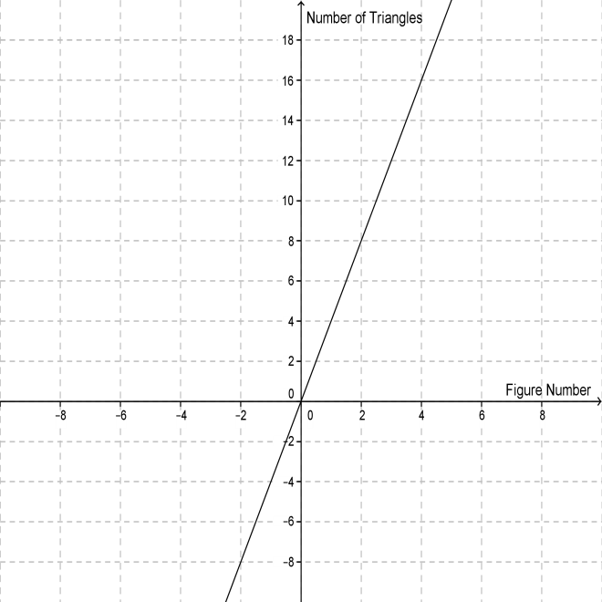

- Two rectangles are similar. The length of the smaller rectangle is proportional to the length of the larger rectangle. This relationship is graphed below. Identify the unit rate, origin, and another point on the graph. Explain the meaning of each point within the context.
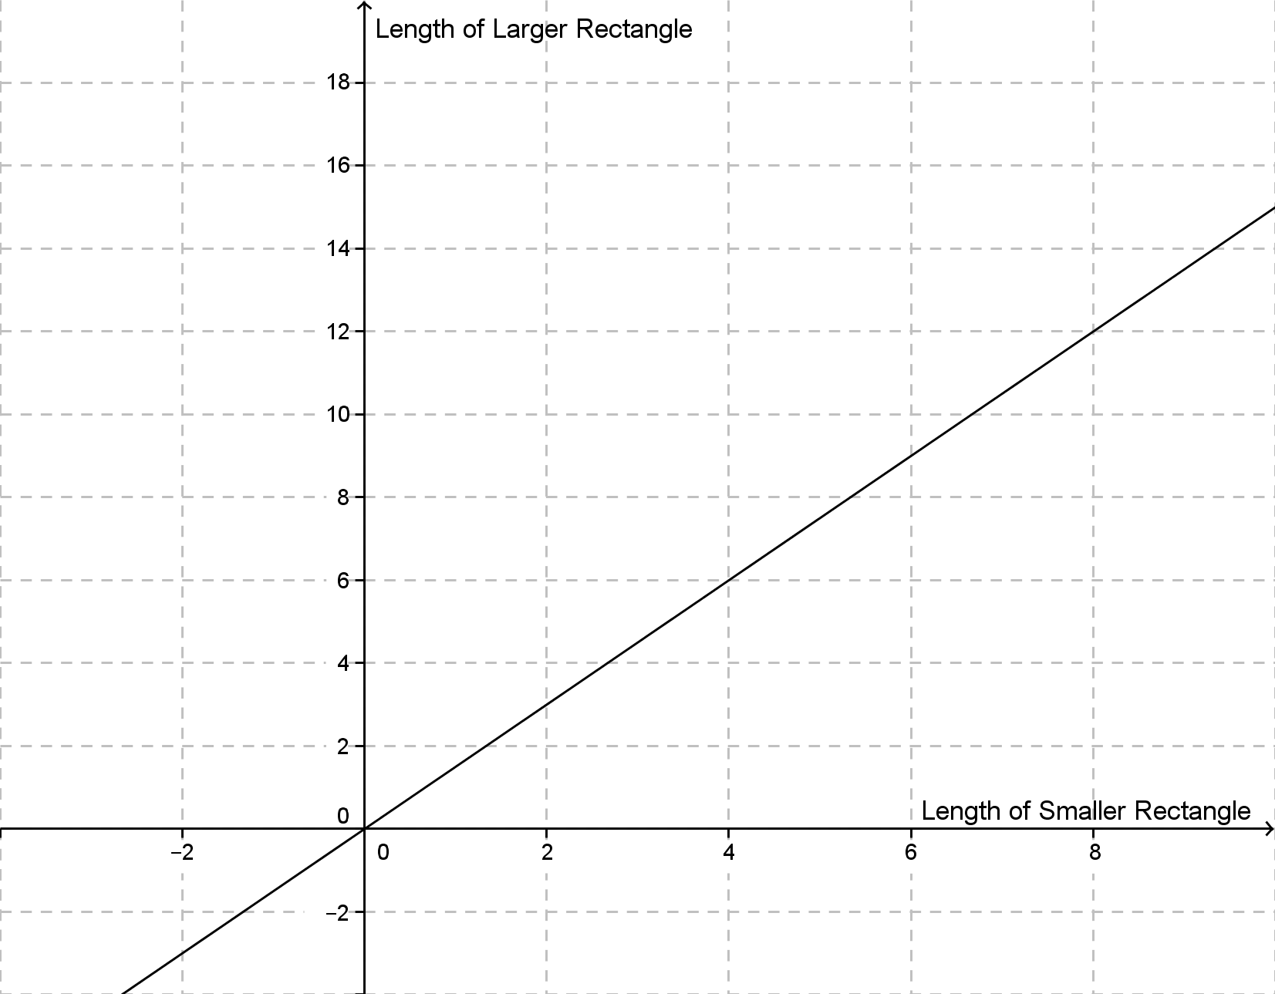
- The number of miles Ana has driven is proportional to the number of hours that have passed. This relationship is graphed below. Identify the unit rate or constant of proportionality and explain its meaning in relation to the context. Explain the meaning of the points (0, 0) and (5, 350) within this context.

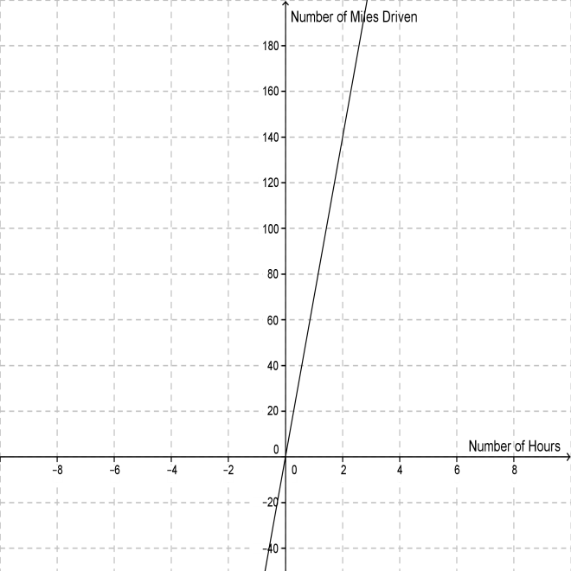

- The cost of gasoline is proportional to the number of gallons of gasoline used. Suppose the cost per gallon is $3.50. Describe the appearance of the graph of the relationship, including the unit rate and point at which the graph crosses the y-axis. Name at least two other points on the graph and explain their meaning, as related to this context.

- Describe a proportional relationship. Graph the relationship and identify at least four points on the line, including the origin and unit rate. Explain the meaning of each point, as related to the described context.

Lesson 3 Exit Ticket (KEY)

- The constant of proportionality is 4 (k = 4). This means that each figure number has 4 more triangles than the one previous. The point (0, 0) indicates that figure number 0 will have 0 triangles. The point (4, 16) indicates that figure number 4 will have 16 triangles.

- The unit rate is 1.5 (k = 1.5). The origin indicates that when the length of the smaller rectangle is 0, the length of the larger rectangle is also 0. The point (4, 6) indicates that when the length of the smaller rectangle is 4, the length of the larger rectangle is 6.

- The constant of proportionality is 70 (k = 70). This means that Ana is driving 70 miles per hour. The point (0, 0) indicates that when Ana has been driving for 0 hours, she has traveled 0 miles. The point (5, 350) indicates that when Ana has driven for 5 hours, she has traveled 350 miles.

- The graph will be a straight line that passes through the points (0, 0) and (1, 3.5). The unit rate is 3.5. The graph crosses the y-axis at the origin. Two other points are (2, 7) and (3, 10.5). The point (2, 7) means that 2 gallons of gas costs $7. The point (3, 10.5) means 3 gallons of gas costs $10.50.

- Answers will vary.

