Small Group Practice Name________________________

- Given the graph below, identify the unit rate and explain its meaning.

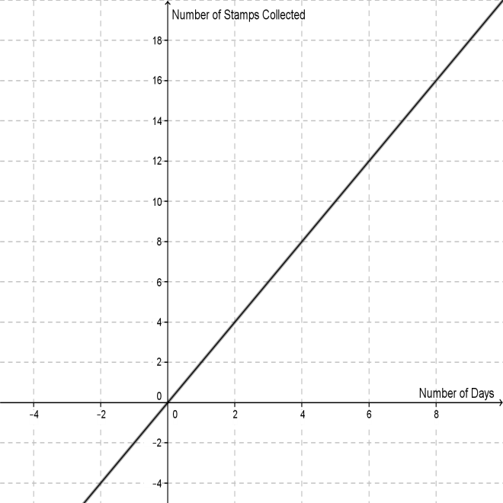

- Given the graph below, identify the unit rate and explain its meaning.

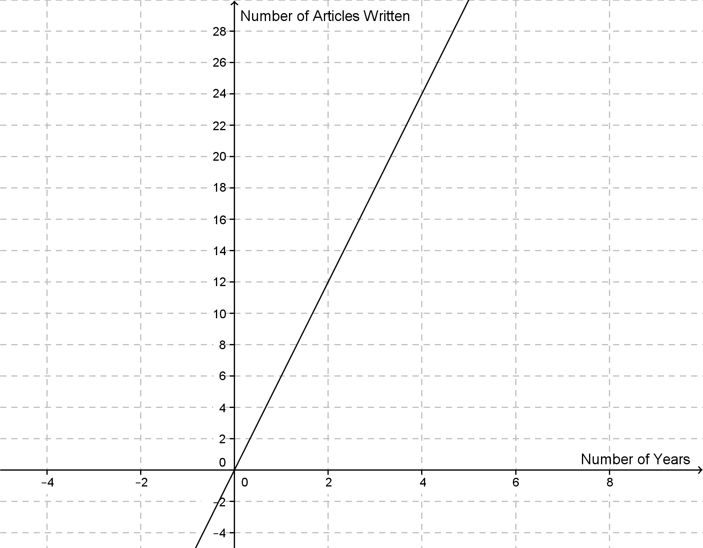
- The total cost of gallons of milk is proportional to the number of gallons purchased. This relationship is graphed below. Identify the unit rate, point at which the graph crosses the
y-axis, and at least one other point on the line. Explain the meaning of each of these points, as related to the context.

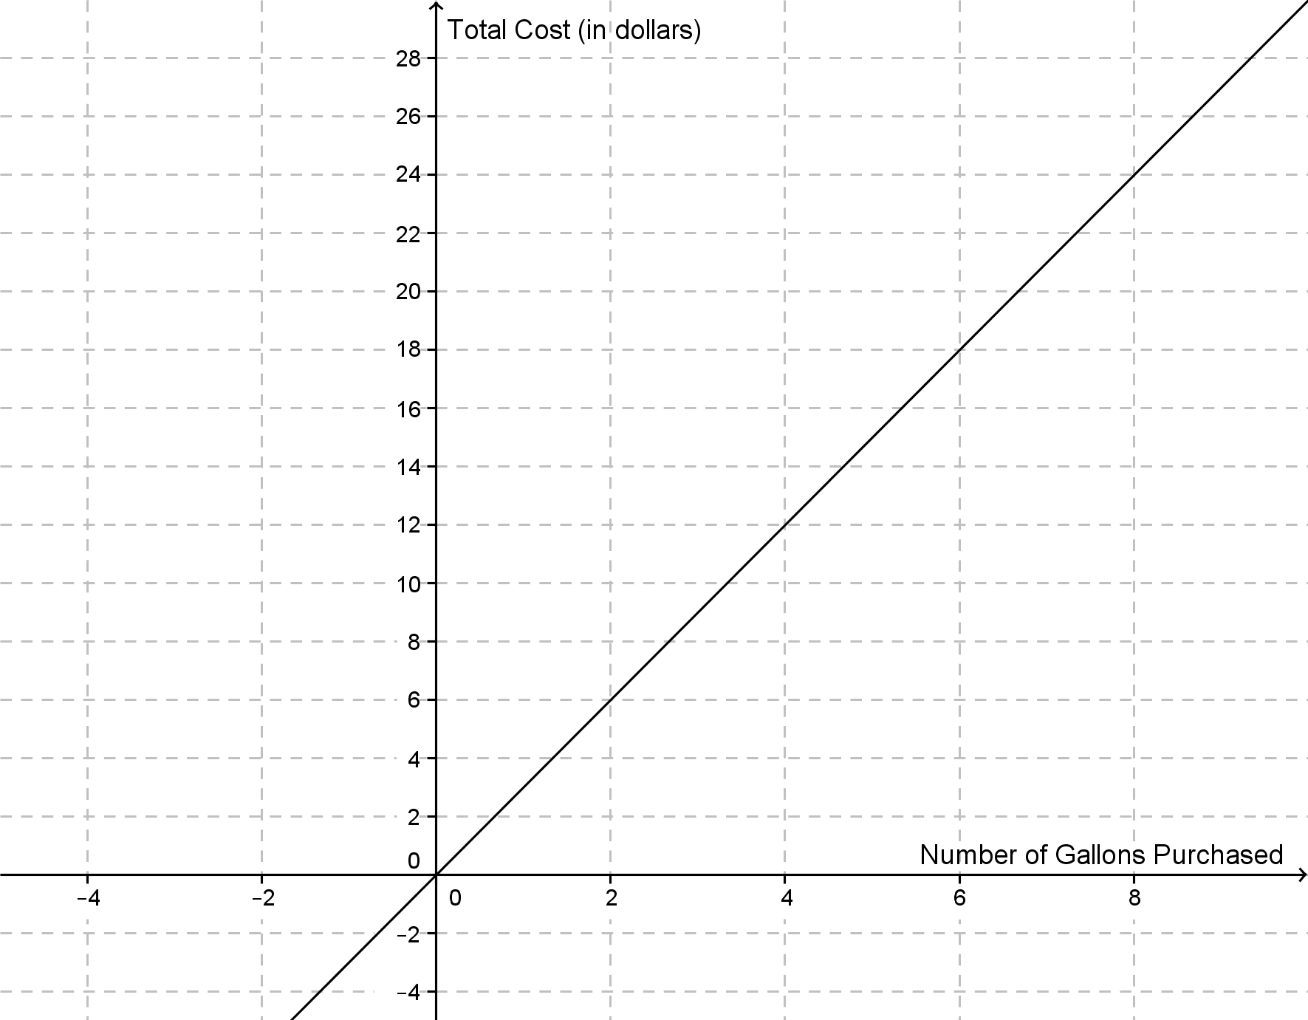

- The amount of money Amy has saved is proportional to the number of weeks that have passed. This relationship is graphed below. Identify the unit rate or constant of proportionality and explain its meaning, related to this context. Explain the meaning of the points, (0, 0) and (4, 40), within this context.

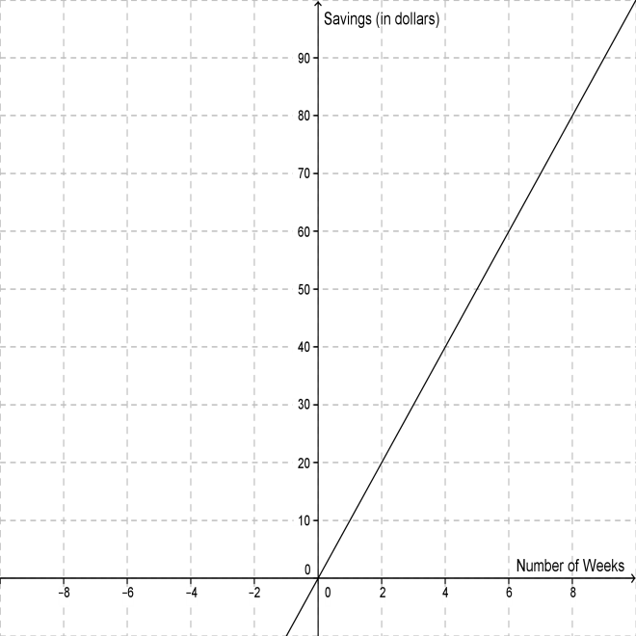

- State a proportional relationship. Describe the appearance of the graph of the relationship. Identify the unit rate, the point at which the graph crosses the y-axis, and at least two other points on the line. Explain the meaning of these points, as related to the stated context.
Small Group Practice (KEY)

- The unit rate is 2. This means that it takes 2 days to collect 1 stamp.

- The unit rate is 6. This means that 6 articles are written in 1 year.

- The unit rate is 3. The graph crosses the y-axis at the origin. Another point on the line is (2, 6). The origin means that 0 gallons of gas costs $0. The point (2, 6) means that 2 gallons of gas costs $3.

- The unit rate is 10. This means that Amy saves $10 in 1 week. The origin means that after 0 weeks, Amy will have saved $0. The point (4, 40) means that after 4 weeks, Amy will have saved $40.

- Answers will vary.

