Lesson 1 Exit Ticket
- In the space below, draw a number line from −5 to 5, showing the numbers you would say when counting by 1s.

- On the number line below, mark where the numbers −4 and 7 are located.

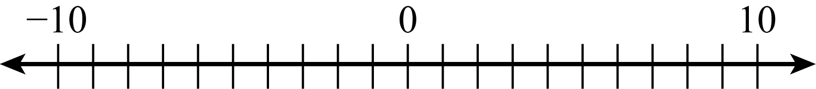

- State what the numbers 0, −5, and 5 would mean in terms of a bank account balance.

Lesson 1 Exit Ticket – KEY
- In the space below, draw a number line from −5 to 5, showing the numbers you would say when counting by 1s.

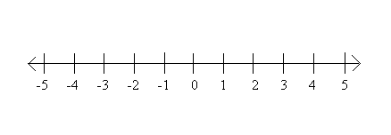

- On the number line below, mark where the numbers −4 and 7 are located.
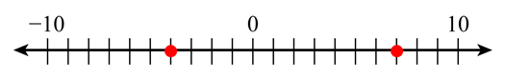

- State what the numbers 0, −5, and 5 would mean in terms of a bank account balance.
0 would mean there is no money in the bank account.
−5 would mean the owner of the account overdrew by $5.
5 would mean that there is $5 in the account.

