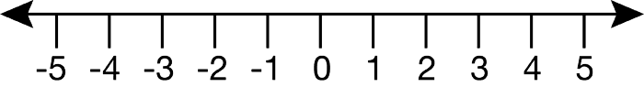

Clipart source: http://etc.usf.edu/clipart/41600/41633/-5-5_41633.htm

