Use your Place-Value Mat and Number Cards to show this number.  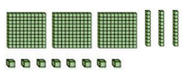 | Show this number by placing base-ten blocks on your Place-Value Mat.  423
Use your Number Cards to show the number with a  7 in the ones place,  2 in the tens place, and  8 in the hundreds place. | In 348, which number is  In the ones place?  In the tens place?  In the hundreds place?
Read this number.  308 | Use your Place-Value Mat and Number Cards to show this number.  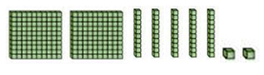
Show this number by placing base-ten blocks on your Place-Value Mat.  320 | Read this number.  750
In 207, which number is  In the tens place?  In the hundreds place?  In the ones place? | Use your Number Cards to show the number with a  6 in the tens place,  7 in the hundreds place, and  8 in the ones place.
Show this number by placing base-ten blocks on your Place-Value Mat.  407 | In 215, which number is  In the tens place?  In the hundreds place?  In the ones place?
Read this number.  707 | Use your Place-Value Mat and Number Cards to show this number.  