Place-Value Worksheet Name:________________________

Write the number for each group of base-ten blocks.

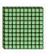_______________

_______________

_______________

Write a number with Write a number with
4 in the hundreds place, 7 in the tens place,
6 in the tens place, and 2 in the hundreds place, and
9 in the ones place. 3 in the ones place.

_______________ _______________

In 381, In 407,
How many hundreds? _______ How many hundreds? _______
How many tens? _______ How many ones? _______
How many ones? _______ How many tens? _______

Draw base-ten blocks to show the following numbers.

Number | Picture
318

240

403

Place -Value Worksheet KEY

Write the number for each group of base-ten blocks.

325

150

207

Write a number with Write a number with
4 in the hundreds place, 7 in the tens place,
6 in the tens place, and 2 in the hundreds place, and
9 in the ones place. 3 in the ones place.

469 273

In 381, In 407,
How many hundreds? 3 How many hundreds? 4
How many tens? 8 How many ones? 7
How many ones? 1 How many tens? 0

Draw base-ten blocks to show the following numbers.
Number | Picture
318 | 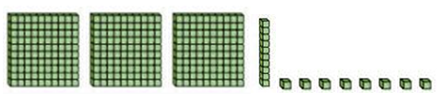
240 | 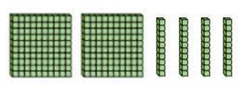
403

