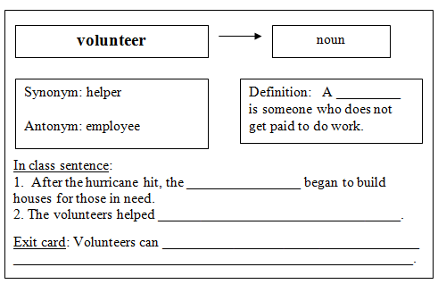

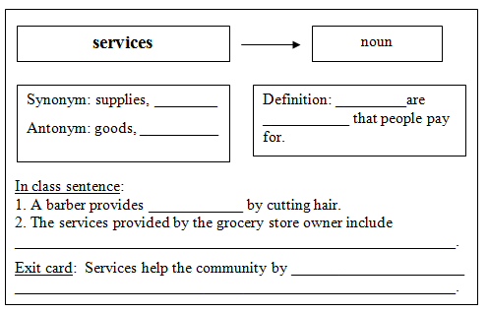

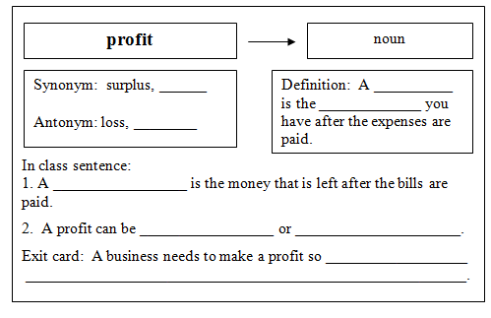

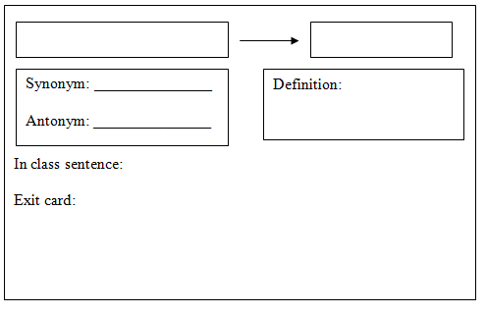

Sample answers:
Volunteer:
Definition: A volunteer is someone who does not get paid to do work.
In class sentence:
- After the hurricane hit, the volunteers began to build houses for those in need.
- The volunteers helped pass out food to people.
Exit card: Volunteers can help people. Volunteers can provide services.

Services:
Synonym: helpful jobs
Antonym: objects
Definition: Services are helpful jobs that people pay for.
In class sentence:
- A barber provides a service by cutting hair.
- The services provided by the grocery store owner include selling food and putting food in shopping bags.
Exit card: Services help the community by providing people with things they need. Services help the community by keeping people safe.

Profit:
Synonym: extra
Antonym: expense
Definition: A profit is the extra money you have after the expenses are paid.
In class sentence:
- A profit is the money that is left after the bills are paid.
- A profit can be spent or saved.
Exit card: A business needs to make a profit so it can pay people who work there.

