The Cycling of Matter
Matter- anything that has mass and takes up space
Law of Conservation of Energy- energy cannot be created or destroyed
3 Cycles Where Matter and Energy are Reused:
- The Carbon Cycle
- The Nitrogen Cycle
- The Phosphorus Cycle
The Carbon Cycle
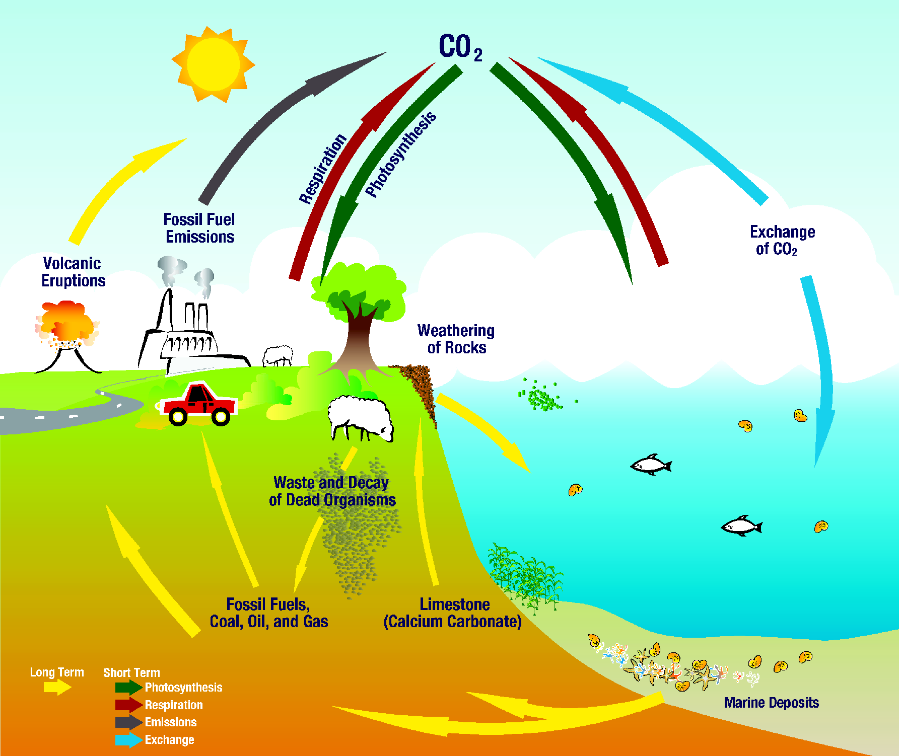
The Carbon Cycle- a process by which carbon is cycled between the atmosphere, land, water, and organisms
Basics of the Carbon Cycle:
-carbon makes up organisms
-carbon is cycled (goes in a circle) with the atmosphere, land, water, and organisms

Short Term:
1. Producers (like plants) make carbon dioxide from the air into carbohydrates because of photosynthesis (energy from the sun)
2. The consumers eat the producers and get the carbohydrates.
3. The consumer breaks down the carbohydrates is got from the producers during cellular respiration.
4. Carbon goes back into the atmosphere as carbon dioxide.

Long Term:
-Carbon converts into carbonates (carbonates make up the hard parts of bones and shells)
-Because bones and shells don’t break down easily, they make limestone rock.
-The limestone rocks make carbon sinks (carbon pools) on Earth
-Carbon can go into the soil or air when an organism dies
-Then it makes fossil fuels (coal, oil, and natural gas underground)

**Humans affect the carbon cycle- We burn fossil fuels!!
All organisms need nitrogen to build proteins. Proteins are used to build new cells.
Most organisms cannot use nitrogen from the atmosphere. The nitrogen has to be fixed before they can use it.
Nitrogen Fixing Bacteria- they can fix nitrogen from the atmosphere into a form they can use- ammonia.
The Nitrogen Cycle

Nitrogen Cycle- a process in which nitrogen is cycled (keeps going over and over again) between the atmosphere, soil, and organisms
Nitrogen enters the soil from lightning
The energy in the lightning breaks apart nitrogen in the air, making nitrogen oxide.
Rainwater combines with the nitrogen oxide to make nitrates in the soil (the ground)
*Nitrogen fixing bacteria live in nodules on the roots of plants
Legumes- beans, peas, and clover that produce nitrogen compounds
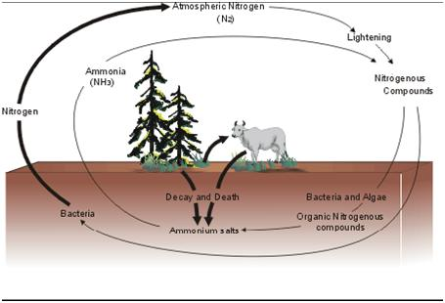
Plants can get nitrogen from the soil (ground)
Animals get nitrogen by eating plants or other animals

*Decomposers are very important in the nitrogen cycle!!
-They break down wastes (urine, dung, leaves, decaying (dying) plants and animals
-Then the decomposers return nitrogen to the soil
After the decomposers do their job, the bacteria give a small amount of the nitrogen to nitrogen gas, which goes back to into the atmosphere. So, then the nitrogen is reused.

The Phosphorus Cycle

Phosphorus helps make up cells in living things, like bones and teeth in animals
-Plants get phosphorus from soil and water
-Animals get phosphorus by eating plants and other animals that have eaten plants
Phosphorus Cycle- the movement of phosphorus from the environment to organisms and then back to the environment
Phosphorus Cycle: ENVIRONMENT ORGANISMS ENVIRONMENT
****This cycle does NOT include the atmosphere!!

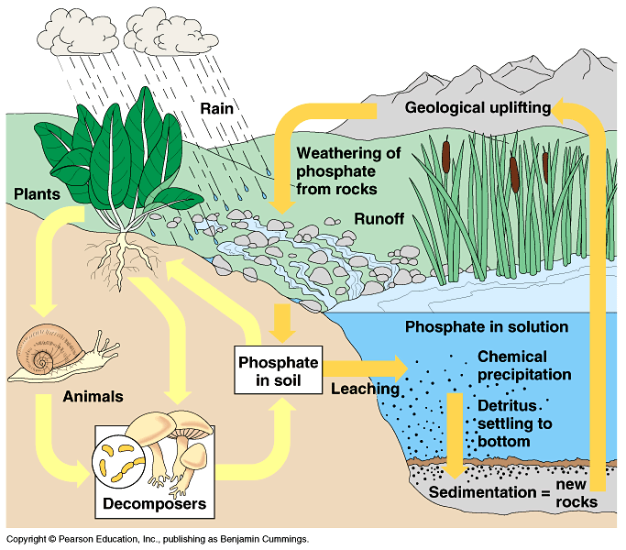
- Phosphorus enters the soil and water in many ways
- Rocks erode (break away) by weathering, putting phosphorus into the soil, water, and ground water
- Phosphorus goes into the soil and water when organisms make waste and decompose
- Phosphorus washes off the land into different forms of water, which goes to the bottom of the water and makes sediment (rocks)

PHOSPHORUS AND FERTILIZERS:
-Fertilizers have phosphorus in them. When this phosphorus runs off the land into water, it makes algai blooms. Algai blooms get rid of important things that water animals need to live, like oxygen.

