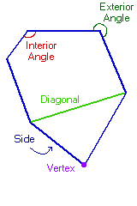
6-1 Properties and Attributes of Polygons
Side of the polygon- each segment that forms a polygon
Vertex of the polygon- the common endpoint of two sides
Diagonal- a segment that connects any two nonconsecutive vertices

You can name a polygon by the number of sides:
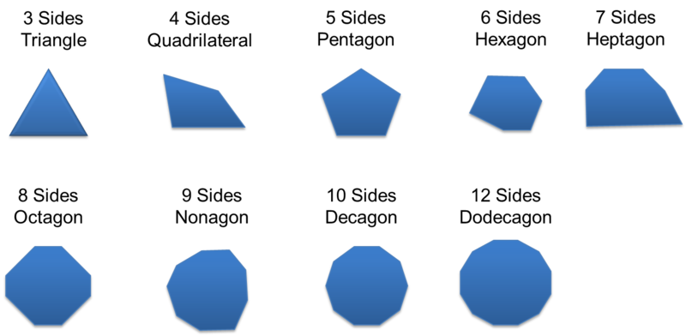

Convex Polygon- if no diagonal contains points in the exterior, then the polygon is convex.
Concave Polygons- if any part of a diagonal contains points in the exterior of the polygon
A concave polygon seems to “cave in” or have a dent.

Theorem 6-1-1 Polygon Angle Sum Theorem
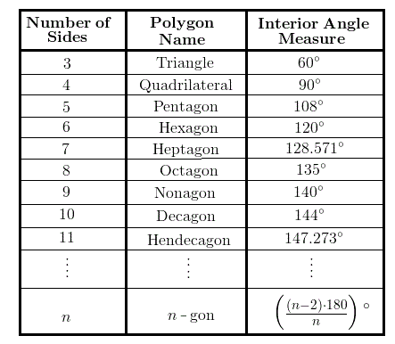
The sum of the interior angle measures of a convex polygon with n sides is (n – 2)180⁰

Example: Find the sum of the interior angle measures of a convex octagon.
- (n-2) 180⁰ (Polygon Angle Sum Theorem)
- (8-2) 180⁰ (An octagon has 8 sides, so substitute 8 for n)
- (8-2)180= 1440 – 360 (Distribute through- 180 x 8= 1440, then 180 x 2=360)
- 1080⁰ (1440-360= 1080..simplify by subtracting)

Theorem 6-1-2 Polygon Exterior Angle Sum Theorem
The sum of the exterior angle measures, one angle at each vertex, of a convex polygon is 360⁰
Example: Find the measure of each exterior angle of a regular hexagon.
- A hexagon has 6 sides and 6 vertices.
- The sum of the exterior angles = 360⁰ Polygon Exterior Angle Sum Theorem
- The measure of one exterior angle is
360 ÷ 6 = 60⁰ A regular hexagon has 6 congruent exterior angles, so divide the sum by 6.

