4.2 Overview of Photosynthesis
Key Concept: The overall process of photosynthesis produces sugars that store chemical energy.

Photosynthetic organisms are producers.
Producers are organisms that produce their own sources of chemical energy. Plants are producers. Plants capture energy from sunlight and store it as chemical energy in the form of sugar. All of this happens through photosynthesis. Chloroplasts are where photosynthesis takes place.
Chlorophyll- a molecule in chloroplasts that absorbs energy in visible light. Plants use chlorophyll for photosynthesis. Plants are green because green wavelengths of light are reflected by chlorophyll.
What is the role of chlorophyll in photosynthesis? It absorbs energy in visible light for plants to use during photosynthesis.

Photosynthesis in plants occurs in chloroplasts.
There are 2 main parts in the chloroplast:
- Grana are stacks of compartments called thylakoids. Thylakoids are enclosed by membranes that contain chlorphyll.
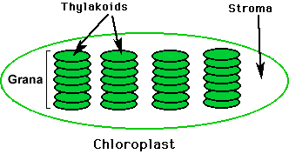
- Stroma is a fluid that is all around the grana inside the chloroplast.

2 stages of photosynthesis:
- Light-Dependent Reactions- captures energy from sunlight.
-happens in the thylakoid and their membranes
-chlorophyll absorbs energy from sunlight
-the energy moves along the thylakoid membrane
-the energy is transferred to molecules that carry energy (ATP)
-water molecules are broken down
-oxygen is released
2.) Light-Independent Reactions- uses energy from the light-dependent reactions to make sugars.
-happens in the stroma
-carbon dioxide (CO₂)
-builds sugars, usually glucose
Overview of Photosynthesis
Stage 1: Light-Dependent Reactions
- Energy from sunlight is absorbed. Water molecules are broken down and oxygen is released.
- Energy-carrying molecules, including ATP, transfer energy.

Stage 2: Light-Independent Reactions
- Carbon dioxide molecules are used to build sugars.
- Six-carbon simple sugars are made. The sugars are often used to build starches and cellulose.

