DRAGON
FIRE BREATHER
SPEEDING, FLYING, SWOOPING
THE TERRIBLE BEAST IS MUCH FEARED
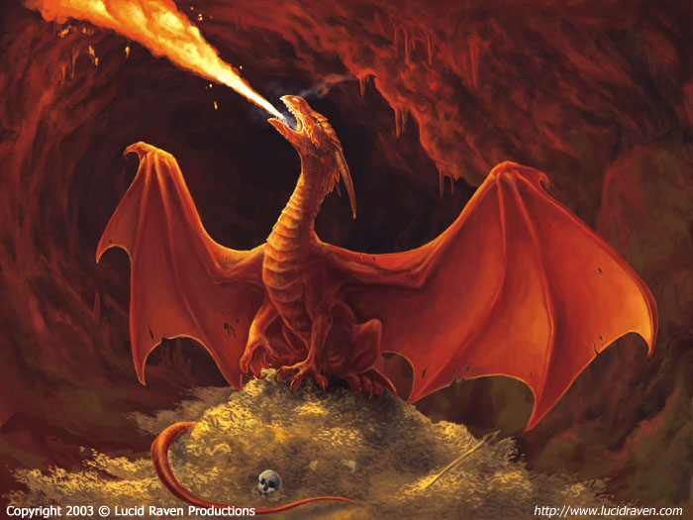
MONSTER

WATER
FAST SWOOSHING
CARRYING FISH AWAY
COMBING THE ROCKS SMOOTH
COLD

The giraffe

There once was a giraffe, who lived on A raft,
The raft was a chubby old craft,
She stood on her head, in a humongous bed,
On a river of red,
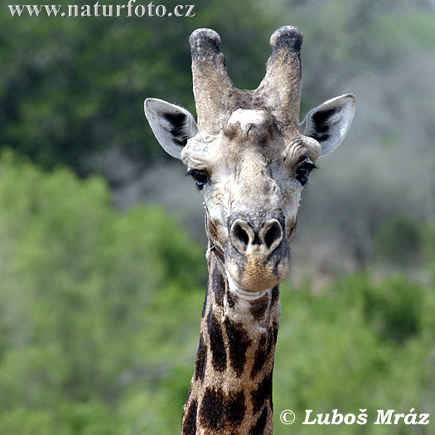
Everyone loved this zestful giraffe.

