Dice
Directions: This program allows you to verse the computer in a guessing game involving one die. The computer will ask you to guess the correct number before the die is rolled. If you guess the correct number, you will earn 5 points. If you do not guess the correct number, the computer will earn a point. The program will keep track of the points and quit when a score limit is reached.
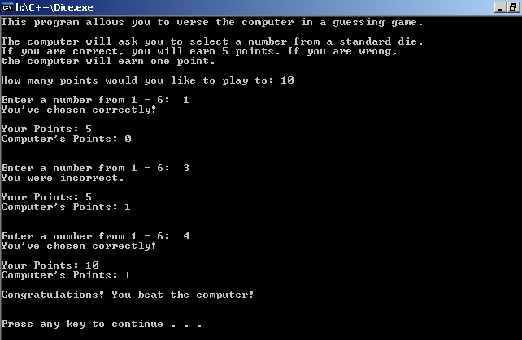

** If the computer beats you in the game, the program should print:
“You have been defeated by the computer.”

