Bubble Sort

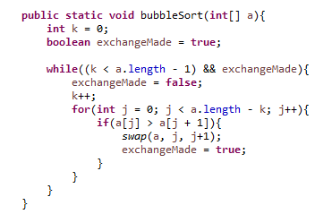
Bubble Sort Example) 8 3 5 7 9 1
3 8 5 7 9 1
3 5 8 7 9 1
3 5 7 8 9 1
3 5 7 8 9 1
3 5 7 8 1 9
3 5 7 8 1 9
3 5 7 8 1 9
3 5 7 8 1 9
3 5 7 1 8 9
3 5 7 1 8 9
3 5 7 1 8 9
3 5 1 7 8 9
3 5 1 7 8 9
3 1 5 7 8 9
1 3 5 7 8 9

Directions: Use the BubbleSort method above to sort the array below.
- How many swaps are made when sorting the integer array arry ?

int[] arry = {6, 7, 1, 3, 5, 0};

