Insertion Sort

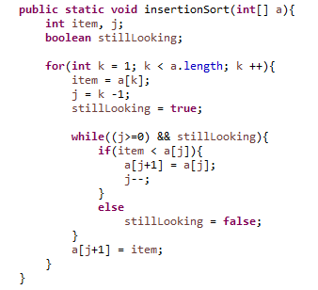

Insertion Sort Example) 8 3 5 7 9 1
3 8 5 7 9 1
3 5 8 7 9 1
3 5 7 8 9 1
3 5 7 8 9 1
1 3 5 7 8 9

