Selection Sort

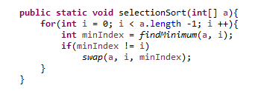

Selection Sort Example) 8 3 7 5 9 1 0
0 3 7 5 9 1 8
0 1 7 5 9 3 8
0 1 3 5 9 7 8
0 1 3 5 9 7 8
0 1 3 5 7 9 8
0 1 3 5 7 8 9

