MergeSort
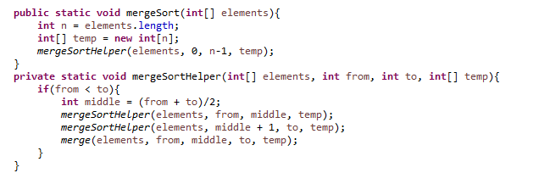
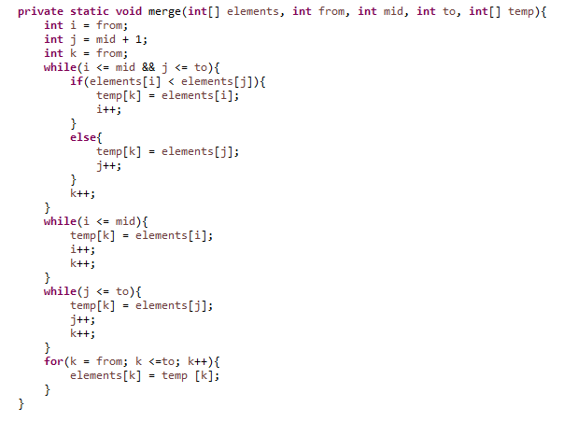

Merge Sort Example) 8 3 5 7 9 1
3 8 5 7 9 1
3 5 8 7 9 1
3 5 8 7 9 1
3 5 8 1 7 9
1 3 5 7 8 9

