RandomArray
Directions: The program below creates an integer array that contains 5 elements initialized to random values between 1 and 5 (inclusive). Each value 1, 2, 3, 4, and 5 must be used once and only once.

Sample Printout)
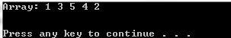

Sample Printout)
