ChristmasLights
Directions: A man has five different sets of Christmas Lights outside his house. He would like each set of lights to randomly blink on and off. Create an Array of 5 booleans. Each boolean in the array has a value determined by a random number. Use the boolean array to create the printout below.
Requirements:
- All of the lights cannot be OFF at the same time
- All of the lights can be turned ON at the same time

Sample Printout)
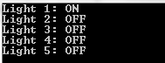

Sample Printout)
