MonthlyMortgage.cpp
Direction: This program can calculate an estimated monthly mortgage payment when given the number of years, the interest rate, and the principal amount of the loan. Use the following formula to calculate the Monthly Mortgage Payment:
P = Principal, I = Monthly Interest Rate, N = Months of Loan Term
Payment = ( P * I ) / ( 1 – (1 + I) ^-N)
A Sample Printout Follows:
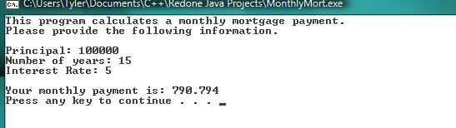

**Also, note that the program takes in different information than the formula uses. For example, the formula uses Monthly Interest Rate but the program accepts the number of years of the loan term. Use the following additional information to ensure that your formula is correct:
MonthsOfLoanTerm = years * 12
MonthlyInterestRate = InterestRate/(12*100)

