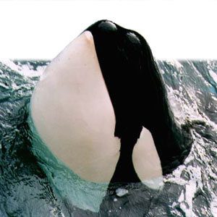
Orca Whale
What they look like: The orca (killer whale) is a toothed whale and is the largest member of the Dolphin family. These large marine mammals are easily distinguished by their black-and-white coloration, large dorsal fin and a sleek, streamlined body. The dorsal surface and pectoral flippers are black except for a grayish patch (saddle) that lies behind the dorsal fin and a white eyespot located just above and slightly behind each eye. The ventral surface, lower jaw and undersides of the flukes are predominately bright white. The distinctive patterns are a form of camouflage to hide their presence when in search of food.
Where they live:
Orcas are found in oceans worldwide. They are most abundant in the Arctic and Antarctic and in areas of cold-water upwelling.
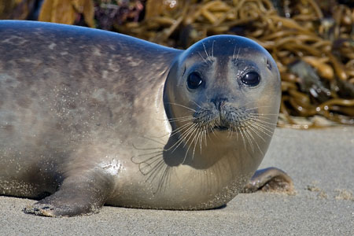
What they eat: Orcas are carnivorous (meat-eating) predators. They primarily prey upon marine mammals such as seals, sea lions, and even whales - using their sharp teeth that can be four inches (ten centimeters) long. They are known to grab seals right off the ice. They also eat seabirds, fish, and squid.
The whales in the Puget Sound region are know as fish-eating "resident" killer whales - since they tend to eat primarily fish, catching salmon, schooled herring or rockfish. While those in the open ocean are called mammal-eating "transient" killer whales - they regularly travel several hundred miles hunting for seals, sea lions, and other large mammals.
An adult orca consumes 100-300 pounds of food a day, depending on the animals size and energy needs.
Behavior: Like all dolphins, orcas use sophisticated biological sonar, called echolocation. Echolocation enables them to locate and discriminate objects underwater.
The vocalizations within a whale community are different from those in other communities, serving to keep the pods together. The calls also bring the pods together over large areas of water when it is not possible for the whales to see each other.
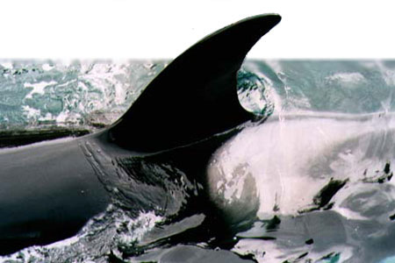
How do Whales Swim?
Their large bodies are streamlined (hydrodynamic), like a submarine, for moving through the water. Whales have flukes or a tail used for swimming. The flukes are moved in an up-and-down motion to accelerate.
The dorsal fin acts like the keel of a boat; it keeps the whale from rolling side to side while swimming.
Whales have pectoral flippers just behind the head. These pectoral flippers are used for steering, turning, and stopping.
How do Whales Breathe?
Whales have lungs they use to get the oxygen they need by breathing air (like humans). But instead of breathing through their mouth, they breathe through their nostrils, called blowholes, located on top of their heads. They can easily breathe through the blowhole without lifting their entire head out of the water.
Hunting Techniques: Orcas have perfected several inventive techniques to catch their prey. One method is for large groups of orcas to work as a team to herd victims together before attacking from different angles. Orcas will also frequently force seals and sea lions to beach, giving the hunter an easy catch in the shallow water. Tipping over ice floes to unbalance a tasty meal is another trick.
Did you know?
- Whales are warm-blooded like other mammals.
- A fatty tissue called "blubber" keeps them warm.
- Echolocation enables them to locate and discriminate objects.
- Orcas live in small, close-knit, groups called pods.
- Males usually live into their 40s and females into their 60s.
- Orcas have no predators.
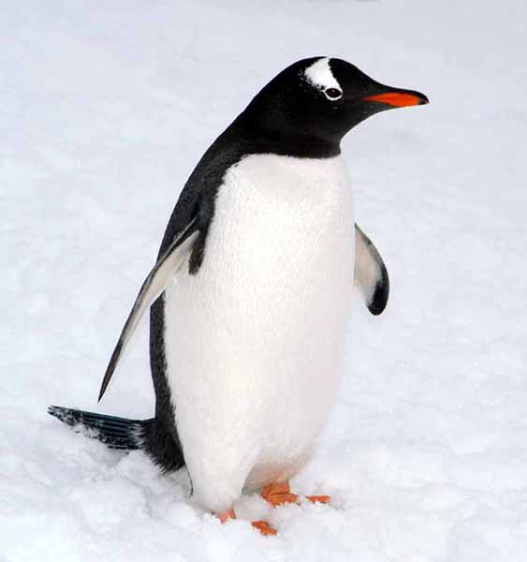
Penguin

How penguins stay warm and dry:
The downy under portion of the feathers traps a layer of air against the skin. This layer of air is then warmed by body heat, much the way our body heats the air in a down jacket. Their feathers overlap like shingles on a roof and form a barrier, keeping water away from the skin. Penguins also have a layer of blubber, or fat, under the skin. As a rule, larger penguins live in colder areas. This is because larger, rounder bodies lose heat slower than smaller, slimmer bodies. This explains why Antarctica’s emperor penguins, which survive the harshest winters, are the largest penguins in the world.

How penguins stay cool:
Some penguin species have bare patches (heat windows) around their eyes. These areas have no feathers and allow excess heat to escape. The patches become very pink when the penguin is warm. Penguins can voluntarily raise their feathers to let the warm air escape. Penguins have many tiny blood vessels (capillaries) close to the skin on their wings, which helps them to cool down by just holding their wings out and letting the air move across them. Penguins can release heat through their feet, where they have a counter-current blood exchange system.

How they swim:
A streamlined body, webbed feet and oar-like wings enable penguins to shoot through the water at speeds up to 15 miles per hour. It is often said that penguins look like they are flying through the water. Underwater quickness and the ability to hold their breath aid penguins in catching prey. All penguins use their short, stiff wings for propulsion and their webbed feet for steering. The position of their feet on the lower part the body aids in both steering and hydrodynamics.

How they hide:
As mentioned before, penguins have black backs and white bellies. This pattern of coloration is called countershading and serves to camouflage the bird when it is in the water. Since penguins spend most of their time in the ocean, this coloration is an effective form of protection. Countershading also helps the penguins hunt with more success.

How they dive deeper:
Most birds have hollow bones, making them lighter for flying. Penguins, however, have solid bones, making them heavier and making it easier to dive underwater for food.

How they shake off the salt:
Penguins have almond-shaped glands beneath the skin above their eyes that help them filter out the excess salt from the ocean. The salt drips down their beak, the penguins make a sneeze-like sound, and they are able to shake it off.
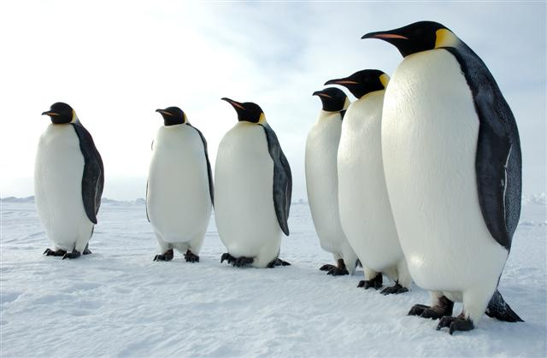

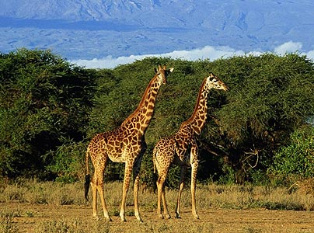
Giraffe
What they look like:
Giraffes are the world's tallest mammals, thanks to their towering legs and long necks. A giraffe's legs alone are taller than many humans—about 6 feet (1.8 meters). These long legs allow giraffes to run as fast as 35 miles (56 kilometers) an hour over short distances and cruise comfortably at 10 miles (16 kilometers) an hour over longer distances.
Typically, these fascinating animals roam the open grasslands in small groups of about half a dozen.
How they eat:
Giraffes use their height to good advantage and browse on leaves and buds in treetops that few other animals can’t reach. Even the giraffe's tongue is long! The 21-inch tongue helps them pluck tasty morsels from branches. Giraffes eat most of the time and, like cows, regurgitate food and chew it as cud. A giraffe eats hundreds of pounds of leaves each week and must travel miles to find enough food.
Advantages:
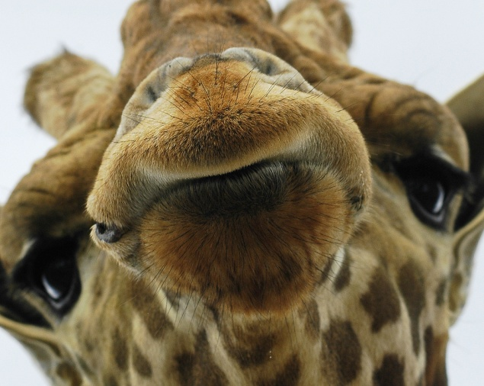
The giraffe's height also helps it to keep a sharp lookout for predators across the wide expanse of the African savanna.
Disadvantages:
The giraffe's stature can be a disadvantage as well—it is difficult and dangerous for a giraffe to drink at a water hole. To do so they must spread their legs and bend down in an awkward position that makes them vulnerable to predators like Africa's big cats. Giraffes only need to drink once every several days; they get most of their water from the luscious plants they eat.
Giraffes have beautiful spotted coats. While no two individuals have exactly the same pattern, giraffes from the same area appear similar.
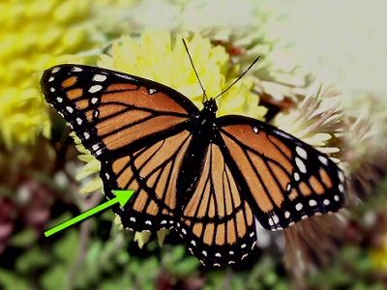
Viceroy Butterfly
What it looks like:
The Viceroy butterfly looks like a Monarch butterfly, except for the black line across the bottom of its wings and the single row of white dots on the black band.
The Monarch butterfly has an interesting relationship to the Viceroy butterfly. The Viceroy butterfly is a mimic of the Monarch butterfly. The monarch serves as a model to the viceroy. The two butterfly species have similar color patterns even though they are not related. Both the Viceroy butterfly and the Monarch butterfly taste bad to their predators. Predators learn not to prey on either butterfly species because they look so much alike.
The viceroy butterfly is dark orange with black veins. A row of white spots edge its wings.

Habitat:
Mature viceroy butterflies seek out moist areas along bodies of water to live and breed in.

Diet:
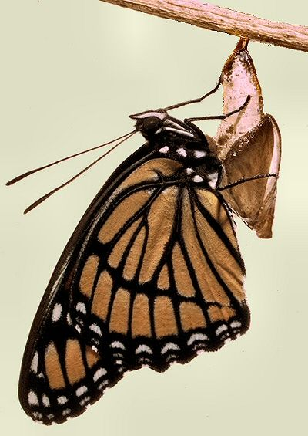
Viceroy caterpillar larvae eat tree leaves, including the cottonwood and willow. Adult butterflies feast on flowers, decomposing fruit and animal remains.
Behavior:
The viceroy and monarch were once thought to exhibit Batesian mimicry where a harmless species mimics a toxic species. Studies conducted in the early 1990's suggest that the viceroy and the monarch are actually examples of Mullerian mimicry where two equally toxic species mimic each other to the benefit of each. Just goes to show you there's always something new to discover in the natu ral world!
Laying Eggs:

Female Viceroy butterflies lay their eggs on the tips of willow tree or cottonwood leaves. Predators have a hard time spotting the eggs.

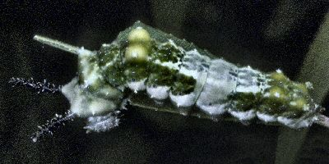
Caterpillars:

Viceroy caterpillars are found living in willow, poplar, and cottonwood trees. They eat the leaves of these trees. Viceroy caterpillars are olive green and brown with bristly bumps at the back of their heads. The caterpillars have a white spot on their backs. Because of their coloring, they look like bird droppings, which gives them protection from predators.
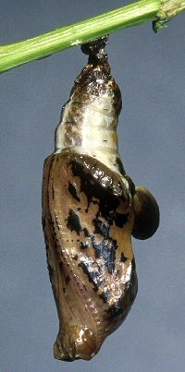

Chrysalis:
The Viceroy chrysalis is brown with cream markings. Predators may also mistake the chrysalis for bird droppings.
Viceroy butterflies drink sap that oozes from trees. Once flowers bloom, adult Viceroy butterflies sip the nectar of aster, goldenrod, thistle and other flowers.

