Animal Adaptations
Animal | Adaptation
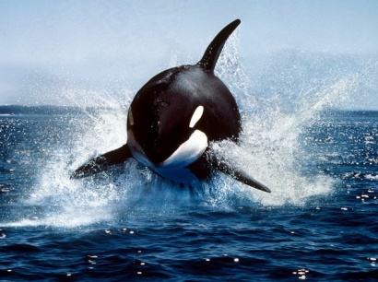  Orca Whale | Behavior
 | Physical
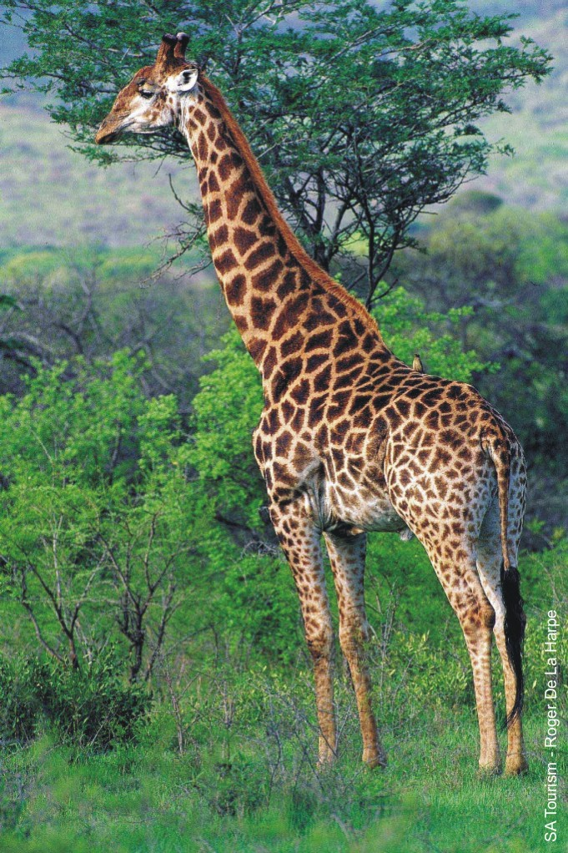  Giraffe | Behavior
 | Physical
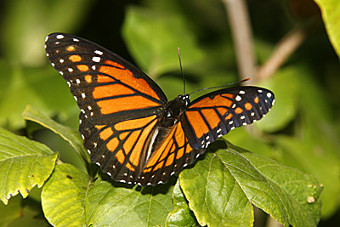  Viceroy Butterfly | Behavior
 | Physical
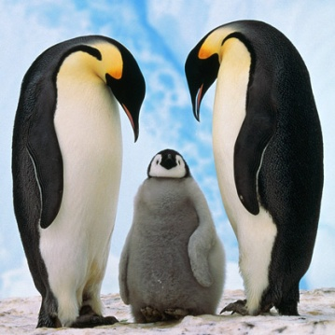  Penguin | Behavior
 | Physical

Name ____________________________________________
Directions: Look at each animal below. Name several adaptations - behavioral and physical – for each animal. For example: getting food is a behavior. HINT: Use your articles to help you.

