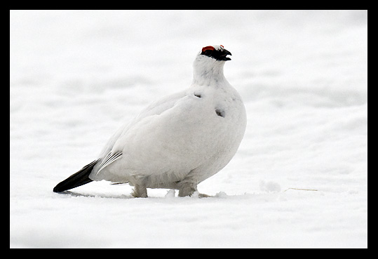

Number

Tundra Adaptations

Rock ptarmigans can often be found in high, rocky, sloped areas of the tundra. The tundra is an area where the deeper soil is permanently frozen. The surface soil will thaw in the short summer allowing plants to grow. One of the characteristics of tundra is that it is often treeless. Another characteristic of tundra is that it, like deserts, receives little precipitation. Tundra will also reach extremely cold temperatures, especially in the winter when it receives little to no sunlight.

Adult ptarmigans will feed on leaves, flowers, berries, buds, twigs and other types of plants. Young ptarmigan chicks will also be fed insects in addition to plants. Rock ptarmigans are between 12 - 16 inches in length. The Rock ptarmigans molt their feathers several times a year and will change colors when it does so. During the summer months, their feathers will have a spotted brown color. In the winter the birds shed their brown feathers for an almost pure white coat of feathers. Ptarmigans are a food source for many other animals that are found in the tundra, including arctic foxes and snowy owls.  
  
Which characteristics are adaptations that the Rock Ptarmigan needs to survive in the Tundra?

____ sharp claws ____ long- sharp beak

____ long fur ____ white feathers

____ short- strong beak ____ speckled brown feathers

____ feathered legs ____ small bodies

____ webbed-feet ____ no feathers on their heads

Explain how the characteristics that you selected will help the rock Ptarmigan to survive in the tundra. __________________________________________________________________________________________________________________________________________________________________________________________________________________________________________________________________________________________________