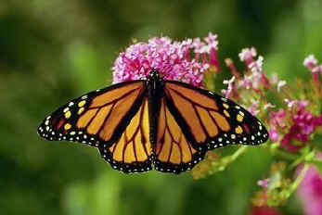
Animal Adaptation Quiz *adapted*
Name _________________________________
Vocabulary: Write the vocabulary word with its correct definition.
___1. Migration
____2. Chemical defense
____3. Physical adaptation

____4. Hibernation
____5. Camouflage
____6. Adaptation
____4. Mimicry
____6. Body coverings and parts
____7. Instinctive behavior
____10. Learned behavior
- Body structures that allow an animal to find and consume food, defend itself, and to reproduce its species, it helps an animal survive in its environment.
- When an animal or group of animals move from one region to another and then back again to find a better climate, food, a safe place to live, and raise young.
- A physical adaptation that animals use to defend themselves (venom, ink, and sprays).

- A physical adaptation that allows an animal to change color to blend into their surroundings.
- The evolutionary process where a population becomes better suited to its habitat for survival. This process takes place over many generations.
- A deep sleep in which animal’s body temperatures drop and body activities are slowed to conserve energy.

- Behaviors that happen naturally and don’t have to be learned (migrating, hibernating, raising young, defending oneself…)
- A physical adaptation that animals have to help them survive (claws, beaks, feet, armor plates, skulls, teeth…)
- A physical adaptation that allows an animal to look, sound, or act like another living organism.
- Behaviors that must be taught. They are obtained by interacting with the environment and cannot be passed on to the next generation except by teaching

Direction: Circle the best response.

11. Why do storks have long beaks?
a. to spit at animals
b. to hunt fish
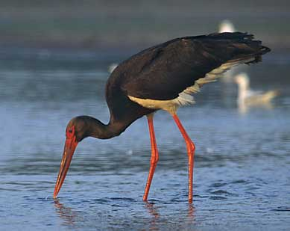
c. to drink water from a pond
d. to defend itself
12. Why does the blowfish blow itself to a bigger size?
a. to scare predators away
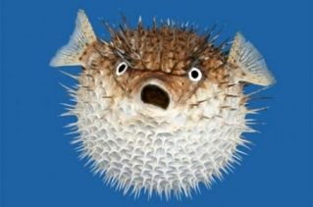
c. to float to the top of the water
d. to fit in more food

13. Why is a cheetah long and skinny?
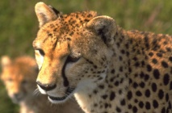
a. so it doesn’t need to eat very much
b. so it can run fast to catch animals to eat

14. Why would a rabbit’s fur be colored white?
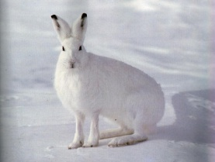
a. to keep it soft
b. to look like snow so it can hide

15. Which one of these below is a physical adaptation?
a. bears hibernating
b. mimicry and camouflage

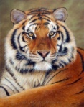

16. Why does a tiger have stripes?
a. to blend in with zebras so it can kill one
b. to blend into the grass when it is hunting

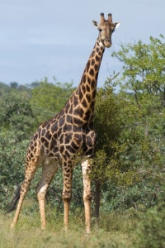
17. Why to giraffes have long necks?
a. to breath cooler air
b. to reach leaves high in trees

18. Why does an eagle have a hooked beak?
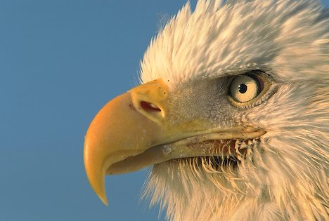
a. to tear meat
b. to crack nuts
d. to fly faster in the air

The Viceroy butterfly looks like the Monarch butterfly, which tastes terrible to birds, so birds won't take the chance and eat the Viceroy. What is this kind of adaptation?
Circle: Hibernation Mimicry Migration
Please demonstrate this adaptation with the two butterflies below.
