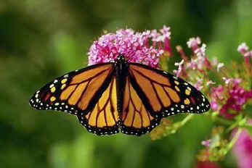
Animal Adaptation Quiz
Name _________________________________
Vocabulary: Write the vocabulary word with its correct definition.
- A deep sleep in which animal’s body temperatures drop and body activities are slowed to conserve energy.
- When an animal or group of animals move from one region to another and then back again to find a better climate, food, a safe place to live, and raise young.
- A physical adaptation that animals use to defend themselves (venom, ink, and sprays).
- A physical adaptation that allows an animal to change color to blend into their surroundings.
- The evolutionary process where a population becomes better suited to its habitat for survival. This process takes place over many generations.
- Behaviors that must be taught. They are obtained by interacting with the environment and cannot be passed on to the next generation except by teaching
- Behaviors that happen naturally and don’t have to be learned (migrating, hibernating, raising young, defending oneself…)
- A physical adaptation that animals have to help them survive (claws, beaks, feet, armor plates, skulls, teeth…)
- A physical adaptation that allows an animal to look, sound, or act like another living organism.
- Body structures that allow an animal to find and consume food, defend itself, and to reproduce its species, it helps an animal survive in its environment.

____1. Adaptations
____2. Physical adaptations
____3. Camouflage
____4. Mimicry
____5. Chemical defense
____6. Body coverings and parts
____7. Instinctive behavior
____8. Migration
____9. Hibernation
____10. Learned behavior

Direction: Circle the best response.

11. Why do storks have long beaks?
a. to spit at animals
b. to hunt fish
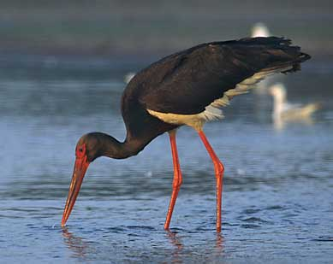
c. to drink water from a pond
d. to defend itself
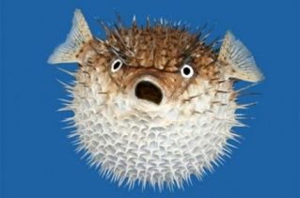
12. Why does the blowfish blow itself to a bigger size?
a. to scare predators away
b. to look pretty for its mate
c. to float to the top of the water
d. to fit in more food
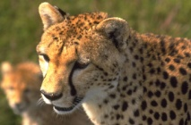
13. Why is a cheetah long and skinny?
a. so it can walk quietly
b. so it doesn’t need to eat very much
c. so it can run fast to catch animals to eat
d. so it can jump high
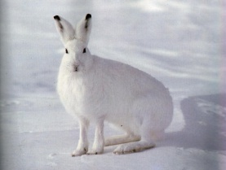
14. Why would a rabbit’s fur be colored white?
a. to keep it soft
b. to keep it warm
c. to keep it cool
d. to look like snow so it can hide
15. Which one of these below is a physical adaptation?
a. a cat hissing
b. bears hibernating
c. mimicry and camouflage
d. all of the above

16. Why does a tiger have stripes?
a. to blend in with zebras so it can kill one
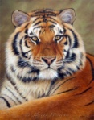
b. to blend into the grass when it is hunting
c. to look scary
d. to keep it warm
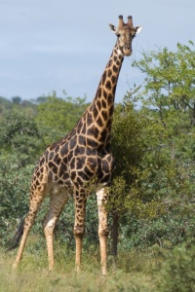
17. Why to giraffes have long necks?
a. to breath cooler air
b. to help digest its food
c. to reach leaves high in trees
d. to reach down to eat small insects
18. Why does an eagle have a hooked beak?
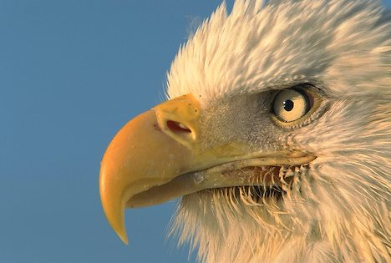
a. to tear meat
b. to crack nuts
c. to dig for seeds
d. to fly faster in the air

The Viceroy butterfly looks like the Monarch butterfly, which tastes terrible to birds, so birds won't take the chance and eat the Viceroy. What is this kind of adaptation? __________________
Please demonstrate this adaptation with the two butterflies below.
