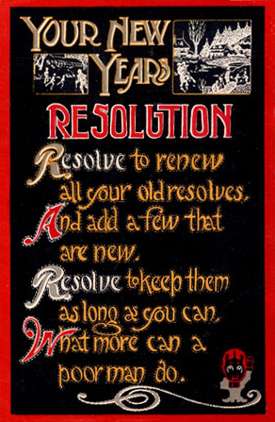

*January 2014*

**New Year – New Me?**

*Marian High School – Tamaqua, PA 18252*

**Marianews**

New Year’s Resolutions

By Sara Bauer

Think about which resolutions you want to make. Pick ones you can realistically complete and that will improve your life. If exercising more won’t really help you in the long run (no pun intended), don’t make that resolution (though exercise is always a good idea even if it’s not a resolution).

Share your goals with family and friends. That way you can be held accountable if you cheat or slack off. And they can motivate you (meaning tease you until you get annoyed enough to get back to work).

Finally, don’t beat yourself up if you couldn’t reach your goal. Just try again next year. The good thing about life is it lasts about 70 years, and you don’t have to wait until January 1 to improve your life.

New Year’s resolutions seem like a good idea when you make them, but soon they are abandoned. Gyms see a rush of new customers in January, but in February numbers are back to normal. And of course Valentine’s Day and the Super Bowl make it hard to cut back on junk food. Whay are New Year’s resolutions so hard to keep? According to HowStuffWorks.com, it’s more than just human nature.

Ever Since the Babylonians started the tradition to find favor with the gods, humans have been making resolutions. And since then, people have been failing to keep them. This is because many people overwelm themselves. Some people make too many resolutions, and some make resolutions that are too broad or unobtainable. A lot of people have a combination of both.

So what can you do about it? Set specific goals that can be monitored. This will help you figure out the steps you need to take to reach the goal. It will also make you feel good when you look back at how much progress you made later on.

Also, work one resolution at a time. If your goal is to lose weight, stop smoking, get a job, and get good grades, you will be overwhelmed. Choose one resolution, see it through to the end, and then work on another one.

Some popular resolutions

Lose weight – volunteer to help others – quit smoking – get a better education – get a better job – save money – get fit – eat healthy – manage stress – manage debt - take a trip – reduce, reuse and recycle

Christmas Production of Yester-Year by Annette Ritzko

With all the Christmas Production had given us by that point, you must wonder what they had in store with the finale, and would they really be able to top the previous performances. To put it simply, the finale was heart-touching! Memorable Chorus members of the past, now alumni, joined the current Chorus members in a gentle rendition of “O Holy Night,” that no doubt put a tear in a few eyes! After such a Christmas Production, no doubt the audience went home spirited and ready to celebrate Christmas!

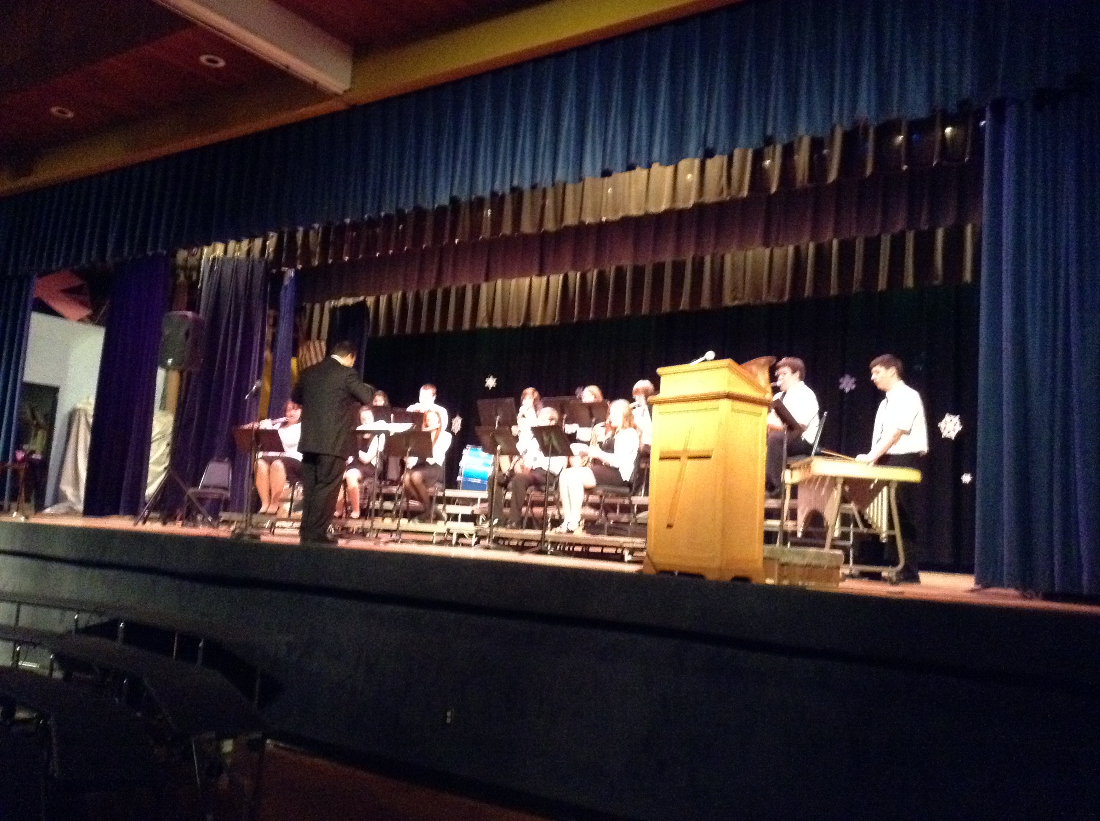

to be center stage. The songs ranged from recognizable classics like “O Come, O Come, Emmanuel” to newer favorites like “Mary, Did You Know?,” which was sung superbly by Olivia Sposato, who also played the piano to it. Fortunately, the night didn’t end with only a few soloists, in the songs “Prepare the Way of the Lord” and “Breath of Heaven,” Joseph Letcher and Amanda Champion, respectively, had solos and did marvelously! And before the night was through, County Chorus was put into the spotlight when they were featured in the song “No Eye Had Seen.”

Hurst performed a beautiful rendition of “Christmas Eve/ Sarajevo 12/24” on piano. “Christmas Lights” soon followed, with Joseph Letcher being the vocalist, Kelsey Hurst on piano, Michael Dino being lead guitarist, James McKinley on drums, Seth Harkin on rhythm guitar, Taylor Horvat playing the bass, and John Sieirczeck as the sound engineer.

After a short intermission, which included yummy cookies, it was chorus’s turn

Christmas may have come and gone and it may be a whole new year, but the memories still linger. Way back in 2013, if you can think back that far, there was the annual Marian Christmas Production. I fortunately got the opportunity to not only go to it, but also perform in it!

The production began with concert band performing “Bulger’s Holiday*”* and a favorite of many, “Hot Chocolate!*”* Then Kelsey

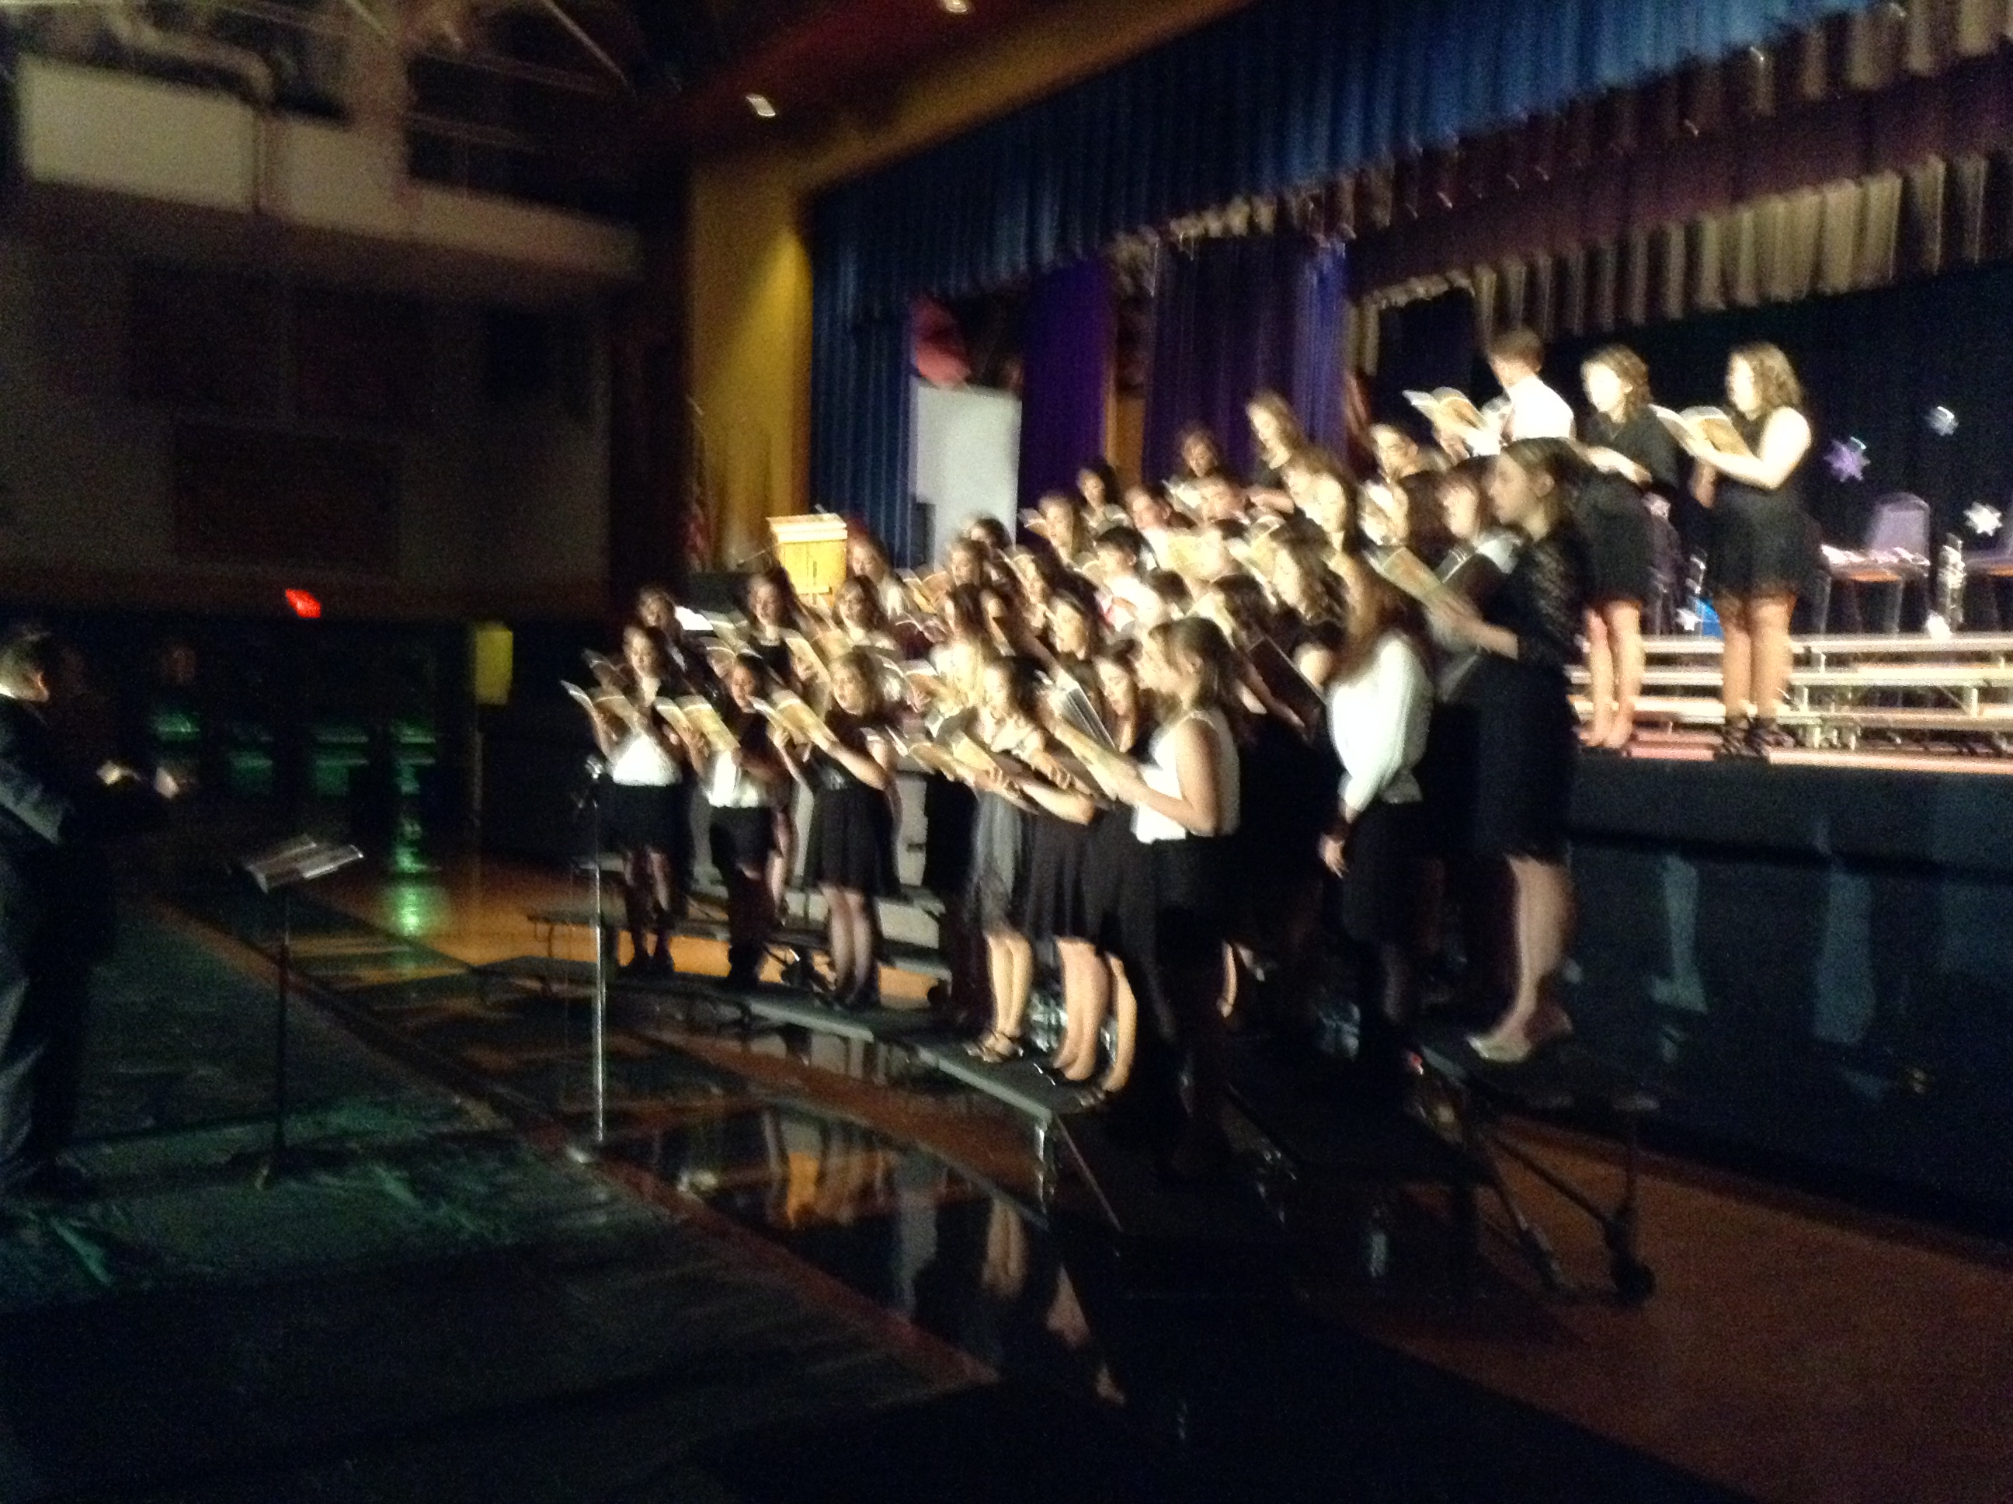

**Want to hear some of it?**

**Scan this QR code and it will take you to the webpage with some videos of the concert. Be patient it loads slowly.**

**http://websites.pdesas.org/mcostello/2014/1/4/539580/content.aspx**  (if you



If you don’t know about QR codes, download a QR reader

app for your phone and just scan to see what happens.

The scan takes you to an internet site based on the subject

of the scan, in this case the Christmas Concert.

**A Night in Paris** by Britney Ziegler

C:\Program Files (x86)\Microsoft Office\MEDIA\CAGCAT10\j0157763.wmf

The theme for this year’s semiformal dance was **A Night in Paris** held January 18. It was a night of dancing and fun food such as a chocolate fountain. The D.J was J.D. Roadshow who played a lot of dance music and even some slow stuff. There was a ton of people dancing and enjoying themselves. The girls were dressed very nicely; there were some long dresses but mostly short. The men looked handsome in their suits. The highlight of the night was Mrs. Coles who became the center of a giant mosh pit. Everyone enjoyed the spectacle.

**Senior Play - West Side Story**

Casting

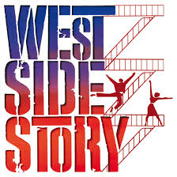C:\Users\M. Costello\AppData\Local\Microsoft\Windows\Temporary Internet Files\Content.IE5\YCUP9P0B\MC900018267[1].wmfC:\Users\M. Costello\AppData\Local\Microsoft\Windows\Temporary Internet Files\Content.IE5\YCUP9P0B\MC900018267[1].wmfC:\Users\M. Costello\AppData\Local\Microsoft\Windows\Temporary Internet Files\Content.IE5\YCUP9P0B\MC900018267[1].wmf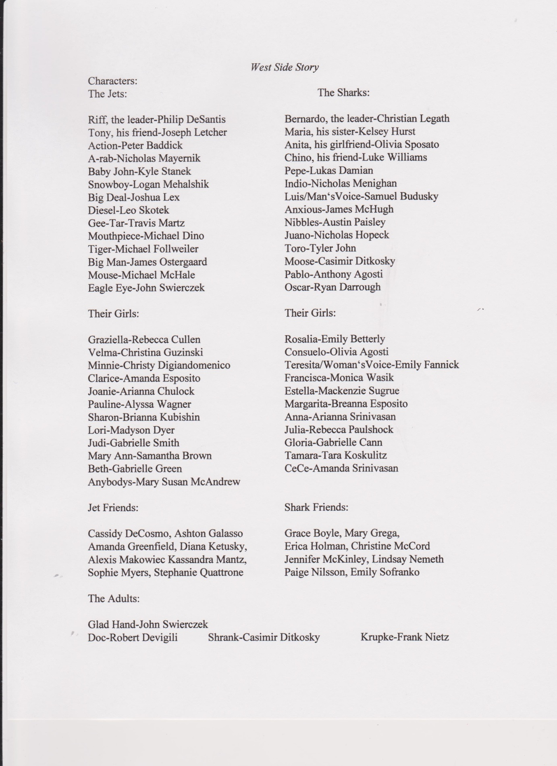

C:\Users\M. Costello\AppData\Local\Microsoft\Windows\Temporary Internet Files\Content.IE5\YCUP9P0B\MC900018267[1].wmf

**Happy New**

**Year?**

Ha



In Lucena, Spain, some Carmelite nuns got an interesting voicemail on their phone on New Year’s Eve. Though this may not sound eventful, you may change your mind after you hear who the call was; none other than Pope Francis. The Pope left this message on the nun’s machine, in a playful voice, “What are the nuns doing that they can't answer? I am Pope Francis, I wish to greet you in this end of the year, and I will see if I can call you later. May God bless you!" It didn’t take the nuns, who were in prayer at the time of the call, to eagerly release the recording to the media. Soon the entire world was chuckling at the Pope’s humorous antics. Sister Adriana, the prioress of the convent, stated “I literally wanted to die!” Then she explained, “Our friendship goes back 15 years but we never thought the pope would remember to think of us.” Hours later, Pope Francis called again, and this time, thankfully, the nuns answered.

By Robert Devigili

**Snow Days** by Andrew Dotter



The winter season and the wintry weather that comes with it is upon us!! That winter weather is bad news for schools; there are possible delays or even cancellations. Two-hour delays are bad for teachers; there are fewer to no students in their classes and their lesson plans become messed up because they might have to spend another day re-teaching the work to the students that weren't there. Snow days are even worse, for the teachers that is. Students love days off and the excitement that comes with being able to sleep in, getting a free day or just the fact that they don't have to come to school!! But if the weather is really bad, what can you do on a snow day? You're stuck in the house with nothing to do... Might I suggest a movie? Simply grab a blanket, some hot chocolate (maybe) and your favorite movie and just enjoy yourself!! And if movies aren't your thing, try something else to do on your day off. I think Mrs. Costello might suggest a good book! But most of all stay warm and safe, below zero temps are nothing to play around with.

­­

­­

C:\Users\M. Costello\AppData\Local\Microsoft\Windows\Temporary Internet Files\Content.IE5\F8BXVBPL\MC900060307[1].wmf

Upcoming Events

Feb 1 – Diocesan Music festival

Feb. 4 – Gold Activity

Feb. 11-24 – Phon-a-thon

Feb 14 – Valentine’s Day

Feb. 17 – President’s Day

Feb. 20 – Blue Activity

Feb. 21 – Failure Warnings

**Catholic Schools Week**

by Maggie Nicholson

There were many activities planned for this year’s Catholic Schools’ Week. On Monday, we started the birthday box project. Each homeroom got a box and a theme. They were to fill the box up with birthday items that matched up to their given theme. These boxes will be donated to local Catholic Social Services. Ice cream was served at lunches this day. Tuesday’s talent show was moved to February 6th due to school delays in the bitter cold weather. On Wednesday, we wore red, white, or blue t-shirts to celebrate our government officials. We also had mass on this day. On Thursday, representatives from Catholic Social Services came to speak with the students. Lastly, on Friday, the boys’ volleyball game took place. This is such a nice way to celebrate out Catholic schools with this year’s theme: *Catholic Schools – Communities of Faith, Knowledge and Service.*

Open House

Marian held it’s annual Open House to start Catholic School s Week on Sunday January 26. The turnout was terrific, almost 100 perspective students attended with their families. The gym was set up with stations from each department for visitors to see and talk with teachers there. After a prayerful and uplifiting beginning with song, the students and parents went to various rooms to learn about what Marian has to offer. It was a busy day for teachers and student volunteers but a successful one. Visitors were impressed with what they saw. Hopefully Marian will see all of these students in the future.

Upcoming Events

Feb 1 – Diocesan Music festival

Feb. 4 – Gold Activity

Feb. 11-24 – Phon-a-thon

Feb 14 – Valentine’s Day

Feb. 17 – President’s Day

Feb. 20 – Blue Activity

Feb. 21 – Failure Warnings